Considerations for Making Admissions Test-Optional
Jesse Delaney, Director of Student Success Data Analysis
(i) Reasons to retain the current test-optional policy
Why keep the test-optional policy of the past two years?
- A first benefit of the test-optional policy is that it has reportedly improved access, state representativeness, and diversity along race/ethnicity and HS/regional lines.

- A second benefit of the test-optional policy is increased freshman enrollment and resulting options for reshaping future enrollment.
Growth in new freshman enrollment beyond the old norm of 4,300-5,000 per fall to 6,000+ can be attributed entirely to the test-optional policy. Last fall, enrollment among the student group newly eligible for the NRTA (i.e., non-residents with 3.2+ HS GPAs and ø-23 ACT equivalents) was 1,716, 4.1 times the 2012-2020 average. Enrollment among other freshmen, at 4,296, was identical to the 2012-2020 average.

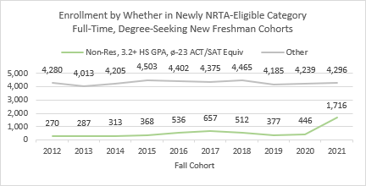
The test-optional policy has apparently attracted many strong students. Focus first on the newly NRTA-eligible group. Historically, the retention and graduation rates of non-residents who have 3.2+ HS GPAs, ø-23 test scores, and a resident tuition exception, have surpassed the university’s overall rates (first figure below). Last fall’s set of 1,716 newly NRTA-eligible students so far have a 3.7 mean HS GPA, 3.0 mean first-fall GPA, and 94.3% one-term retention rate. And more generally, since implementing the test-optional NRTA, non-resident enrollment has increased most in the 3.6-3.79 and 3.8-3.99 HS GPA bands (second figure).
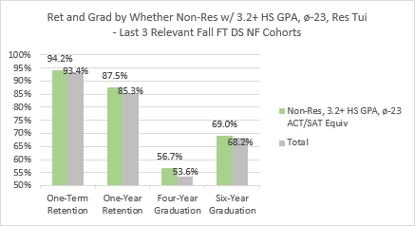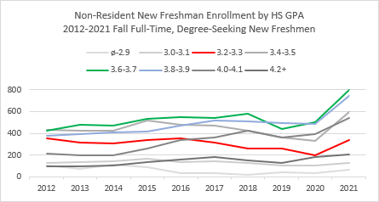
Based on 2022 admissions indicators, the test-optional policy appears capable of attracting more than 6,500 freshmen per fall. That expanded pool of would-be students gives the university the opportunity to trim future enrollment in ways that optimize retention and graduation.

- Given an opportunity to trim enrollment by excluding either the lowest test scores or the lowest HS GPAs, historical retention and graduation data generally recommend carving by HS grades.
As a contrast of the line graphs below begins to show, HS GPAs explain historical outcomes far better than test scores. Note how much more steeply success rates slope in the first graph than in the second. Whereas one-year retention rates are 60% among students who lacked a 3.0+ HS GPA and below 70% in every HS GPA band below 3.2, rates are 72% or higher in every test score bin.

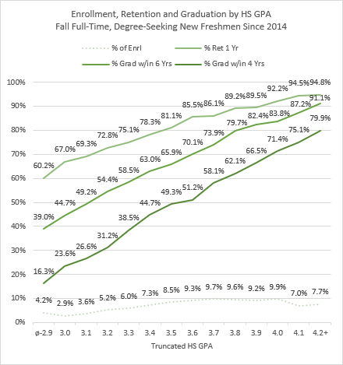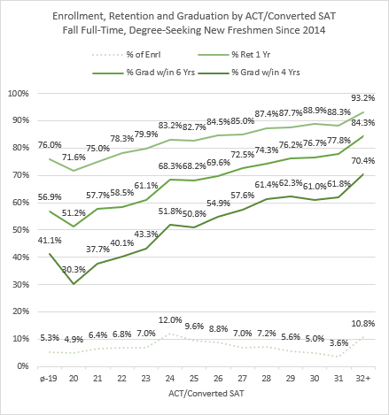
Consider next how outcomes change by each measure of HS preparation when controlling for the other.
First taking students with a given test score, represented in a heat chart column below, you can see the margins by which success rates improve (from red to green) with increases in HS GPA. Among students with 25s, e.g., for each 0.1 increase in HS GPA, the one-year retention rate increases by an average of 3 percentage points and the four-year graduation rate by an average of 5 points.
Within many HS GPA bands, in contrast, test scores are not positively associated with retention. Among students with ø-3.2 HS GPAs, test scores historically have been negatively associated (p < .01) with retention. (Each value in the heat charts below represents at least 15 observations. Tabs b-c of the attached file give enrollment by GPAs and scores. Tabs d-e give ENGR- and WCOB-specific information.)

One-Year Retention by Truncated HS GPA and ACT/Converted SAT- Fall FT DS NF - 2014-2020 Cohorts
 | ø-19 | 20 | 21 | 22 | 23 | 24 | 25 | 26 | 27 | 28 | 29 | 30 | 31 | 32+ | Total
ø-2.9 | 66.4% | 57.4% | 61.2% | 62.1% | 60.2% | 64.8% | 58.6% | 52.0% | 50.8% | 61.9% | 63.6% | 47.1% |  |  | 60.2%
3.0 | 68.7% | 69.1% | 65.7% | 73.8% | 65.4% | 70.6% | 60.2% | 65.7% | 66.7% | 50.0% | 76.9% | 46.2% |  |  | 67.0%
3.1 | 74.3% | 62.7% | 73.9% | 75.3% | 74.0% | 69.9% | 68.0% | 66.7% | 62.5% | 62.0% | 62.1% | 57.1% |  |  | 69.3%
3.2 | 72.9% | 68.1% | 74.3% | 69.5% | 72.3% | 77.4% | 73.0% | 77.4% | 68.5% | 77.9% | 70.6% | 62.5% | 62.5% | 60.0% | 72.8%
3.3 | 81.1% | 71.9% | 70.7% | 73.1% | 73.9% | 78.5% | 76.0% | 71.5% | 78.9% | 73.2% | 81.7% | 88.9% | 72.2% | 64.9% | 75.1%
3.4 | 76.9% | 73.9% | 72.5% | 80.3% | 82.0% | 81.9% | 78.5% | 82.8% | 80.1% | 69.7% | 75.0% | 79.1% | 66.7% | 70.7% | 78.3%
3.5 | 79.7% | 79.3% | 76.9% | 83.2% | 83.3% | 81.9% | 79.8% | 81.5% | 83.3% | 80.0% | 78.0% | 76.2% | 89.7% | 86.8% | 81.1%
3.6 | 84.0% | 84.8% | 79.8% | 81.9% | 88.0% | 86.9% | 85.9% | 87.7% | 83.6% | 87.8% | 84.2% | 89.3% | 78.3% | 85.4% | 85.5%
3.7 | 82.1% | 76.6% | 82.9% | 81.9% | 85.2% | 85.7% | 85.6% | 87.7% | 89.2% | 89.0% | 90.1% | 89.7% | 85.2% | 81.1% | 86.1%
3.8 | 82.8% | 80.3% | 87.9% | 92.5% | 86.9% | 89.8% | 89.3% | 89.9% | 90.3% | 91.6% | 89.0% | 91.2% | 87.7% | 85.5% | 89.2%
3.9 | 88.6% | 91.4% | 92.3% | 84.3% | 90.3% | 88.8% | 89.5% | 89.2% | 86.7% | 92.6% | 91.1% | 86.2% | 89.1% | 92.0% | 89.5%
4.0 | 82.6% | 68.0% | 95.0% | 87.5% | 84.6% | 90.1% | 92.1% | 89.7% | 94.9% | 91.7% | 92.0% | 93.8% | 93.2% | 94.9% | 92.2%
4.1 |  |  | 93.8% | 94.1% | 94.7% | 88.2% | 94.2% | 93.6% | 94.4% | 94.3% | 93.3% | 93.8% | 91.6% | 97.4% | 94.5%
4.2+ |  |  |  |  | 95.8% | 89.3% | 91.5% | 92.3% | 88.0% | 94.0% | 92.3% | 93.3% | 94.0% | 97.2% | 94.8%
Total | 76.0% | 71.6% | 75.0% | 78.3% | 79.9% | 83.2% | 82.7% | 84.5% | 85.0% | 87.4% | 87.7% | 88.9% | 88.3% | 93.2% | 83.8%

Four-Year Graduation by Truncated HS GPA and ACT/Converted SAT- Fall FT DS NF - 2014-2017 Cohorts
 | ø-19 | 20 | 21 | 22 | 23 | 24 | 25 | 26 | 27 | 28 | 29 | 30 | 31 | 32+ | Total
ø-2.9 | 18.8% | 10.7% | 17.0% | 14.8% | 21.8% | 22.4% | 15.1% | 9.7% | 13.6% | 0.0% |  |  |  |  | 16.3%
3.0 | 25.0% | 20.5% | 24.8% | 25.0% | 16.9% | 21.1% | 21.1% | 24.0% | 28.6% |  |  |  |  |  | 23.6%
3.1 | 36.4% | 18.8% | 28.8% | 27.1% | 29.0% | 26.5% | 29.2% | 16.3% | 27.5% | 25.0% | 35.3% | 15.4% |  |  | 26.6%
3.2 | 31.6% | 22.4% | 34.6% | 30.5% | 32.7% | 38.4% | 29.0% | 34.9% | 34.4% | 21.6% | 23.8% | 21.1% |  |  | 31.2%
3.3 | 51.5% | 29.7% | 37.9% | 38.2% | 35.5% | 47.5% | 39.6% | 33.1% | 43.1% | 38.7% | 31.4% | 20.0% | 23.1% | 22.7% | 38.5%
3.4 | 44.8% | 39.5% | 41.0% | 44.6% | 43.2% | 51.7% | 44.0% | 46.8% | 52.3% | 44.3% | 35.3% | 42.3% | 15.0% | 26.3% | 44.7%
3.5 | 46.8% | 32.9% | 45.5% | 49.3% | 53.7% | 55.6% | 50.2% | 52.1% | 52.0% | 44.4% | 43.2% | 29.1% | 52.6% | 51.3% | 49.3%
3.6 | 44.6% | 46.2% | 47.9% | 45.5% | 54.2% | 52.2% | 52.3% | 52.9% | 54.5% | 55.1% | 56.7% | 51.4% | 37.8% | 36.2% | 51.2%
3.7 | 55.8% | 50.0% | 56.0% | 51.5% | 46.8% | 62.2% | 57.5% | 67.4% | 62.9% | 64.7% | 50.5% | 59.6% | 47.9% | 39.7% | 58.1%
3.8 | 61.5% | 59.4% | 51.0% | 65.7% | 60.2% | 65.0% | 62.6% | 70.4% | 64.5% | 66.3% | 57.8% | 59.3% | 58.0% | 47.2% | 62.1%
3.9 | 75.0% | 75.0% | 65.6% | 54.8% | 58.0% | 66.9% | 68.8% | 62.4% | 65.9% | 73.2% | 73.2% | 61.9% | 68.1% | 62.5% | 66.5%
4.0 | 60.0% | 53.3% | 65.0% | 61.8% | 67.5% | 63.5% | 67.0% | 66.5% | 75.0% | 73.7% | 78.6% | 73.1% | 72.8% | 73.0% | 71.4%
4.1 |  |  |  | 56.3% | 71.4% | 61.7% | 71.4% | 79.7% | 67.1% | 80.0% | 78.8% | 78.5% | 71.7% | 77.1% | 75.1%
4.2+ |  |  |  |  |  | 76.9% | 77.1% | 77.0% | 75.9% | 78.7% | 79.3% | 76.8% | 75.8% | 82.9% | 79.9%
Total | 41.1% | 30.3% | 37.7% | 40.1% | 43.3% | 51.8% | 50.8% | 54.9% | 57.6% | 61.4% | 62.3% | 61.0% | 61.8% | 70.4% | 52.9%

The test-optional policy experiment is new enough that we are yet to see how the current crop of freshmen will do. That point is especially relevant regarding the nearly half of current freshmen who have ø-23 test scores. That large subset of current freshmen differs from past freshmen without 24+ ACT scores in a few important respects: though the current group has a higher one-term retention rate (first figure) and higher mean adjusted HS GPA (second figure) than their past counterparts, as well as a higher percentage (97% vs. 79%) who are paying resident-equivalent tuition, they also have a far lower pledge rate (third figure) and, given ø-19 scores, a lower mean first-fall GPA (fourth figure).
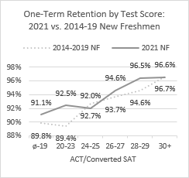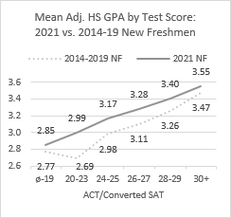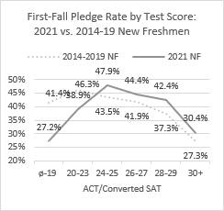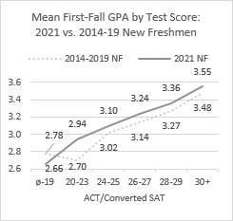
Given the changes in these predictors of UA success, among students who lack 24+ scores, the group’s future success rates may also differ from its past success rates. The coming fall’s one-year retention outcomes will provide important information. In the meantime, all presently available retention and graduation data advise a preference for better HS GPAs over higher test scores.
(ii) Possible cost of test-optional policy
Suspending the general admission test requirement may have lowered the percentage of resident freshmen who are receiving either an Academic Challenge or Governor’s Scholarship. Compared to the pre-pandemic years when the Academic Challenge had its present structure, the percentage dropped by roughly 10 points, from 85% to 75%. This poses a problem because first-year Challenge/Governor’s recipients historically have significantly higher success rates than similarly prepared non-recipients.

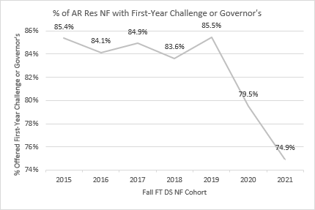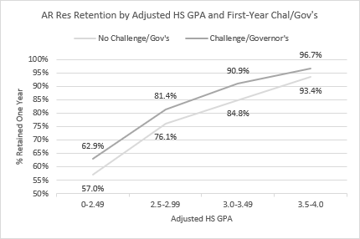
(iii) Proposed alternatives to reinstatement of test requirements
What admissions and NRTA criteria would right-size enrollment and optimize retention and graduation rates? Based on historical data, it appears that either or both of the following strategies would result in better student success rates than NRTA test requirements.
- Increase the NRTA’s HS GPA requirements.
Last fall’s new freshman cohort included 329 NRTA recipients with 3.2-3.39 HS GPAs and 574 NRTA recipients with HS GPAs of 3.4-3.59. Those students historically have retention rates of 80% or below, compared to rates of 87% or better for their counterparts in the higher HS GPA ranges. Graduation rates divide similarly.
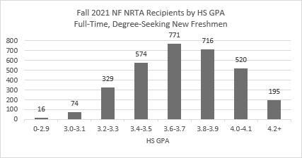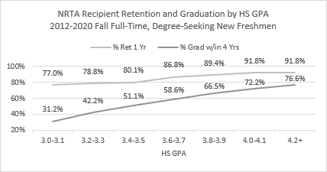
- Possibly through a holistic review process, admit non-residents based on factors including adjusted HS GPA. This measure, based not just on the student’s HS GPA but also on the relation between past GPAs from their high school and UA GPAs, explains retention and graduation outcomes far better than standardized HS GPAs. (The second attachment gives, as promised, the numbers used to calculate each freshman’s adjusted HS GPA last fall. It would be easy to provide updates in advance of each year’s admissions process. )

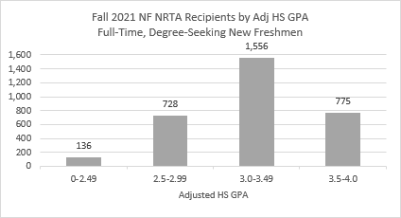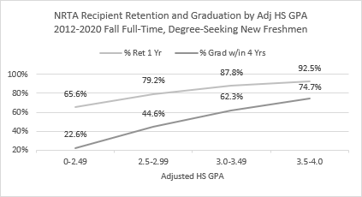
Pardon for erring on the side of too many charts. Please let me know if you could use other information along these lines.

