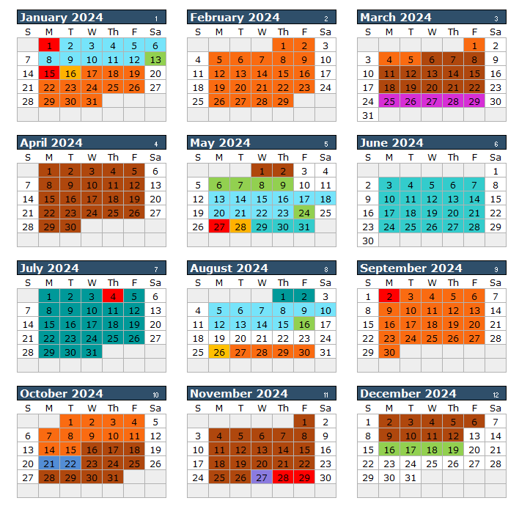

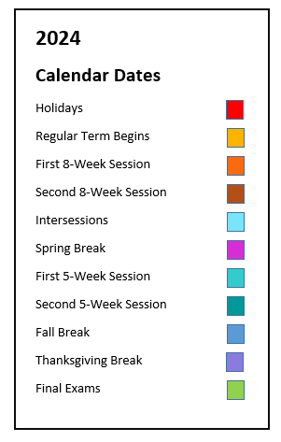

Spring (January) Intersession 2024
(10 class days; includes 2 Saturdays)
Jan. 2 Classes Begin
Jan. 12 Last Day of Classes
Jan. 13 Final Exams

Spring 2024 73 class days (43 MWF, 30 TT)
Jan. 15 Martin Luther King
Holiday
Jan. 16 Classes Begin
(Regular Session & 8W1)
Mar. 5 First 8-Week Session Ends
Mar. 6 Second 8-Week Session
Begins
Mar. 25-29 Spring Break
May 2 Last Day of Classes
(Regular Session & 8W2)
May 3 Dead Day
May 6-9 Final Exams
May 10-11 Commencement

Summer (May) Intersession 2024
(10 class days; includes Saturday)
May 13 Classes Begin
May 23 Last Day of Classes
May 24 Final Exams
Summer 2024 10-Week Session
(48 class days)
May 27 Memorial Day Holiday
May 28 Classes Begin
July 4 Independence Day Holiday
Aug. 2 Last Day of Classes

Summer 2024 First 5-Week Session
(24 class days)
May 27 Memorial Day Holiday
May 28 Classes Begin
June 28 Last Day of Classes

Summer 2024 Second 5-Week Session
(24 class days)
July 1 Classes Begin
July 4 Independence Day Holiday
Aug. 2 Last Day of Classes

Summer 2024 8-Week Session
(37 class days)
May 27 Memorial Day Holiday
May 28 Classes Begin
July 4 Independence Day Holiday
July 18 Last Day of Classes

Fall (August) Intersession 2024
(10 class days; includes Saturday)
Aug. 5 Classes Begin
Aug. 15 Last Day of Classes
Aug. 16 Final Exams

Fall 2024 73 class days (43 MWF, 30TT)
Aug. 26 Classes Begin
(Regular Session & 8W1)
Sept. 2 Labor Day Holiday
Oct. 15 First 8-Week Session Ends
Oct. 16 Second 8-Week Session
Begins
Oct 21-22 Fall Break
Nov. 27 Thanksgiving Break
Nov. 28-29 Thanksgiving Holiday
Dec. 12 Last Day of Classes
(Regular Session & 8W2)
Dec. 13 Dead Day
Dec. 16-19 Final Exams
Dec. 21 Commencement

