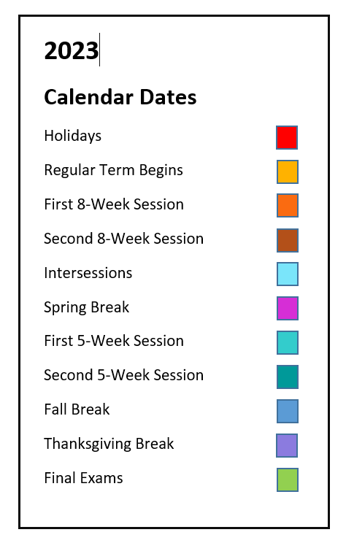
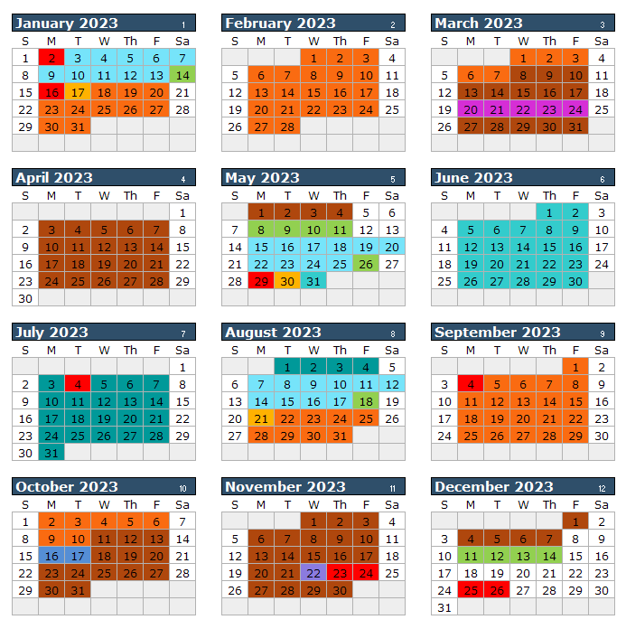
Spring (January) Intersession 2023
(10 class days; includes two Saturdays)
Jan 3 Classes Begin
Jan 13 Last Day of Classes
Jan 14 Final Exams

Spring 2023 73 class days (43 MWF, 30 TT)
Jan 16 Martin Luther King
Holiday
Jan 17 Classes Begin
(Regular Session & 8W1)
Mar 7 First 8-Week Session Ends
Mar 8 Second 8-Week Session
Begins
Mar 20-24 Spring Break
May 4 Last Day of Classes
(Regular Session & 8W2)
May 5 Dead Day
May 8-11 Final Exams
May 12-13 Commencement

Summer (May) Intersession 2023
(10 class days; includes Saturday)
May 15 Classes Begin
May 25 Last Day of Classes
May 26 Final Exams
Summer 2023 10-Week Session
(48 class days)
May 29 Memorial Day Holiday
May 30 Classes Begin
Jul 4 Independence Day Holiday
Aug 4 Last Day of Classes

Summer 2023 First 5-Week Session
(24 class days)
May 29 Memorial Day Holiday
May 30 Classes Begin
Jun 30 Last Day of Classes

Summer 2023 Second 5-Week Session
(24 class days)
July 3 Classes Begin
Jul 4 Independence Day Holiday
Aug 4 Last Day of Classes

Summer 2023 8-Week Session
(37 class days)
May 29 Memorial Day Holiday
May 30 Classes Begin
Jul 4 Independence Day Holiday
Jul 20 Last Day of Classes

Fall (August) Intersession 2023
(10 class days; includes Saturday)
Aug 7 Classes Begin
Aug 17 Last Day of Classes
Aug 18 Final Exams

Fall 2023 73 class days (43 MWF, 30TT)
Aug 21 Classes Begin
(Regular Session & 8W1)
Sept 4 Labor Day Holiday
Oct 10 First 8-Week Session Ends
Oct 11 Second 8-Week Session
Begins
Oct 16-17 Fall Break
Nov 22 Thanksgiving Break
Nov 23-24 Thanksgiving Holiday
Dec 7 Last Day of Classes
(Regular Session & 8W2)
Dec 8 Dead Day
Dec 11-14 Final Exams
Dec 16 Commencement

