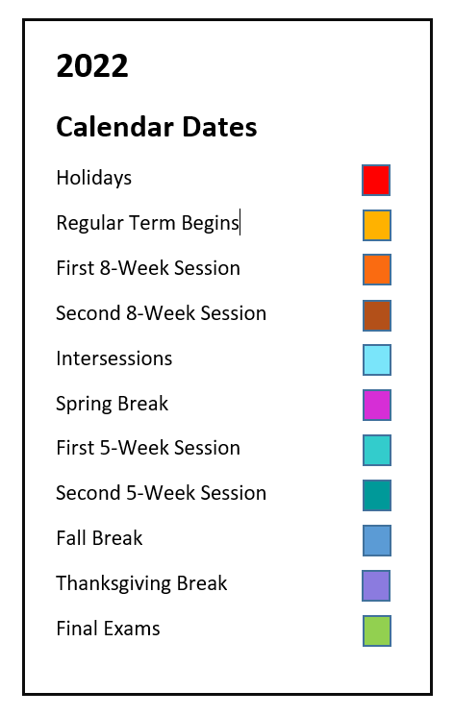
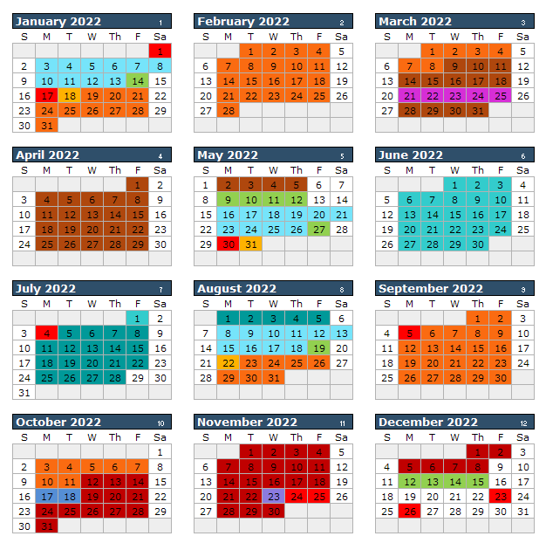

Spring (January) Intersession 2022
(10 class days; includes Saturday)
Jan 3 Classes Begin
Jan 13 Last Day of Classes
Jan 14 Final Exams

Spring 2022 73 class days (43 MWF, 30 TT)
Jan 17 Martin Luther King
Holiday
Jan 18 Classes Begin
(Regular Session & 8W1)
Mar 8 First 8-Week Session Ends
Mar 9 Second 8-Week Session
Begins
Mar 21-25 Spring Break
May 5 Last Day of Classes
(Regular Session & 8W2)
May 6 Dead Day
May 9-12 Final Exams
May 13-14 Commencement

Summer (May) Intersession 2022
(10 class days; includes Saturday)
May 16 Classes Begin
May 26 Last Day of Classes
May 27 Final Exams
Summer 2022 10-Week Session
(48 class days)
May 30 Memorial Day Holiday
May 31 Classes Begin

Jul 4 Independence Day Holiday
Aug 5 Last Day of Classes

Summer 2022 First 5-Week Session
(24 class days)
May 30 Memorial Day Holiday
May 31 Classes Begin

July 1 Last Day of Classes

Summer 2022 Second 5-Week Session
(24 class days)
Jul 4 Independence Day Holiday
Jul 5 Classes Begin

Aug 5 Last Day of Classes

Summer 2022 8-Week Session
(37 class days)
May 30 Memorial Day Holiday
May 31 Classes Begin

Jul 4 Independence Day Holiday
Jul 21 Last Day of Classes

Fall (August) Intersession 2022
(10 class days; includes Saturday)
Aug 8 Classes Begin
Aug 18 Last Day of Classes
Aug 19 Final Exams

Fall 2022 73 class days (43 MWF, 30TT)
Aug 22 Classes Begin
(Regular Session & 8W1)
Sept 5 Labor Day Holiday
Oct 11 First 8-Week Session Ends
Oct 12 Second 8-Week Session
Begins
Oct 17-18 Fall Break
Nov 23 Thanksgiving Break
Nov 24-25 Thanksgiving Holiday
Dec 8 Last Day of Classes
(Regular Session & 8W2)
Dec 9 Dead Day
Dec 12-15 Final Exams
Dec 17 Commencement

