**LETTER OF NOTIFICATION – 3**

NEW OPTION, EMPHASIS, CONCENTRATION or MINOR

(Maximum 21 semester credit hours of theory courses and 6 credit hours of practicum courses)

1. Institution submitting request: University of Arkansas Fayetteville

1. Contact person/title: Dr. Terry Martin, Vice Provost for Academic Affairs
2. Phone number/e-mail address: (479) 575-2151/tmartin@uark.edu
3. Proposed effective date: Fall 2018
4. Title of existing degree program:

(Indicate if the degree listed above is approved for distance delivery)

NA

1. CIP Code: 11.0401
2. Degree Code: DATA-M
3. Proposed name of new option/emphasis/concentration/minor (circle one):

Undergraduate Minor in Data Analytics

1. Reason for proposed action:

Data analytics, which encompasses data collection, analysis of data, and making decisions from data is a global megatrend that will offer staggering business opportunities in decades to come. Data analytics professionals have successfully shown significant impact on improving business across industries globally. Although there are a lot of professionals in the workforce in Northwest Arkansas, only a minor fraction is equipped with knowledge and skills in data analytics. There is an ever-increasing need of a larger and well-prepared workforce in data analytics professionals in almost all business sectors in Northwest Arkansas. There is an explosion of market demand among employers in Northwest Arkansas for qualified graduates in the NW Arkansas region with data analytics skills.

With full support from the College of Engineering, the Sam M. Walton College of Business, and the J. William Fulbright College of Arts and Sciences, the University has established a new industry research partnership called the Institute for Advanced Data Analytics (IADA). The Institute is coordinating this undergraduate minor in data analytics, which is a customized education and training program in analytics for undergraduate students, to create the supply bloodline to feed the growing demand in analytics professionals in the region. This minor has been fully endorsed by the Industrial Engineering (INEG) and Computer Science and Computer Engineering (CSCE) departments, of which the majority of students enrolled in the minor will be from. The INEG faculty discussed the minor proposal at a faculty meeting and the department fully endorsed this endeavor. The CSCE Undergraduate Studies Committee reviewed the proposed minor plan and unanimously voted to support the minor. The Information Systems (ISYS) Faculty Curriculum committee also reviewed the proposed minor and is supportive of the proposed minor with a Business Analytics option. The committee proposed a very compromise solution for non-business students to take business courses by having minimal prerequisites – an accounting course, an economics course, plus the computer competency. This solution will make it possible for the students under this analytics minor to have an undisrupted flow of classes if they choose to take courses from ISYS.

1. New option/emphasis/concentration/minor objective:

The primary objective of the Data Analytics minor is to prepare students for entry-level jobs in fields that apply Data Analytics and for graduate work in disciplines that utilize Data Analytics. The program will equip students with both hard and soft skills to analyze complex business problems using large datasets and turn all that raw information into actionable insight. The proposed minor will provide a means for our graduates to distinguish themselves by obtaining technical skills and knowledge in quantitative methodologies and technologies, and to demonstrate to potential employers that they are competent and ready for data analytics professionals.

1. Provide the following:
2. Curriculum Outline – List of courses in new option/emphasis/concentration/minor

–Underline required courses

With the consideration of what employers are looking for, both hard analytical skills (e.g., machine learning, statistics, big data technologies) and soft management/business skills (e.g., decision and business analysis, the ability to communicate and think critically) are equally important. To produce solid, well-rounded graduates with these foundational skills and technical talent, the undergraduate minor in Data Analytics is designed to provide students with 3 foundations: *Applied Statistics and Modeling*, *Computing and Informatics*, and *Analytics*. The curriculum designed to deliver the training requires 15-17 credit hours of study with a mixed of lower and upper division courses from the College of Engineering, the Fulbright College of Arts and Sciences, and the Sam M. Walton College of Business.

Specifically, the minor requires completion of 15-17 credits of coursework, including

* 1 Course (3 credits) of *Applied Statistics and Math Modeling* Foundation,
* 2 Courses (6-8 credits) of *Computing and Informatics* Foundation, and
* 2 Courses (6 credits) of *Analytics* Foundation.



|  |  |
| --- | --- |
| Foundation in ***Applied Statistics and Modeling***  *Select 1 course*  *(3 credits)* | * INEG 2333 Applied Probability and Statistics for Engineers II (Sp, Fa)   *[Prerequisite: INEG 2313]*   * ELEG 3143 Probability & Stochastic Processes (Sp)   *[Pre- or Corequisite: ELEG 3124]*   * STAT 2023 Biostatistics (Sp)   *[Pre- or Corequisite: MATH 2554]*   * STAT 3013 Introduction to Probability (Sp, Su, Fa)   *[Prerequisite: MATH 2564]* |
| Foundation in ***Computing and Informatics***  *Select 2 courses*  *(6-8 credits)* | * CSCE 2004 Programming Foundations I (Sp, Fa) [4 credits]   *[Prerequisite: MATH 2554 or MATH 2554C]*   * CSCE 2014 Programming Foundations II (Sp, Fa) [4 credits]   *[Prerequisite: CSCE 2004]*   * INEG 4683 Decision Support in Industrial Engineering (Sp)   *[Prerequisite: CSCE 2004 and INEG 2313]*   * INEG 4833 Introduction to Database Concepts for Industrial Engineer (Irregular) *[Prerequisite: CSCE 2004]* * ISYS 2263 Principles of Information Systems (Sp, Fa)   *[Prerequisite: ACCT 2013 or WCOB 1023, and MATH 2053]*   * STAT 4003/4001L Statistical Methods [with SAS laboratory] (Sp, Fa) [4 credits]   *[Prerequisite: MATH 2554 or MATH 2554C]* |
| Foundation in ***Analytics***  *Select 2 courses*  *(6 credits)* | * ECON 4743 Introduction to Econometrics (Sp)   *[Prerequisite: ((ECON 2013 and ECON 2023) or ECON 2143) and ((MATH 2043 or MATH 2554 or higher)) and (WCOB 1033 or STAT 2303)]*   * ECON 4753 Forecasting (Fa)   *[Prerequisite: (ECON 2013 and ECON 2023) or (ECON 2143) and (MATH 2043 or MATH 2554) and (WCOB 1033 or STAT 2303)]*   * ISYS 4193 Business Analytics and Visualization (Fa)   *[Prerequisite: WCOB 1033]*   * ISYS 4293 Business Intelligence (Sp)   *[Prerequisite: ISYS 4193]*   * STAT 4333 Analysis of Categorical Responses (Sp)   *[Prerequisite: STAT 4003 or departmental consent]* |

1. Provide degree plan that includes new option/emphasis/concentration/minor

(See Appendix A for 8-semester plans for INEG and CSCE students)

The new Data Analytics minor is intended to complement undergraduate degree programs in the College of Engineering, the Fulbright College of Arts and Sciences, and the Sam M. Walton College of Business, especially Industrial Engineering (INEG), Computer Science and Computer Engineering (CSCE), Mathematics with Statistics option (MATH), Economics (ECON) and Information Systems (ISYS). However, the minor will also be attractive to undergraduate degree programs that already equip students with basic calculus and computer programming.

There are no additional credits needed for INEG, CSCE, ISYS, and MATH students required for graduation, should they choose to complete the Data Analytics minor.

|  |  |  |  |  |
| --- | --- | --- | --- | --- |
| **Discipline** | **Free Elective Credits** | **Applied Statistics and Math Modeling** | **Computing and Informatics** | **Analytics** |
| INEG | 6 credits |  | (6 INEG elective credits) | 6 free or 3 free + 3 INEG elective credits |
| CSCE | 12 credits | (3 free elective credits) |  | 6 free or 6 CSCE elective credits |
| ISYS | 12 credits | 3 elective credits | (3 free elective credits) |  |
| MATH | 34 credits |  | 3 elective credits | 6 elective credits |

INEG Students: 6 free technical elective credits

* *Applied Statistics and Math Modeling*: Already satisfy therequirements in the regular curriculum
* *Computing and Informatics*: Need all 6 credits but they may be INEG elective credits
* *Analytics:* Need all 6 credits but they may be INEG elective credits

CSCE Students with Computer Engineering option: 12 free technical elective credits

* *Applied Statistics and Math Modeling*: Need 3 elective credits, which may be chosen as 3 free elective credits
* *Computing and Informatics*: Already satisfy therequirements in the regular curriculum
* *Analytics:* Need all 6 credits but they may be CSCE or free elective credits

ISYS Students with concentration on Business Analytics: 12 General education elective credits

* *Applied Statistics and Math Modeling:* Need 3 elective credits to satisfy the requirements
* *Computing and Informatics*: Already satisfy 3 required credits but need additional 3 elective credits
* *Analytics:* Already satisfy therequirements in the regular curriculum

MATH Students with concentration on Statistics: 34 General education elective credits

* *Applied Statistics and Math Modeling:* Already satisfy therequirements in the regular curriculum
* *Computing and Informatics*: Need additional 6-8 elective credits
* *Analytics:* Need all 6 credits to satisfy therequirements but 3 of which may be STAT elective credits

1. Total semester credit hours required for option/emphasis/concentration/minor:

A total of 15-17 semester credit hours: 3 credits of *Applied Statistics and Math Modeling* Foundation, 6-8 credits of *Computing and Informatics* Foundation, and 6 credits of *Analytics* Foundation

1. New courses and new course descriptions

N/A

1. Goals and objectives of program option/emphasis/concentration/minor

The overarching goal of the new undergraduate minor in Data Analytics is to address the need for a high-quality workforce in analytics and related disciplines supported by the program and for the increased success of academically talented students in the local region who are pursuing baccalaureate, or graduate degrees in disciplines that require knowledge and skills in data analytics (e.g., engineering, business, mathematics, science, etc.). The specific objectives of the new minor are to (1) increase enrollment, student success, and graduation of students who pursue a degree in the Engineering, Science and Business disciplines with the needed knowledge and skills in Data Analytics, which are essential to promote the environment-shift in the Northwest Arkansas to be a new technology hub, (2) implement a model of student engagement that affects the enrollment, student success, academic and career pathways, and degree attainment of students pursing a degree in these disciplines; internship and co-ops program as a pipeline for student cohorts, and (3) contribute to the implementation and sustainability of effective evidence-based curricular/co-curricular activities for its students – with feedback from local industry to drive the needed skills for new graduates to fill their needs in their workforce in analytics.

1. Expected student learning outcomes

The Analytics program will equip students with a solid amalgamation of give capabilities:

* 1. Ability to use informatics knowledge to design and deploy an infrastructure to collect, organize, and retrieve business data,
  2. Ability to apply data management and computation to effectively manipulate, store, and analyze very large amounts of data using state-of-the-art technologies,
  3. Ability to develop and implement mathematical/statistical models to provide abstractions of business problems,
  4. Ability to adapt the business analytics concept to interpret and communicate meaningful pattern of business data leading to industry insights and/or business decisions, and
  5. Ability to harness business insights from the data and use and translate it into actions, decisions and business practice.

1. Documentation that program option/emphasis/concentration/minor meets

employer needs (if applicable)

(See attached support letters from JB Hunt and Acxiom)

As the labor market in NW Arkansas has been thriving in the past few years and what will continue to gain momentum in the next decade, the demand for workforce with data analytics skills has been ever increasing. According to the Robert Half study, Technology, Healthcare, and Manufacturing are the top 3 fastest growing industries in the West South Central region (including AR, OK, TX, LA). Companies looking to hire graduates with data analytics skills often focus on majors such as economics, mathematics, statistics, computer science, operations research, and industrial engineering. In 2015 there were 164,000 graduates across these majors nationwide; however, the growth in jobs seems to be outpacing the growth in graduates. During the same time-period, job growth for these data analytics professionals grew at a much faster pace: 325,000 new jobs, or 24%. And much of that growth (241,000 jobs) occurred just between 2010 and 2015.

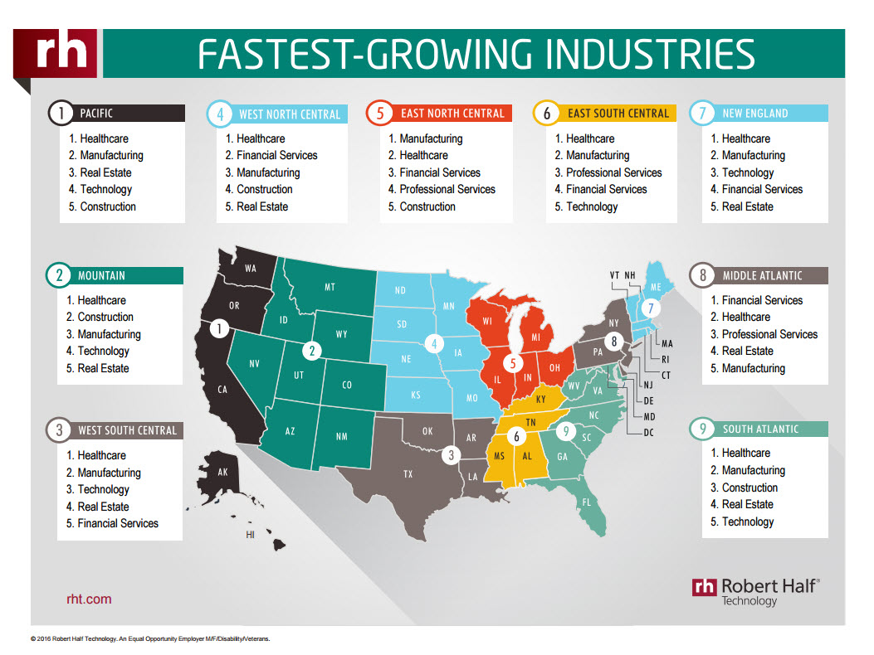

1. Student demand (projected enrollment) for program option/emphasis/ concentration/minor

Increases in enrollment in analytics-related majors (including INEG, CSCE, ISYS, MATH/STAT) is expected to be around 20%, and participation of existing students in those majors is expected to be around 25% of current enrollment.

We project that there will be at least 40 students per year enrolled in this minor with the majority from INEG (~20 students) and CSCE (~20 students). We also anticipate about 10 students from other colleges (e.g., WCOB, Fulbright, Bumper).

1. Name of institutions offering similar program option/emphasis/concentration/ minor and the institution(s) used as a model to develop the proposed program option/emphasis/concentration/ minor (if applicable)

* Minor in Statistics and Data Science, MIT

<https://stat.mit.edu/academics/minor-in-statistics/>

* Data Analytics Minor, Baruch College, CUNY

http://zicklin.baruch.cuny.edu/programs/undergrad/minors/business-minors-for-business-majors-1/data-analytics

* Data Analysis Minor, George Washington University

<http://statistics.gmu.edu/pages/data_analysis_minor.html>

* Data Analytics Minor, Kent State University

<https://www2.kent.edu/catalog/2016/bu/minors/daan>

* Data Analysis Minor, Wesleyan University

<http://www.wesleyan.edu/qac/minor/index.html>

* Computational Data Analytics Minor, Northeastern University

<http://www.coe.neu.edu/degrees/computational-data-analytics-minor>

* Data Analytics Major and Minor, Drake University

<http://www.drake.edu/analytics/majorandminor/>

* Data Analytics Minor, Webster University

http://www.webster.edu/catalog/current/undergraduate-catalog/minors/data-analytics.html

* Data Analytics Minor, Stetson University

http://catalog.stetson.edu/undergraduate/arts-sciences/interdisciplinary-minors/dataanalytics/

* Data Analytics Minor, Champlain College

http://www.champlain.edu/academics/undergraduate-academics/minors/data-analytics-minor

* Data Analysis and Data Mining Minor, DePaul University

https://www.depaul.edu/university-catalog/degree-requirements/undergraduate/cdm/data-analysis-and-data-mining-minor/Pages/default.aspx

* Data Analytics Minor, Eastern Washington University

https://www.ewu.edu/cbpa/programs/business-analytics-minors/business-analytics-degrees/data-analytics-minor

1. Institutional curriculum committee review/approval date: January 17, 2018
2. Will the new option/emphasis/concentration/minor be offered via distance delivery? If yes, indicate mode of distance delivery:

No. On campus delivery only.

1. Explain in detail the distance delivery methods/procedures to be used: N/A
2. Specify the amount of additional costs required for program implementation, the source of funds, and how funds will be used.

The new minor will exploit existing resources and expertise in Data Analytics on campus. Thus, there are no additional costs required for program implementation. However, in parallel, the Institute for Advanced Data Analytics is planning to submit a proposal to the National Science Foundation (NSF) Scholarships in Science, Technology, Engineering and Mathematics (S-STEM) program to obtain financial resources to recruit, retain, and promote undergraduate students who are interested in this minor program, especially those with low-income and academically talent.

1. Provide additional program information if requested by ADHE staff.

President/Chancellor Approval Date: January 22, 2018

Board of Trustees Notification Date: March 29, 2018

Chief Academic Officer: James S. Coleman Date: January 18, 2018

Appendix A: 8-Semester Plan

A.1 INEG Students: Typical INEG students have 6 free elective courses (18 technical elective credits, 12 of which from INEG). Based on their graduation requirements, they already satisfy 3 credits of Applied Statistics and Modeling. They need 6 credits of technical electives for Computing and Informatics (all of which may be INEG elective credits) and 6 credits for Analytics (3 of which may be INEG elective credits).

|  |  |
| --- | --- |
| **Fall Semester Year 1**  4 MATH 2554 Calculus I  3 CHEM 1103 University Chemistry I  4 PHYS 2054 University Physics I  1 GNEG 1111 Introduction to Engineering I  3 ENGL 1013 Composition I  **15 Semester hours** | **Spring Semester Year 1**  4 MATH 2564 Calculus II  4 Freshman Science Elective  3 Select one of the following:   * HIST 2003 History of the American People to 1877 * HIST 2013 History of the American People, 1877 to Present * PLSC 2003 American National Government   1 GNEG 1121 Introduction to Engineering II  3 ENGL 1023 Composition II  **15 Semester hours** |
| **Fall Semester Year 2**  1 INEG 2001 Industrial Engineering Seminar  3 INEG 2103 Introduction to Industrial Engineering  3 INEG 2313 Applied Probability and Statistics for Engineers I  3 INEG 2413 Engineering Economic Analysis  4 MATH 2574 Calculus III  3 Science Requirement    **17 Semester hours** | **Spring Semester Year 2**  3 INEG 2403 Industrial Cost Analysis  **3 INEG 2333 Applied Probability and Statistics for Engineers II**  4 MATH 2584 Elementary Differential Equations  3 MEEG 2303 Introduction to Materials  **4 CSCE 2004 Programming Foundations I**  **17 Semester hours** |
| **Fall Semester Year 3**  3 INEG 3623 Simulation  3 INEG 3713 Methods and Standards  3 MEEG 2003 Statics  3 ELEG 3903 Electric Circuits and Machines  3 Fine Arts (from University/State Core List)  3 Technical Elective  **18 Semester hours** | **Spring Semester Year 3**  3 INEG 3613 Introduction to Operations Research  3 INEG 3723 Ergonomics  3 INEG 3513 Manufacturing Processes  3 Selection one option from the following:   * ECON 2143 Basic Economics: Theory and Practice * ECON 2013 Principles of Macroeconomics * ECON 2023 Principles of Microeconomics   **3 Technical Elective (INEG 4683 Decision Support in Industrial Engineering)**  **15 Semester hours** |
| **Fall Semester Year 4**  3 INEG 4433 Systems Engineering and Management  3 INEG 4553 Production Planning and Control  3 Technical Elective  **3 Technical Elective (ISYS 4193 Business Analytics and Visualization)**  3 Social Science (from University/State Core List)  1 INEG 4911 Industrial Engineering Capstone Experience I  **16 Semester hours** | **Spring Semester Year 4**  3 INEG 4923 Industrial Engineering Capstone Experience II  3 Technical Electives  **3 Technical Elective (ISYS 4293 Business Intelligence)**  3 Humanities (from University/State Core List)  3 Social Science (from University/State Core List)    **15 Semester hours** |

A.2 CSCE Students with Computer Science option: Typical CSCE students with Computer Science option have 12 free elective credits and 12 CSCE technical elective credits. Based on their graduation requirements, they already satisfy 8 credits of Computing and Informatics Foundation. They need 3 credits of technical electives for Applied Statistics and Modeling and 6 credits for Analytics (3 of which may be CSCE elective credits).

|  |  |
| --- | --- |
| **Fall Semester Year 1**  4 MATH 2554 Calculus I 3 CHEM 1103 University Chemistry I 4 PHYS 2054 University Physics I 1 GNEG 1111 Introduction to Engineering I  3 ENGL 1013 English Composition  **15 Semester hours** | **Spring Semester Year 1**  4 MATH 2564 Calculus II 4 Freshman Science elective* 1 GNEG 1121 Intro to Engineering II  3 ENGL 1023 Composition II 3 History/Government elective  **15 Semester hours** |
| **Fall Semester Year 2**  3 MATH 2603 Discrete Math 4 Basic Science elective with lab ***4 CSCE 2004 Programming Foundations I***  4 CSCE 2114 Digital Design 3 Social Science elective    **18 Semester hours** | **Spring Semester Year 2**  3 MATH 3103 Combinatorics ***4 CSCE 2014 Programming Foundations II***  4 CSCE 2214 Computer Organization 3 Fine Arts elective 3 Social science elective  **17 Semester hours** |
| **Fall Semester Year 3**  3 CSCE 3193 Programming Paradigms  3 CSCE 3613 Operating Systems 3 COMM 1313 Public Speaking 3 MATH 3083 Linear Algebra  3 PHIL 3103 Ethics & the Professions  **15 Semester hours** | **Spring Semester Year 3**  3 CSCE 4523 Database Management  3 CSCE 3513 Software Engineering  3 CSCE elective *3 Free elective (an economics or accounting class as prerequisite for ISYS class)*  *3 INEG 2313 Applied Probability and Statistics for Engineers I*  **15 Semester hours** |
| **Fall Semester Year 4**  1 CSCE 4561 Capstone I  3 CSCE 4133 Algorithms  3 CSCE elective 3 CSCE elective  **3 Free elective (INEG 2333 Applied Probability and Statistics for Engineers II)**  **3 Free elective (ISYS 4193 Business Analytics and Visualization)**  **16 Semester hours** | **Spring Semester Year 4**  3 CSCE 4963 Capstone II **3 Free Elective (ISYS 4293 Business Intelligence)** 3 CSCE 4323 Formal Languages  3 Free elective 3 Social Science elective  **15 Semester hours** |