Establishment of an Administrative Unit
Organizational Chart

Current Organizational Chart for Sam M. Walton College:

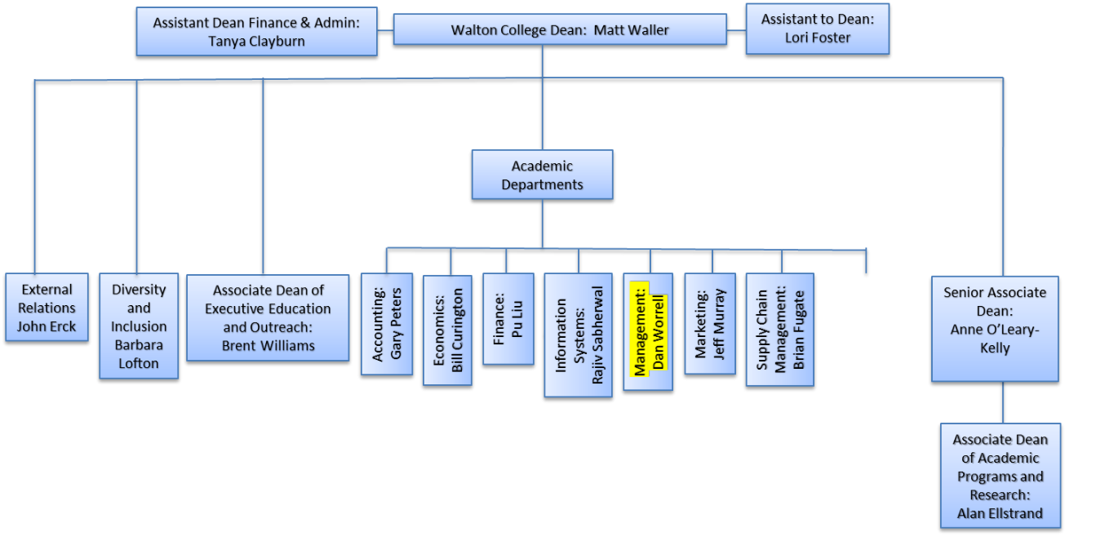

Revised Organizational Chart for Sam M. Walton College:

