LETTER OF NOTIFICATION – 11

RECONFIGURATION OF EXISTING DEGREE PROGRAMS
(Consolidation or Separation of Degrees to Create New Degree)

- Institution submitting request: University of Arkansas Fayetteville

- Contact person/title: Dr. Terry Martin, Vice Provost for Academic Affairs
(479) 575-2151/tmartin@uark.edu

- Title(s) of degree programs to be consolidated/reconfigured:

Doctor of Nursing Practice with concentrations in Adult-Geriatric Acute Care Nurse Practitioner, Adult-Geriatric Clinical Nurse Specialist, and Family Nurse Practitioner

- Current CIP Code(s)/Current Degree Code(s): 51.3818/7393

- Proposed title of consolidated/reconfigured program:

Doctor of Nursing Practice with concentrations in Adult-Gerontology Acute Care Nurse Practitioner and Family Nurse Practitioner

- Proposed CIP Code for new program: 51.3818 (no change)
- Proposed Effective Date: Fall, 2019

- Reason for proposed program consolidation/reconfiguration:
[Indicate student demand, (projected enrollment) for the proposed program and document that the program meets employer needs]

  - Changing name of concentration from Adult-Geriatric Acute Care Nurse Practitioner to Adult-Gerontology Acute Care Nurse Practitioner. Program concentration title should be updated to reflect current professional standards as well as the title of the certification examination.
  - Curriculum will be updated to meet current demands of the profession and of employers, and to ensure graduates are prepared for national certification examinations.
  - There has been no enrollment in the Adult Geriatric Clinical Nurse Specialist concentration since 2015, nor have there been applications to this concentration. Thus, we will be deleting this concentration.
  - The Adult Geriatric Acute Care and Family Nurse Practitioner concentrations of the program have grown from an enrollment of 27 students in 2013 to a current enrollment of 81 students. To date, 100% of graduates for whom employment data are known are employed in advanced-practice roles.

- Provide current and proposed curriculum outline by semester. Indicate total semester credit hours required for the proposed program. Underline new courses and provide new course descriptions. (If existing courses have been modified to create new courses, provide the course name/description for the current/existing courses and indicate the related new/modified courses.) Identify required general education core courses with an asterisk.
Current Curriculum for the Doctor of Nursing Practice
ESRM 6403 Educational Statistics and Data Processing
NURS 6123 Evaluation Methods and Translational Research for Evidence-based
Practice
NURS 5523 Healthcare Informatics
NURS 6263 Organization Management and Systems Leadership
NURS 6233 Healthcare Economics and Finance
PBHL 6833 Principles of Epidemiology II
NURS 6224 Specialty Practice Clinical III
NURS 6244 Specialty Practice Clinical IV
NURS 628V Specialty Practice Clinical V
NURS 7113 Capstone Seminar I
NURS 7122 Capstone Implementation in Practice Setting I
NURS 7132 Capstone Seminar II
NURS 7142 Capstone Implementation in Practice Setting II

Current Requirements for the Adult-Geriatric Acute Care Nurse Practitioner Concentration
NURS 5003 Theoretical and Scientific Foundations for Nursing Practice
NURS 5033 Role Development
NURS 5043 Concepts of Health Promotion Within Diverse Populations
NURS 5053 Evidence-Based Practice and Innovation in Nursing
NURS 5063 Health Care Policy
NURS 5143 Advanced Pathophysiology
NURS 5102 Advanced Health Assessment, Physical Examination and Diagnostic
Reasoning
NURS 5111 Clinical Practicum: Advanced Health Assessment, Physical Examination,
and Diagnostic Reasoning
NURS 5123 Pharmacotherapeutics
NURS 5272 Clinical Practicum: Interpretive Diagnostic Reasoning
NURS 5443 Chronic Health Problems in Adult and Geriatric Populations
NURS 5454 Adult-Geriatric (Chronic) Clinical I
NURS 5463 Acute and Critical Illness in Adult and Geriatric Populations
NURS 5475 Adult-Geriatric (Acute/Critical) Clinical II
NURS 6224 Specialty Practice Clinical III
NURS 6244 Specialty Practice Clinical IV
NURS 628V Specialty Practice Clinical V 1-4
NURS 5523 Healthcare Informatics
NURS 6123 Evaluation Methods and Translational Research for Evidence-based
Practice
ESRM 6403 Educational Statistics and Data Processing
NURS 6233 Healthcare Economics and Finance
NURS 6263 Organization Management and Systems Leadership
PBHL 6833 Principles of Epidemiology II
NURS 7113 Capstone Seminar I
NURS 7122 Capstone Implementation in Practice Setting I
NURS 7132 Capstone Seminar II
NURS 7142 Capstone Implementation in Practice Setting II
Current Requirements for the Family Nurse Practitioner Concentration
ESRM 6403 Educational Statistics and Data Processing
NURS 5003 Theoretical and Scientific Foundations for Nursing Practice
NURS 5033 Role Development
NURS 5043 Concepts of Health Promotion Within Diverse Populations
NURS 5053 Evidence-Based Practice and Innovation in Nursing
NURS 5063 Health Care Policy
NURS 5102 Advanced Health Assessment, Physical Examination and Diagnostic
Reasoning
NURS 5111 Clinical Practicum: Advanced Health Assessment, Physical Examination,
and Diagnostic Reasoning
NURS 5123 Pharmacotherapeutics
NURS 5143 Advanced Pathophysiology
NURS 5523 Healthcare Informatics
NURS 6123 Evaluation Methods and Translational Research for Evidence-based Practice
NURS 6233 Healthcare Economics and Finance
NURS 6263 Organization Management and Systems Leadership
PBHL 6833 Principles of Epidemiology II
NURS 5272 Clinical Practicum: Interpretive Diagnostic Reasoning
NURS 5483 Primary Care of Emerging Issues
NURS 5454 Adult-Geriatric (Chronic) Clinical I
NURS 5543 Primary Care of Women and Children
NURS 5495 Primary Care of Emerging Issues
NURS 6224 Specialty Practice Clinical III
NURS 6244 Specialty Practice Clinical IV
NURS 628V Specialty Practice Clinical V 1-4
NURS 7113 Capstone Seminar I
NURS 7122 Capstone Implementation in Practice Setting I
NURS 7132 Capstone Seminar II
NURS 7142 Capstone Implementation in Practice Setting II

Proposed Curriculum for the Doctor of Nursing Practice
In addition to the general requirements of the Graduate School, students who have earned a Bachelor of Science in Nursing must complete a minimum of 78 hours with the following general requirements for the Doctor of Nursing Practice, while completing additional coursework in one of two advanced-practice nursing concentrations: Family Nurse Practitioner or Adult-Gerontology Acute Care Nurse Practitioner. At least three campus visits are required for program orientation, skills acquisition, and dissemination of scholarly work.

ESRM 5393 Statistics in Education and Health Professions
NURS 5403 Scholarly Writing
NURS 5523 Healthcare Informatics
NURS 6123 Evaluation Methods and Translational Research for Evidence-based Practice
NURS 6343 Analytic Methods and Epidemiology for Health Care
This course guides students to critically appraise and interpret scientific evidence
from multiple disciplines as a foundation for translation to improve outcomes in clinical practice. Students apply quantitative and qualitative methodologies to determinants across community and global populations with a focus on epidemiology. Concepts surrounding data management and analysis to measure risk and prevalence of disease are emphasized in the advanced practice role. This course assists students in understanding foundational knowledge in preparation for the DNP project.
NURS 6233 Healthcare Economics and Finance
NURS 6224 DNP Clinical Practicum I (Course title change only)
NURS 6263 Organization Management and Systems Leadership
NURS 5063 Healthcare Policy
NURS 6244 DNP Clinical Practicum II (Course title change only)
NURS 7122 DNP Project Implementation I (Course title change only)
NURS 628V DNP Clinical Practicum III (Course title change only)
NURS 7142 DNP Project Implementation II (Course title change only)
NURS 5033 Scientific Foundations and Role Development in Advanced Practice
Nursing (Course title change and minor course description revision)
Examines the role development of advanced practices in nursing and the evolution of the Doctor of Nursing Practice (DNP). Concepts include scientific foundations of practice, role development, interdisciplinary collaborative strategies, advanced scope of practice, and legal/ethical practice in the advanced practice role.
NURS 5043 Concepts of Health Promotion within Diverse Populations
NURS 5053 Evidence-Based Practice and Innovation in Nursing
NURS 5123 Pharmacotherapeutics
NURS 5143 Advanced Pathophysiology
NURS 5101 Advanced Health Assessment and Diagnostic Reasoning
NURS 5112 Advanced Health Assessment and Diagnostic Reasoning Clinical Practicum

Additional requirements for the Adult-Gerontology Acute Care Nurse Practitioner
Concentration
NURS 5463 Acute and Critical Illness in Adult and Gerontology Populations
NURS 5475 Adult-Geriatric (Acute/Critical) Clinical II
NURS 5434 Common Problems in Acute Care in Adult and Gerontology Populations
Examine principles of pathologic mechanisms of disease, refine skills for history
taking, physical examination, and clinical decision making for adult and geriatric individuals with common acute illnesses.
NURS 5332 Common Problems in Acute Care in Adult and Gerontology Populations
Clinical Practicum
Focuses on the management of adult-gerontology patients with common
acute illnesses. Emphasizes the application of principles of pathologic mechanisms of disease, history taking, physical examination, and clinical decision making.
NURS 5443 Chronic Health Problems in Adult and Gerontology Populations
NURS 5454 Chronic Health Problems in Adult and Gerontology Populations Clinical
Practicum

Additional requirements for the Family Nurse Practitioner Concentration
NURS 5483 Common Problems in Primary Care
NURS 5495 Common Problems in Primary Care Clinical Practicum
NURS 5543 Primary Care of Children
NURS 5683 Primary Care of Children Clinical Practicum
NURS 5873 Complex Problems in Primary Care
Focuses on application of health promotion and chronic disease management in
complex adult patients. Students will utilize evidence-based approaches to health promotion, assessment, differential diagnosis and disease management. Emphasizes clinical decision making, chronic care models, coordination of care, poly-drug therapy and information systems

NURS 5884 Complex Problems in Primary Care Clinical Practicum
Clinical component to NURS 5873 Complex Problems in Primary Care. Offers
the student an opportunity to exercise critical judgment and implement theoretical knowledge in the management of care of adults experiencing complex health problems

See appendices for curriculum outline by semester.

- Provide program budget. Indicate amount of funds available for reallocation. Courses continuing to be taught.

Program budget for 2017-2018 is $234,211.56. No additional funds will be available for reallocating as a result of the discontinuation of the Clinical Nurse Specialist concentration because courses in this concentration have not been taught for several years. Those funds have been applied to the Adult Geriatric Acute Care Nurse Practitioner and Family Nurse Practitioner concentrations.
- Provide current and proposed organizational chart.

Current Organizational Chart

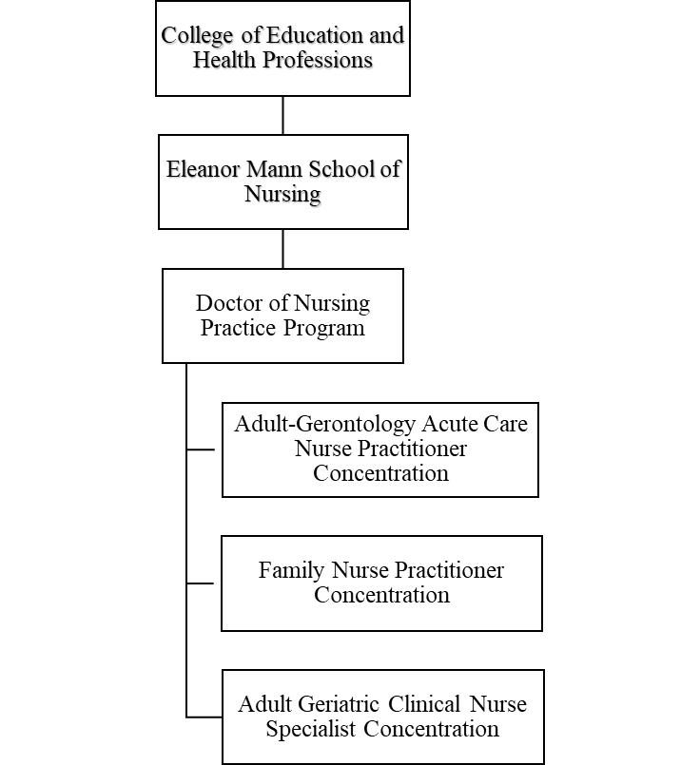

Proposed Organizational Chart

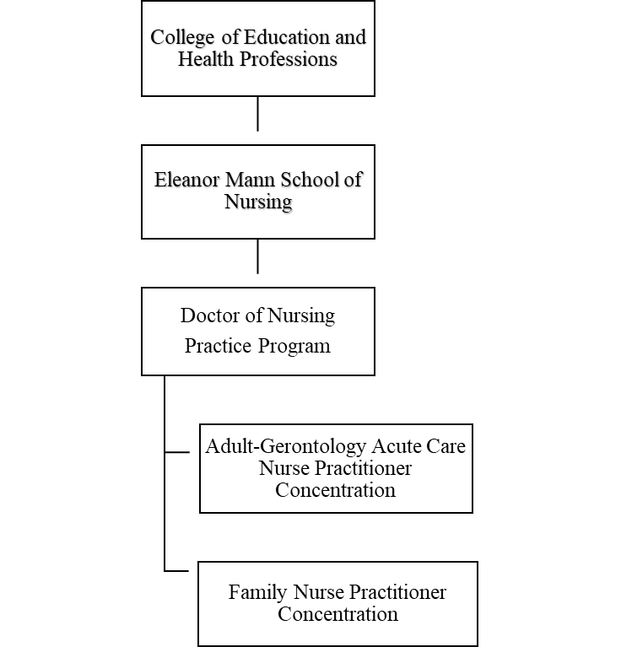
- Institutional curriculum committee review/approval date: UCPC approval September 28, 2018; Faculty Senate approval December 5, 2018

- Are the existing degrees offered off-campus or via distance delivery? Yes

- Will the proposed degree be offered on-campus, off-campus, or via distance delivery? If yes, indicate mode of distance delivery.

The program will be offered via distance delivery. Blackboard Learning Management System with email, videoconferencing, discussion board, and other online tools. Students meet on campus for orientation, advanced skills labs, and project presentation. Clinical hours are arranged in approved sites with qualified preceptors.

- Provide documentation that proposed program has received full approval by licensure/certification entity, if required. (A program offered for teacher/education administrator licensure must be reviewed/approved by the Arkansas Department of Education prior to consideration by the Coordinating Board; therefore, the Education Protocol Form also must be submitted to ADHE along with the Letter of Notification).

- Provide copy of e-mail notification to other institutions in the area of the proposed program.

- List institutions offering similar program and identify the institution(s) used as a model to develop the proposed program.

UAMS, University of Tennessee, UMKC

Model programs: Duke, Johns Hopkins, University of Washington, Rush University, Columbia University

- Provide scheduled program review date (within 10 years of program implementation).
Spring 2020
- Provide additional program information if requested by ADHE staff.

President/Chancellor Approval Date: January 21, 2019

Board of Trustees Notification Date: March 28, 2019

Chief Academic Officer: James S. Coleman Date: January 10, 2019

Appendix A
Sample Curriculum Outline by Semester
University of Arkansas
Eleanor Mann School of Nursing (EMSON)
Adult-Gerontology Acute Care Nurse Practitioner (AGACNP)
Proposed Program of Study (78 Credit Hours)

SUMMER I | FALL I | SPRING I
ESRM 5393: Statistics in Education and Health Professions | NURS 5043: Concepts of Health Promotion within Diverse Populations | NURS 5123: Pharmacotherapeutics
NURS 5403: Scholarly Writing | NURS 5033 Role Development | NURS 5143: Advanced Pathophysiology
 | NURS 5XX3 Analytic Methods and Epidemiology for Health Care Practice | NURS 5053: Evidence-based Practice and Innovation in Nursing
Total: 6 credits | Total: 9 credits | Total: 9 credits
SUMMER II | FALL II | SPRING II
NURS 5523: Health Informatics | NURS 5101: Advanced Health Assessment and Diagnostic Reasoning | NURS 5424: Common Problems in Acute Care in Adult and Gerontology Populations
NURS 5063: Health Policy | NURS 5112: Advanced Health Assessment Clinical Practicum (90 contact hours) | NURS 5442: Common Problems in Acute Care in Adult and Gerontology Populations Clinical Practicum (90 contact hours)
 | NURS 6123: Evaluation Methods and Translational Research for Evidence-based Practice | NURS 6233: Healthcare Economics and Finance
Total: 6 credits | Total: 6 credits | Total: 9 credits
SUMMER III | FALL III | SPRING III
NURS 6263: Organizational Management and Systems Leadership | NURS: 5443: Chronic Health Problems in Adult and Gerontology Populations | NURS 5463: Acute and Critical Illness in Adult and Gerontology Populations
 | NURS 5454: : Chronic Health Problems in Adult and Gerontology Populations Clinical Practicum (180 contact hours) | NURS 5475: Adult-Geriatric (Acute/Critical) Clinical II (225 contact hours)
Total: 3 credits | Total: 7 credits | Total: 8 credits
SUMMER IV | FALL IV | SPRING IV
NURS 6224: DNP Practicum I (180 contact hours) | NURS 6244: DNP Practicum II (180 contact hours) | NURS 628V: DNP Practicum III (135 contact hours)
 | NURS 7122: DNP Project Implementation I | NURS 7142: DNP Project Implementation II
Total: 4 credits | Total: 6 credits | Total: 5 credits

Appendix B
Sample Curriculum Outline by Semester

University of Arkansas
Eleanor Mann School of Nursing (EMSON)
Family Nurse Practitioner (FNP)
Proposed Program of Study (78 Credit Hours)

SUMMER I | FALL I | SPRING I
ESRM 5393: Statistics in Education and Health Professions | NURS 5043: Concepts of Health Promotion within Diverse Populations | NURS 5123: Pharmacotherapeutics
NURS 5403: Scholarly Writing | NURS 5003 Role Development | NURS 5143: Advanced Pathophysiology
 | NURS 5XX3 Analytic Methods and Epidemiology for Health Care Practice | NURS 5053: Evidence-based Practice and Innovation in Nursing
Total: 6 credits | Total: 9 credits | Total: 9 credits
SUMMER II | FALL II | SPRING II
NURS 5523: Health Informatics | NURS 5101: Advanced Health Assessment and Diagnostic Reasoning | NURS 5483: Common Problems in Primary Care
NURS 5063: Health Policy | NURS 5112: Advanced Health Assessment Clinical Practicum (90 contact hours) | NURS 5495: Common Problems in Primary Care Clinical Practicum (225 contact hours)
 | NURS 6123: Evaluation Methods and Translational Research for Evidence-based Practice | NURS 6233: Healthcare Economics and Finance
Total: 6 credits | Total: 6 credits | Total: 9 credits
SUMMER III | FALL III | SPRING III
NURS 6263: Organizational Management and Systems Leadership | NURS 5543: Primary Care of Children | NURS: 5873: Complex Problems in Adult and Gerontology Populations
 | NURS 5683: Primary Care of Children Clinical Practicum (135 contact hours) | NURS 5884: Complex Problems in Adult and Gerontology Populations Practicum (180 contact hours)
Total: 3 credits | Total: 7 credits | Total: 8 credits
SUMMER IV | FALL IV | SPRING IV
NURS 6224: DNP Clinical Practicum I (180 contact hours) | NURS 6244: DNP Clinical Practicum II (180 contact hours) | NURS 628V: DNP Clinical Practicum III (135 contact hours)
 | NURS 7122: DNP Project Implementation I | NURS 7142: DNP Project Implementation II
Total: 4 credits | Total: 6 credits | Total: 5 credits

