University of Arkansas Center and Institute Proposal

Center for Advanced Surface Engineering (CASE)

Proposed by Min Zou
Professor, Department of Mechanical Engineering

CENTER MISSION AND VISION

CASE was established through a statewide planning process that involves researchers from over 10 Arkansas universities. This one year-long planning process resulted in a highly competitive proposal to the National Science Foundation (NSF) that was selected for a $20M NSF EPSCoR Research Infrastructure Improvement (RII) Track-1 award. The State of Arkansas provided an additional $4M Match for the center. The mission of the CASE is to accelerate the discovery, design, development, and technology transfer of the next generation of material surfaces, enabling new applications and innovative products to address national research priorities and industry needs. The vision of the CASE is to become a leading research and education center for engineering durable, nanostructured multifunctional, tunable, and bioactive surfaces. These surfaces have the potential to impact a broad range of industries, ranging from manufacturing, aerospace and defense, agriculture, oil and gas, to healthcare. CASE is the first interdisciplinary research center in Arkansas that focuses on Advanced Surface Engineering Research and Education. CASE brings together a multi-disciplinary team of about 40 researchers with expertise in physics, chemistry, biology, engineering, and computational science from 10 Arkansas universities to conduct the interdisciplinary research. The center functions under the assumption that a single discipline could not achieve the goals set by this team and must integrate multiple disciplines and domains to achieve such success.

Name of the College, School, Department, or Unit in which the Center will be housed.

CASE will be housed in the College of Engineering within the Department of Mechanical Engineering, University of Arkansas - Fayetteville.

Name and title of the person(s) proposing creation of the Center.

Min Zou, Professor of Mechanical Engineering.

The Center type (research, service, or instructional) that is requested.

CASE is the first interdisciplinary research center in Arkansas that focuses on Advanced Surface Engineering Research and Education. Besides basic research, CASE also has a mission of preparing the next generation of scientists and engineers with surface engineering skills; and as such, CASE seeks to involve and train as many graduate and undergraduate students as possible through surface science and engineering related curriculum and various interdisciplinary surface engineering research projects. The center also seeks to strengthen Arkansas industry through innovative materials and surface research.

The unique value of the program to the University, and the distinction to any similar programs in Arkansas.

CASE is the first interdisciplinary research center in Arkansas that focuses on Advanced Surface Engineering Research and Education. It brings together a multi-disciplinary team of researchers with expertise in physics, chemistry, biology, engineering, and computational science. Through interdisciplinary collaborations and industry engagement, CASE will cultivate innovation among faculty, students and industry partners to create strong relationship between industry and academia and generate significant economic impact in Arkansas. CASE distinguishes itself from other existing centers on surface science and engineering which mostly focus on surfaces with fixed properties and single functionality for specific narrow applications. There are no other similar programs in Arkansas.

Information on the Director position and the organizational structure.

Min Zou is a Professor in the Mechanical Engineering Department and currently holds a 21st Century Professorship in Mechanical Engineering. She is the Scientific Director of CASE and proposes the center designation. Min Zou received her Ph.D. in Mechanical Engineering from the Georgia Institute of Technology in 1999 with prior work experience at the Shanghai Aircraft Research Institute (1991-1994). Before joining the University of Arkansas in August 2003, she was a Senior Advisory Development Engineer and then a Staff Engineer at Seagate Technology (1999-2003), where she contributed to the new technology development of the computer hard drive head-disk interface. Her current research focuses on nanoscale surface engineering, nanomechanics and tribology for a wide range of applications. Her research has led to 92 peer-reviewed publications, 100 conference presentations, 3 book chapters, and 3 patents with 4 additional pending. Her research contributions have been recognized by several honors and awards given by various professional societies and her peers in the fields of tribology and surface engineering. She is a Fellow of the American Society of Mechanical Engineers (ASME), a Fellow of the Society of Tribologists and Lubrication Engineers (STLE), and a Fellow of the Arkansas Research Alliance (ARA). Her awards include the Al Sonntag Award (2013), the Walter D. Hodson Award (2001), and the best poster awards (two each in 2016 and 2017) from the STLE, the best poster award (2016) from the Physical Electronics Conference, the best poster award (2013) from the Institute of Electrical and Electronics Engineers (IEEE), the Best Paper Awards (2007 and 2008) from the ASME, the CAREER Award (2007) from National Science Foundation (NSF), the Ralph E. Powe Junior Faculty Enhancement Award (2005) from the Oakridge Associated Universities (ORAU), and the Science and Technology Advancement Award from the Ministry of Aeronautics and Aerospace of P. R. China (1993).

As the Scientific Director, Zou works daily with the principal investigator of the NSF EPSCoR Track-1 award Steve Stanley from the Arkansas Economic Development Commission. She also works closely with a CASE Science Steering Committee that consists of the Co-leads for the four Research Thrusts and the Cyberinfrastructure Team.

The organizational structure of the whole center is illustrated below:
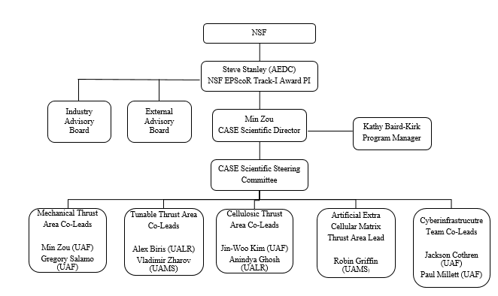

University of Arkansas internal center organization is illustrated below:

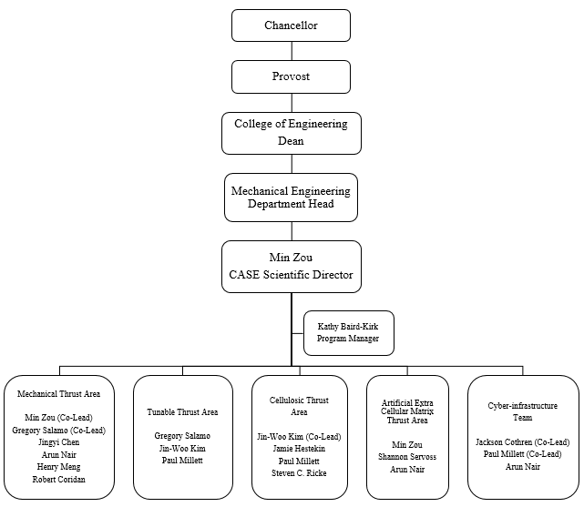

Identification of faculty (or qualifications of type of faculty), other personnel, and academic units that will be involved with the Center.

While the center involves a multidisciplinary team of about 40 faculty from ten Arkansas Universities, The University of Arkansas is contributing a significant amount of faculty and staff efforts to the CASE because of the amount of work to be completed. Min Zou, Professor of Mechanical Engineering, will lead the CASE as the Center Scientific Director. Faculty with nanomaterials and surface fabrication, characterization, performance evaluation, and modeling expertise form the core faculty of the CASE. These faculty members are from many different departments as shown in the University of Arkansas internal center organization chart in the previous section. Besides, Dr. Zou, the Center includes Gregory Salamo (Distinguished Professor of Physics) as a Mechanical Thrust Co-Lead, Jin-Woo Kim (Professor of Biological and Agricultural Engineering) as a Cellulosic Thrust Co-Lead, Jackson Cothren (Professor of Geosciences) and Paul Millett (Assistant Professor of Mechanical Engineering) as the Cyberinfrastructure Team Co-Leads, Jingyi Chen (Associate Professor of Chemistry and Biochemistry), Arun Nair (Assistant Professor of Mechanical Engineering), Jamie Hestekin (Professor of Chemical Engineering), Shannon Servoss (Associate Professor of Chemical Engineering), Steven C. Ricke (Professor of Food Science), Xiangbo Meng (Assistant Professor of Mechanical Engineering), and Robert Coridan (Assistant Professor of Chemistry and Biochemistry). Additionally, the Center includes Kathy Baird-Kirk who serves as the CASE Program Manager.

Student involvement, if any.

Both graduate and undergraduate students will participate in Center research through working on the various research projects. Besides involvement in the research work in the lab, the students will also participate in the monthly Research Thrust Meetings to discuss research progress and collaborations within and outside of their thrust. They will also participate in center events and workshops that provide professional development and entrepreneurship training as well as networking and collaboration opportunities. Research Experience for Undergraduates (REU) funding will be available with emphasis placed on underrepresented minorities. In addition, students may take internships with collaborating industries.

Annual budget for the Unit or the estimated expenditures per year.

The center is funded with a $20 million grant awarded by the National Science Foundation (NSF) and an additional $4 million state match for years 1-5. The estimated research expenditures on the Fayetteville campus is about $1.5 million each year.

Estimated fiscal resources and potential sources of funding (e.g., state, private, endowment, grant, contract, or other).

Currently, fiscal resources include the funding through an NSF award described in the previous section. The collaborations developed through this program will enable the Center team to pursue large collaborative grants from government funding agencies and private foundations. Faculty will also be actively submitting proposals to a variety of government agencies as well as partnerships with private industry. We expect CASE to forge partnerships with industry during the first five years and sustain the center via membership fees from industry partners.

Space and equipment needs of the Center and a description of how they will be met.

While each CASE partner university will contribute space for CASE research, the UA CASE Center will be housed in The Institute for Nanoscale Science and Engineering. Approximately 2,500 square feet in the Nanoscale Material Science and Engineering Building has been allocated as the centralized facility. The space is specially designed for nanotechnology research, housing a suite of equipment with unique capabilities, including a 3D laser lithography system, a laser scanning microscope, a femtosecond laser, an atomic force microscope, a universal materials tester, a dip coater, a friction analyzer, an instrumented nanoindenter, a contract profiler, a goniometer, and an optical transmittance/reflectance meter. Additional equipment may be added in the future through external grants support. In addition, existing facilities such as the High Density Electronics Center in the Engineering Research Center and the Nano & Bio Materials Characterization Facility in the Nanoscale Material Science and Engineering Building are also utilized for the CASE research.

Description of administrative control and lines of authority for the Center.

The Center will follow the campus policy and procedures of the University of Arkansas. The Center Director reports to the Head of the Department of Mechanical Engineering, who reports to the Dean of the College of Engineering. The Dean reports to the Provost, who reports to the Chancellor of the University.

Description of the advisory board including its size, the method of its selection, and length of terms.

CASE has an Industry Advisory Board (IAB) and an External Advisory Board (EAB). The members were selected by each of the four research thrusts and approved by the CASE Science Steering Committee. The IAB and EAB will serve a five-year term. The IAB, representing targeted industries within the state, is a rotating group of seven industry advisors designed to strengthen interactions between researchers and the private sector and serve as a sounding board for future research direction. The EAB includes about eight scientists from universities, industry, and national labs who serve as technical consultants providing recommendations on research progress and strategic and long-term sustainability planning during annual site visits. They will assist CASE in identifying transformative opportunities to be considered by the CASE Management Team for seed funding.

The metrics to be used to evaluate the Center’s feasibility at its five-year review.

- Research proposals submitted and funded associated with the Center
- Annual research expenditures
- Journal and book chapter publications as a result of Center research
- Number of invention disclosures filed based on Center research
- Number of students graduated who worked in the center
- Number of industry collaborators
- Number and value of startups generated by the Center

