LETTER OF NOTIFICATION – 2

ESTABLISHMENT OF ADMINISTRATIVE UNIT

(Center, Division or Institute not offering primary faculty appointments

or certificate/degree programs)

- Institution submitting request: University of Arkansas Fayetteville

- Contact person/title: Dr. Min Zou, Professor

- Phone number/e-mail address: (479) 575-6671 / mzou@uark.edu

- Name of Proposed Administrative Unit: Center for Advanced Surface Engineering (CASE)

- Proposed Location: Nanoscale Material Science and Engineering Building

- Distance of proposed unit from main campus: On campus

- Reason for proposed action: Recognition of a National Science Foundation Supported Research Center with all of the rights and privileges therein.

- Mission and role for proposed unit:

CASE was established through a statewide planning process that involves researchers from over 10 Arkansas universities. This one year-long planning process resulted in a highly competitive proposal to the National Science Foundation (NSF) that was selected for a $20M NSF EPSCoR Research Infrastructure Improvement (RII) Track-1 award. The State of Arkansas provided an additional $4M Match for the center. The mission of the CASE is to accelerate the discovery, design, development, and technology transfer of the next generation of material surfaces, enabling new applications and innovative products to address national research priorities and industry needs. The vision of the CASE is to become a leading research and education center for engineering durable, nanostructured multifunctional, tunable, and bioactive surfaces. These surfaces have the potential to impact a broad range of industries, ranging from manufacturing, aerospace and defense, agriculture, oil and gas, to healthcare. CASE is the first interdisciplinary research center in Arkansas that focuses on Advanced Surface Engineering Research and Education. CASE brings together a multi-disciplinary team of about 40 researchers with expertise in physics, chemistry, biology, engineering, and computational science from 10 Arkansas universities to conduct the interdisciplinary research. The center functions under the assumption that a single discipline could not achieve the goals set by this team and must integrate multiple disciplines and domains to achieve such success.

The University of Arkansas will serve as a major research partner for the Center. As the Science Director of the Center, Dr. Zou plays a critical role in the central administration of the center. In addition to providing administrative leadership, UA faculty are providing research leadership in the center as well. Dr. Zou and Dr. Gregory Salamo serve as the Co-Leads for the Mechanical Thrust, Dr. Jin-Woo Kim serves as the Co-lead for the Cellulosic Thrust, and Drs. Jackson Cothren and Paul Millett serve as the Co-Leads for the Cyberinfrastructure Team.

- Provide current and proposed organizational chart. See attached proposal

University of Arkansas internal center organization is illustrated below:

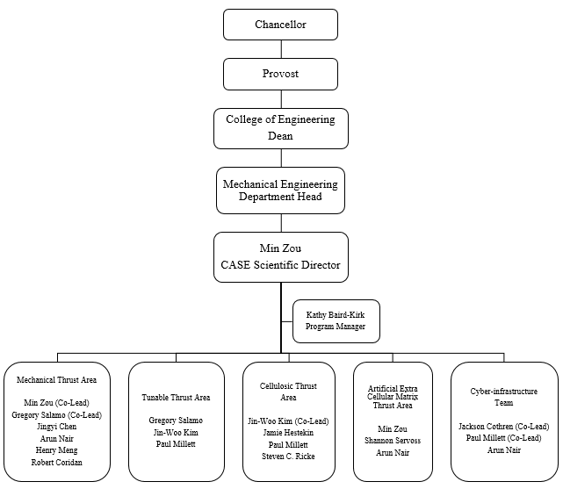

- Provide copy of e-mail notification to other institutions in the area of proposed location.

Not required.

- Provide additional program information if requested by ADHE staff.

See attachment.

President/Chancellor Approval Date: September 10, 2018

Board of Trustees Approval or Notification Date: November 15, 2018

Chief Academic Officer: James S. Coleman Date: August 31, 2018

