Workforce Analysis Request Form

Directions: An institution shall use this form to request workforce data analysis of a proposed degree program. In completing the form, the institution should refer to the document AHECB Policy 5.11 Approval of New Degree Programs and Units, which prescribes specific requirements for new degree programs. Note: This form is required to be submitted by the Chief Academic Officer or individual(s) they designate. Answers need not be confined to the space allotted but may extend to several pages.
Workforce Analysis is not required for certificate of proficiency or technical certificate.

Program Information for Analysis
1. Institution:

University of Arkansas, Fayetteville

2. Program Name – Show how the program would appear on the Coordinating Board’s program inventory (e.g., Bachelor of Business Administration or Associate of Science in Accounting):

Master of Music in Black Sacred Music

3. Proposed CIP Code: If the proposed program does not fit easily into one CIP Code, provide the code it most closely falls into and explain differences / nuances of your program

39.0501 (Religious/Sacred Music)

4a. Standard Occupational Classification (SOC) from CIP-SOC Crosswalk:

Take SOC codes from NCES Crosswalk of CIP to SOC, ranked in order of relevance (i.e., the degree to which program graduates are expected to desire and/or be qualified to work in each occupation) (See Appendix A)

39.0501 | Religious/Sacred Music | 25-1126 | Philosophy and Religion Teachers, Postsecondary
39.0501 | Religious/Sacred Music | 25-2041 | Music Directors and Composers

4b. Standard Occupational Classification (SOC) from Expert/Staff Opinion (optional): If you think the standard NCES crosswalk accurately represents the list of occupations in which graduates of the proposed program will be qualified to work, leave this blank. If you think the list of target occupations is longer, shorter, or different, please provide an alternative list here, ranked in order of relevance. Feel free to add qualitative information about the variety of jobs and pay scales that may exist within target occupations, and where you expect graduates to fit in. (See Appendix A)

Church musicians
Worship directors
Choir directors
Gospel music performers
Gospel songwriters
Gospel recording artists
Producers of Gospel and related musics (Hip-Hop, Soul, R&B etc.)
Teachers of Black Sacred Music (Church, K-12, Higher Education)
Performers, arrangers, and composers of popular and contemporary music (i.e., jazz, pop, hip-hop)
Composers for media (i.e., film, tv, video games, apps)

This will be a highly competitive and internationally regarded program, unique in its field. We expect graduates of this program to rank in the top 10% of earners in Black Sacred Music fields.

Current and recent job openings for whom this degree would be (would have been) desirable in the hiring process:
- Light of the World Christian Church (Indianapolis, IN) - Minister of Worship Arts - Salary: $90,000, plus benefits.
- Abyssinian Baptist Church (Harlem, NY) - Minister of Music – Salary: $128,000, plus benefits.
- University Park Baptist Church (Charlotte, NC) - Minister of Music – Salary: $105,000, plus benefits.
- Princeton University (Princeton, NJ) - Director of Chapel Music – Salary: $93,000, plus benefits.
Certainly, recipients of this degree would be eligible for jobs at smaller churches, which would historically pay significantly less. Jobs in the field relevant to this degree can be found at the following sites: National Baptist Convention, USA, Inc.; Gospel Music Workshop of America

5. Brief Program Description – Describe the proposed program, the costs and investments involved in implementing it, the students you expect to recruit into it, and its educational objectives.

This program is a Master of Music Degree in Black Sacred Music. The program will be unique in the United States as a graduate-level program in Black Sacred Music. It will additionally be supported by a companion center, the Black Music Institute, devoted to scholarship, service, and pedagogy in Black Music. Our program addresses the demand for new voices that diversify Black Sacred Music. It seeks to answer the call to provide increased access to the field for underrepresented scholars and to educate young scholars in Black Sacred Music. Most of the practitioners in this field lack the scholarship and advanced study required for upward mobility. These practitioners are then forced to seek graduate degrees in related fields that do not fully meet the specific academic needs.

Our proposed program is supported by a grant from the Walton Family Charitable Support Foundation, to convert to an endowment yielding the same annual funding after a proven three years of success. It will be housed in the University of Arkansas Department of Music and utilize both current full-time faculty and a special group of guest faculty, uniquely qualified in the field of Black Sacred Music.

We expect to recruit working professionals and aspiring professionals from around the globe into this program. The global popularity of Gospel music is a testament to the potential recruiting pool. With our three-summer model, we have the unique opportunity to attract working professionals in the field for short periods of time during the summers, in that music programs in Black churches are often on hiatus during this time. In addition, this program aims to serve the university’s flagship mission by recruiting local and regional students and elevating the profile of the Department of Music as a driver of the creative culture in Arkansas.

Learning Objectives:

The Master of Music in Black Sacred Music degree identifies the following learning objectives, addressed in the required courses.

Program Learning Objectives
- Evaluate Black Sacred Music within historical, cultural, and social contexts.
- Demonstrate leadership and administrative skills in worship planning and musical direction.
- Perform genres related to Black Sacred Music at the professional level.
- Utilize technology for music composition, production, presentation, and live performance in Sacred Music settings.
- Apply contemporary analytical and performance techniques to Gospel Styles
- Design contemporary, creative worship experiences for the Black church context.
- Develop skills in conducting, rehearsal technique, and transcription specific to the preparation of Gospel music.
- Develop preliminary research skills to effectively study and present topics related to Black Sacred Music.
6. North American Industry Classification System (NAICS) – List some industries and/or companies which graduates would be most likely and/or qualified to work in (optional), and feel free to comment on why/in what capacity. Also, a description of the target industry in your region, its relative strength or weakness relative to other regions, and the reasons for that relative strength or weakness, is welcome. Lookup NAICS Code

We expect graduates to obtain a large variety of traditional and freelance employment upon completion of this program, as is common in music and the arts more broadly. The three NAICS codes below represent approximate categories for such work:

711130 Choirs – Many graduates will be working in choral music and are likely to find or retain employment in choral or related fields (sacred and secular).

711510 Music Directors, Independent – The emphasis on musical leadership in the program prepares graduates for roles as music directors in Black Sacred Music and many related contemporary genres. This includes work in television, film, and other media that necessitates musical direction.

711530 Music Artists, Independent – Graduates of this program will work in many freelance capacities in multiple roles as performers, composers, arrangers, producers, recording artists, and teachers.

The global music industry encompasses many sectors including live (~$31B globally in 2022) and recorded (~$26B Globally in 2022), and music publishing (~$7.4B in 2022). In our own backyard, the creative vitality index of Washington County, AR is .89, compared to the national average of 1.0. This further serves as evidence that the establishment of this degree will bring more national and international attention to the university and the region for music. Choirs in particular are prevalent across the country and around the world. Sound Diplomacy lists 94 choirs in Northwest Arkansas alone. While we expect to recruit students locally who will remain in the NWA region, this program has national and international aims. Graduates of the M.M. in Black Sacred Music will be well prepared for a vast number of roles within the contemporary music industry.

7. Region of Possible Position(s) – Describe the region where you think graduates are most likely to work, e.g., in terms of a list of counties, a metropolitan statistical area, or a commuting radius:

Graduates from this program are most likely to work in every region where Gospel and contemporary popular music are significant portions of the music industry. This includes the majority of cities in the United States, Europe, Japan, South Korea, and Canada.

We expect our graduates to work in a myriad of areas of the broader music industry and Gospel music specifically in the U.S. and abroad. Specific global music industry centers include but are not limited to: New York, Los Angeles, Atlanta, Miami, Houston, Nashville, Toronto, London, Seoul, Cape Town, Rome, Berlin, London, Tokyo, and Mumbai.

8. Existing Data – Describe any existing anecdotes or data you have that would shed light on the job prospects of graduates from the proposed academic program. This data can be helpful to ADFA in conducting labor market analysis.

An informal interest survey was conducted in June 2022. The survey was completed by attendees at the Hampton University Minister’s Conference and Choristers Guild and additionally distributed via social media. It received 51 responses after six days. This sample represented 20 U.S. states along with Jamacia, Canada, Italy, and the U.K. Respondents were asked to rate their interest in applying for a Master of Music in Black Sacred Music Degree on a scale of 1 (Least Interested) to 5 (Most Interested).

- The mean interest level of all respondents was 3.9.
- 29.4% of respondents held undergraduate degrees in music. 78.4% of all respondents indicated that music was their full-time profession.
- 73% of respondents holding an undergraduate degree in music rated their interest in applying to the Master of Music in Black Sacred Music Degree at a “4” or “5” out of 5.
- 67% of respondents for whom music was a full-time profession rated their interest in applying to the Master of Music in Black Sacred Music Degree at a “4” or “5” out of 5.
- 86.5% of respondents who rated their interest in applying as “5” indicated “advance professionally” as a primary reason for their interest in the program.

9. Proposed Implementation Date – (MM/DD/YY): 05/15/2023 (for Summer 2023 term)

10. Contact Person – Provide contact information for the person who can answer specific questions about the program:

Name: Dr. Jeffrey Allen Murdock

Title: Associate Professor, Director of Choral Activities, University of Arkansas

E-mail: jeffreym@uark.edu

Phone: 901-486-5501

Email the completed form: Dr. Nicolas Aguelakakis (Nicolas.Aguelakakis@arkansas.gov).

After the labor market analysis has been completed, the institution will be invited to respond, providing further information that might shed light and help to interpret the data provided.

APPENDIX A. CIP-SOC MATCHING AND THE NCES CROSSWALK (Question 4a & 4b)
Labor market analysis for academic program requires the combination of diverse data sources. The National Center for Education Statistics (NCES) and the Bureau of Labor Statistics (BLS) developed a “CIP-SOC crosswalk” linking fields of study, classified by a well-established classification scheme called Classification of Instructional Programs (CIP), with occupations, classified by a well-established classification scheme called Standard Occupational Classifications (SOC). The CIP-SOC crosswalk is available here, and guidelines on how to use the scheme are posted online here.

In question 4a of the form, institutions are asked to copy and paste a list of occupations that match with their instructional programs, taken directly from the NCES CIP-SOC crosswalk, which can be downloaded here: https://static.ark.org/eeuploads/adhe/CIP-SOC_Crosswalk_for_Workforce_Analysis_Form.xls

To use this file to answer question 4a:
- Select Column A.
- In the Home ribbon, Editing section of the toolbar, click Find & Select to get a drop-down menu, and select the Find command. As you do this, your screen should look something like this.
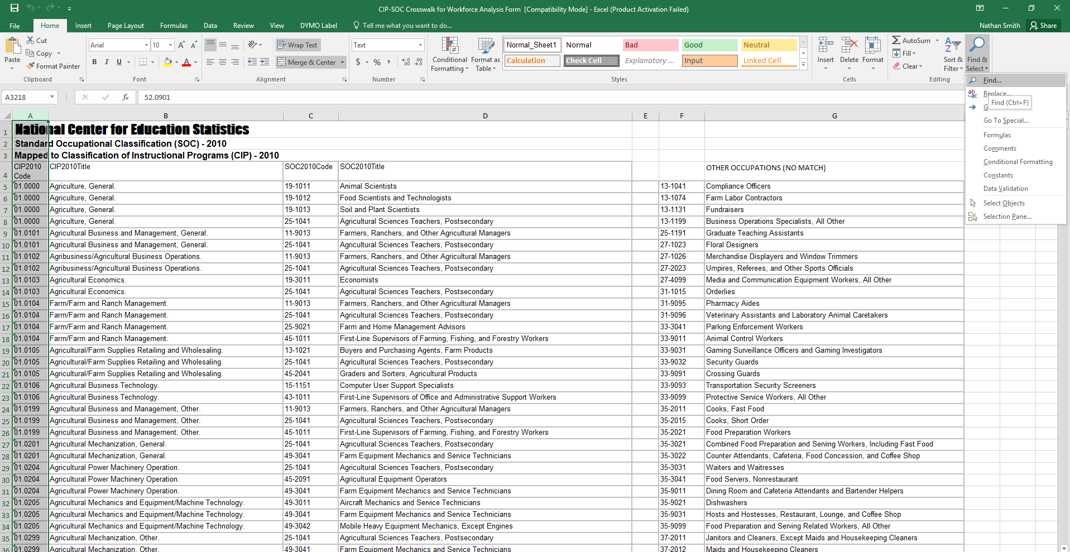

- In the Find and Replace dialog box, enter the CIP code that you’re interested in, and click “Find Next.” Your screen should then look like this:

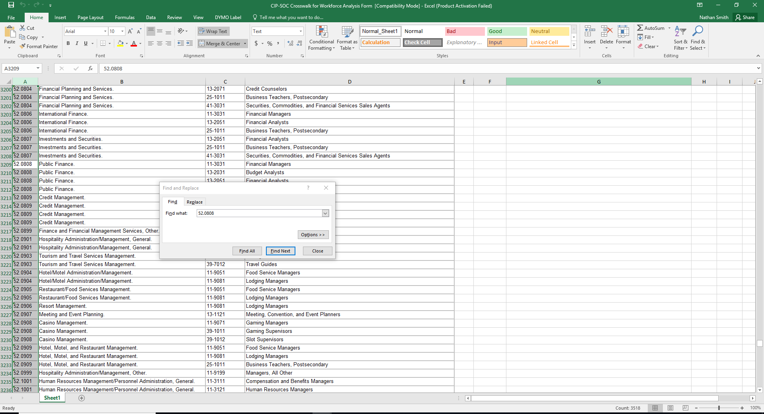

- Since the CIP-SOC crosswalk file is already sorted by row, you can find all the rows corresponding to your CIP simply by starting from the first cell selected and then reading down in column A until you encounter a different CIP code.
- Select all of these rows, columns A through D, this will form a table that can be pasted directly into the response field for question 4a.

52.0808 | Public Finance. | 11-3031 | Financial Managers
52.0808 | Public Finance. | 13-2031 | Budget Analysts
52.0808 | Public Finance. | 13-2051 | Financial Analysts
52.0808 | Public Finance. | 25-1011 | Business Teachers, Postsecondary

- If desired, ask a faculty or staff member to sort the matched occupations from the CIP-SOC crosswalk by relevancy/importance, with the occupations that seem most likely to employ your graduates ranked first.
- Missing occupations from the list should be addressed in question 4b.

Question 4b, is requesting information from your local staff/workforce experts at your institution on the applicability of the NCES list. We are aware that the NCES might be “globally” wrong—the CIP/SOC match may never have been very accurate, or may become obsolete as fields and occupations evolve—or “locally” wrong—the CIP/SOC match may be reasonably robust in general, but fail to capture the role your particular program plays in students’ career paths. Graduates of a particular program may be over or underqualified for some of the matched occupations. Also, there may be SOCs not matched to your CIP by NCES for which, however, your program does help to prepare students, and which are likely to provide gainful employment for your graduates. Question 4b is the place to tell us about those as well.

Defined as graduating four students per year on a three-year rolling average, per ADHE.
International Federation of the Phonographic Industry (IFPI) ranks Gospel the 9th most popular genre in South Korea, as well as popular in Europe and the United States. https://www.ifpi.org/wp-content/uploads/2020/07/Music-Listening-2019-1.pdf
A recent report by Price Waterhouse Cooper estimated this industry value. https://www.digitalmusicnews.com/2018/10/26/latest-live-music-revenue-31-billion-2022/
IFPI: https://www.ifpi.org/wp-content/uploads/2020/07/Music-Listening-2019-1.pdf
Estimate by Mordor Intelligence: https://www.mordorintelligence.com/industry-reports/music-publishing-market
According to data collected by Arkansas for the Arts: https://arkansansforthearts.org/arts-tech-bootcamp/
https://nwacouncil.org/wp-content/uploads/2021/01/NWA-MusicEcosystemStrategyActionPlan.pdf
53 million people in the United States listen to gospel music 2-3 times per week, according to the Gospel Music Association: https://gospelmusic.org/industry-overview-2/
In every country where data is available, music related to Gospel such as Hip-Hop, Soul, R&B, and Rock are ranked in the top 10 most consumed genres. Source: https://www.ifpi.org/wp-content/uploads/2020/07/Music-Listening-2019-1.pdf
See Tschmuck, P. (2017). The economics of music. Agenda Publishing; Siwek, S. E., (2018). The U.S. music industries: jobs & benefits. http://www.riaa.com/wp-content/uploads/2018/04/US-Music-Industries-Jobs-Benefits-Siwek-Economists-Inc-April-2018-1-2.pdf; Passman, D. S. (2004). All you need to know about the music business. Free Press.

