PROPOSAL - 1

NEW DEGREE PROGRAM

1. PROPOSED PROGRAM TITLE: Master of Education (M.Ed.) in Educational Equity

2. CIP CODE REQUESTED: 13.1206 (Teacher Education, Multiple Levels)
Link for CIP Codes: http://nces.ed.gov/ipeds/cipcode/resources.aspx?y=55.

3. PROPOSED STARTING DATE: Summer 2019

4. CONTACT PERSON
Name (Provost/Academic Affairs Officer): Dr. Terry Martin
Title: Senior Vice Provost for Academic Affairs
Name of Institution: University of Arkansas
E-mail Address: tmartin@uark.edu
Phone Number: (479) 575-2151

Name (Program Contact Person): Dr. Tom Smith
Title: University Professor
E-mail Address: tecsmith@uark.edu
Phone Number: (479) 575-3326

5. PROGRAM SUMMARY
Provide a general description of the proposed program. Include overview of any
curriculum additions/modifications; program costs; faculty resources; library resources; facilities and equipment; purpose of the program; and, any information that will serve as introduction to the program.

The Master of Education in Educational Equity is a 33-hour graduate program targeting early career educators who are committed to increasing effectiveness in their classrooms and meeting the educational needs of students in high-poverty districts. Participants work full-time as lead teachers in high-needs districts while enrolled in this program. The overall goal of the program is to increase the effectiveness and support of these early career teachers while they lead classrooms in struggling, high-poverty schools in Arkansas. Aligned to the U.S. Department of Education’s directives that allow states to create outcomes-based training programs, the program’s design leverages innovative best practices and is responsive to the needs identified by local school districts. The program is designed for individuals who have a bachelor’s degree and at least one year of teaching experience. Additionally, degree candidates bring a deep commitment to making a difference across the state of Arkansas, a desire to share in the ambitious work of teacher development, and an unwavering belief that students in high-poverty schools need a consistent, high-quality teacher workforce.

Arkansas, similar to other states across the country with a mix of low-density urban areas and high numbers of rural school districts, faces a significant teacher shortage, especially in districts with high levels of poverty. The lack of highly-effective teachers disproportionately affects students in high-needs schools. Additionally, preparation for the classroom is a continuous process, critically important in the initial years of teaching and being prepared to teach in schools that are struggling with poverty adds to the complexity of effective teacher development. This program helps address the severe teacher shortage, as well as the need for additional professional development, in Arkansas’ highest-need districts by combining a strong set of coursework, coaching, content-area support, and practical pedagogical resources. The two-year program design attracts educators from outside the state of Arkansas as well as educators who are already working in Arkansas districts, and enables all degree candidates to accelerate positive student outcomes in these districts.

Degree candidates enter the Master of Education in Educational Equity program during the summer as a cohort. The degree will be completed in two years (four regular semesters and two summers) and focuses on building skills around teaching particular content areas in high-poverty districts. During the program, candidates complete two courses each term through web-based distance technology, one in-person course during the first summer, and two courses (one in-person course and one course either in-person or online) during the second summer. Candidates also work full-time as lead teachers in high-need districts across the state during the two year program, which provides them with a real-time opportunity, with mentor support, to implement instructional strategies.

List degree programs or emphasis areas currently offered at the institution that support the proposed program
As outlined in the course map included with this proposal, the proposed program is supported by existing program areas and coursework within the Department of Curriculum and Instruction, such as Special Education (SPED), Educational Leadership (EDLE), and Curriculum and Instruction (CIED). Additionally, the Department of Rehabilitation, Human Resources, and Communication Disorders (RHRC) supports the degree through coursework in the area of Educational Foundations (EDFD).

6. NEED FOR THE PROGRAM
(Submit Employer Needs Survey Forms)
Provide survey data. Submit numbers that show job availability, corporate demands and employment/wage projections, not student interest and anticipated enrollment. Focus mostly on state needs and less on regional and national needs, unless applicable to the program.

Survey data can be obtained by telephone, letters of interest, student inquiry, etc. Focus mostly on state needs for undergraduate programs; for graduate programs, focus on state, regional and national needs.

Provide names and types of organizations/businesses surveyed.

Letters of support should address the following when relevant: the number of current/anticipated job vacancies, whether the degree is desired or required for advancement, the increase in wages projected based on additional education, etc.
To identify specific needs for this program, a survey was disseminated among more than ten high-needs districts in Arkansas. Results of this survey indicated strong demand for the Master of Education in Educational Equity program. Many districts mentioned the potential for this degree to help alleviate the teacher shortage that prevents districts from obtaining highly-qualified teachers. Every district surveyed either had teaching positions open currently or anticipated that there would be vacancies in the coming year. Some school districts anticipated as many as 25-50 teaching vacancies in the upcoming year. Many of those surveyed indicated that they would give hiring preference to individuals with the proposed degree and, where districts were able, they offered to provide tuition assistance for employees who enrolled in the program.

Comments provided by districts were very supportive of the proposed program. One district wrote, “this program has the potential to help resolve the teacher shortage in our area of the state. Also, the program provides our teachers the opportunity to pursue an advanced degree.” Another district wrote that the program would provide “a better prepared teaching force.” Districts also spoke about the opportunity for teachers to improve that this program provides. A district shared that this program would “support our teachers in becoming excellent in their craft.” Another district wrote that this program “will provide a more conscience level of advocacy for students and families and help to ensure meaningful experiences and true care and high expectations for all students.”

Additional results from the Employer Needs Surveys are available in the Institutional Summary and the completed Employer Needs Surveys included as Appendix A and Appendix B, respectively.

Indicate if employer tuition assistance is provided or if there are other enrollment incentives.
This program is fully funded through an external grant. As part of the funding, and as a significant enrollment incentive, initial enrollees in the program will have their tuition costs fully covered over the entire course of the program.

Describe what need the proposed program will address and how the institution became aware of this need.
The proposed program is the only program in the state that focuses specifically on preparing teachers to work in districts with high levels of poverty. Unfortunately, most districts with a large percentage of high-needs students have difficulty attracting and retaining quality teachers. While there are teacher shortages in many districts in Arkansas in specific areas, e.g. science, math, and special education, shortages in these areas and most other teaching areas are exacerbated in districts with large percentages of high-needs students and districts that are located in the Southeast and Southwest regions of the state.

A recent study from the University of Arkansas examined the ratio of applications to vacancies at school districts across the state of Arkansas. Survey data of districts from across the state showed that districts with the highest-needs students have the fewest applicants per vacancy. This study found that “the wealthiest districts have nearly 9 applications per vacant position while the poorest districts have between 2 and 3 applications per vacancy” (page 4). This study also found variations between districts in different regions of the state, with districts in the Southwest and Southeast regions having far fewer applications, on average, for each vacancy than districts in other regions of the state. The full policy brief is available as Appendix C.

Existing programs can also provide evidence of the need for teachers in high-needs districts in the state. For six years, the University of Arkansas has been the home of the Arkansas Teacher Corps (ATC), which is a nontraditional licensure program similar to Teach for America that places and supports new teachers in high-needs school districts. Throughout the past six years, ATC has been unable to place sufficient numbers of teachers to meet the needs of districts. For example, during the spring and summer of 2018, ATC received 260 requests for teachers for the 2018-2019 school year but was only able to identify and place 21 teachers. For the 2017-2018 school year, the organization received 240 requests for teachers and was able to place 31 teachers. While ATC is placing teachers in districts that have a difficult time employing and retaining qualified teachers, it has been unable to meet the needs of these districts. At the same time, Teach for America has been reducing the numbers of teachers placed in Arkansas, which has only added to the dire situation for many districts. The Master of Education in Educational Equity offers an incentive for teachers to move into districts with high levels of poverty as well as provides additional support for teachers currently in those districts. Candidates are employed as full-time teachers while enrolled in this program.

Focus groups of teachers in Arkansas and contiguous states were held to determine the level of interest of students in the program. The focus groups found strong interest among early career teachers in this program. In a recent focus group of 15 teachers in Arkansas, 10 teachers said they were interested and two teachers said they had already obtained a Master’s but would have strongly considered the program if it had been available when they were choosing a Master’s program. Similarly, during a focus group of 30 teachers with two or more years of experience in neighboring states, 10 teachers said they were interested and 14 would have strongly considered the program if it had been established before they obtained a Master’s.

Indicate which employers contacted the institution about offering the proposed program.
As noted above, the demand for teachers in the areas of the state that this program will serve is extremely high. Arkansas Teacher Corps receives far more requests for teachers each year than they can fulfill. Please see responses to the Employer Needs Surveys for additional information regarding employer demand for this program.

Indicate the composition of the program advisory committee, including the number of members, professional background of members, topics to be considered by the members, meeting schedule (annually, bi-annually, quarterly), institutional representative, etc.
The Master’s in Educational Equity has formed a program advisory committee comprised of between 11-15 members who will serve to provide feedback to the faculty and staff administering the program. The committee includes representatives from the Arkansas Department of Education, the University of Arkansas, school districts across the state of Arkansas, Chambers of Commerce, state and national education organizations, and community advocates. The group will meet bi-annually and consider topics including curriculum, effectiveness, and growth and recruiting.

Indicate the projected number of program enrollments for Years 1 - 3.
- Year 1 (2019 - 2020): Total enrollment of approximately 40-50 students
- Year 2 (2020 – 2021): Total enrollment of approximately 75-80 students
- Year 3 (2021 – 2022): Total enrollment of approximately 100 students

Indicate the projected number of program graduates in 3-5 years.
The number of program graduates, in 3-5 years, is expected to be approximately 40 graduates per year.

7. CURRICULUM

Provide curriculum outline by semester (include course number and title).

(For bachelor’s degree program, submit the 8-semester degree plan.)
Program of Study: The Master of Education in Educational Equity is a 33-hour graduate program with a focus on content-area support, practical pedagogical resources, and real-time classroom coaching. For more detail, see course listing below and the Course Map included as Appendix D.

Give total number of semester credit hours required for the program, including prerequisite courses. Total Number of Hours: 33

Identify new courses (in italics) and provide course descriptions. New Courses: 6

Required General Education Courses, Core Courses, Major Courses:
There are six core courses in the program. For the remaining five courses (15 credit hours), students may choose electives from a set list of courses.

For each program major/specialty area course, list the faculty member assigned to teach the course.

Identify courses currently offered by distance technology (with an asterisk*) and endnote at the end of the document.
Core courses:
- EDEQ 5003 Best Practices for Teaching in High-Needs Schools
Dr. Tom Smith
This course is designed to equip students with the knowledge and skills to be successful in the classroom. The course primarily focuses on teaching specific content areas, classroom management, and understanding the socioeconomic circumstances driving poverty. Sessions will focus on Cultural Competency and Content and Pedagogy. Students will learn and develop a working knowledge of the concepts of rigor, cultural responsiveness, and learner variability. Students will also engage in a combination of (a) being taught with a teacher-centered approach, (b) working in discussion groups, and (c) meeting 1:1 with their relevant coach.
- EDEQ 5013 Classroom Management Mechanics and Content
Dr. Pamela Yancy-Taylor
The course provides students the knowledge and skills to move from good to great in the areas of classroom mechanics and content. Directors of Content will provide direct classroom observation, feedback, and coaching. Students will periodically meet electronically as a whole cohort for additional sessions on vital skills such as workshopping lesson plans, analyzing data, diagnosing and planning for interventions, sharing best practices, and building community and parent engagement skills.
- EDEQ 5023 Collecting and Analyzing Student Data
Dr. Pamela Yancy-Taylor
This course provides students the knowledge and skills to gather and analyze quantitative and qualitative data. The course is designed for students to master data-driven reflection and improvement. Content coaches will provide direct classroom observation, feedback, and coaching. Students will periodically meet electronically as a whole cohort for additional sessions on vital skills such as workshopping lesson plans, analyzing data, diagnosing and planning for interventions, sharing best practices, and building community and parent engagement skills.
- EDEQ 5033 Teaching Specific Content in High-Needs Schools
Dr. Pamela Yancy-Taylor
This course is designed for students to build the skills necessary to engage in self-directed growth and learning. Students will engage in reflection with their respective coaches, using tools such as StrengthsFinder, to better understand their growth and leadership. The course culminates in a final capstone project presentation to all coaches and cohort members.
- EDEQ 5043 Reflecting and Planning Content Delivery
Dr. Pamela Yancy-Taylor
This course provides students the knowledge and skills to move from good to great in the areas of classroom mechanics and content. Students will explore culturally responsive teaching and how it can be incorporated into their classrooms. Directors of Content will provide direct classroom observation, feedback, and coaching. Students will periodically meet as a whole cohort for additional sessions on vital skills such as workshopping lesson plans, analyzing data, diagnosing and planning for interventions, sharing best practices, and building community and parent engagement skills.
- EDEQ 5053 Understanding and Exploring Community Context
Dr. Tom Smith
This course provides students the opportunity to understand the overall impact of poverty and explore equity within their specific school and community context. The course is designed for students to build the skills necessary for tapping into existing networks and building relationships outside of their school building. Coaches will provide direct classroom observation, feedback, and coaching. Students will periodically meet electronically as a whole cohort for additional sessions on vital skills such as sharing best practices and building community and parent engagement skills.

Electives may be selected from the following list:
- SPED 5173 Introduction to Dyslexia: Literacy Development and Structure of
Language*
Mr. David Hanson
This course provides an introduction to how students develop literacy skills, including students who experience problems in reading and those formally identified as having dyslexia. A key focus of the course is the development of remedial strategies to address various reading deficiencies.
- SPED 5733 Inclusive Practices for Diverse Populations*
Dr. Kathleen Collins
This course provides an overview of students with disabilities included in general classrooms. Legal requirements for inclusion, types of students with disabilities, and strategies for teaching students with disabilities will be the focus of the course.
- EDFD 5683 Issues in Educational Policy*
The course focuses on educational policy and how policy impacts P-12 schools at the district and classroom level.
- EDFD 5373 Psychological Foundations of Teaching and Learning* or EDLE 5033
Psychology of Learning*
Dr. John Pijanowski
Both courses focus on educational psychology and the psychology of learning. Various learning theories are presented as well as the impact different behavioral management strategies have on student success.
- Additional courses identified as supporting the goals and objectives of the
program.

*Indicates course currently offered by distance technology

Indicate the number of contact hours for internship/clinical courses.
The course of study does not include a specific internship course. Rather, all courses include a field component requiring students to practice content. All students are full-time teachers in target school districts. As a result, they have daily opportunities throughout the school year to practice and implement content learned in courses. Each course includes assignments that require in-school activities, reports, and reflections.

State the program admission requirements.
Applicants must meet all requirements for admission to the University of Arkansas Graduate School, except the standardized test score requirement.
- Two years of teaching experience OR a Bachelor’s Degree in Education or a
related field with one year teaching experience.
- Valid teaching license.
- Applicants must complete program-specific admission requirements including an
interview with program staff and providing at least two references.

Describe specified learning outcomes and course examination procedures:
Program Goals:
- To develop and implement a Master of Education in Educational Equity Degree
that provides participants with subject matter support, real-time coaching, and pedagogical training.
- To recruit 50-75 students for the Master’s degree program during the first three
years and place them in high-needs school districts in Arkansas with strong mentor support.
- To recruit 30 - 50 new students each year, beginning in year 4, for the program.

Program Objectives:
- Reduce the shortage of teachers in high-needs districts in Arkansas
- Improve teacher retention in high-needs districts in Arkansas through strong
mentor support
- Enhance the effectiveness of teachers already working in high-needs districts by
providing additional support and training
- Improve education outcomes for students in high-needs districts

Student Learning Outcomes:
- Develop a comprehensive understanding of high-needs school districts
- Understand and implement culturally responsive teaching
- Develop a comprehensive understanding of the unique needs of students from
high-poverty environments
- Understand the inter-relatedness of community factors in high-poverty
environments
- Develop skills related to family involvement in high-poverty environments
- Enhance subject matter knowledge and develop strategies to teach content
effectively
- Learn how to collect and analyze quantitative and qualitative data in order to drive
improved instruction

All students in the Master of Education in Educational Equity program are required to complete a written comprehensive examination.

Additional information about specific coursework and examination procedures is included in the syllabi for courses for this program.

Include a copy of the course evaluation to be completed by the student.
Students will complete the course evaluation required in all web-based courses offered through the Global Campus or as required by the University of Arkansas Graduate School.

Include information received from potential employers about course content.
In Employer Needs Surveys, potential employers consistently mentioned the need for teachers who are trained in classroom management, public speaking, planning and organizing, data analysis, and communication. Each of these subjects is included in the proposed curriculum.

Provide institutional curriculum committee review/approval date for proposed program.
December 12, 2018
8. FACULTY
List the names and credentials of all faculty teaching courses for the proposed program. Include college/university awarding degree; degree level; degree field; subject area of courses faculty currently teaching and/or will teach. (For associate degrees and above: A minimum of one full-time faculty member with appropriate academic credentials is required.)
Indicate lead faculty member or program coordinator for the proposed program.

Faculty teaching core courses in the program:
- Dr. Pamela Yancy-Taylor, Senior Director
of Instructional Leadership for the Academy
- Dr. Tom Smith, University Professor and PI of the Academy Program
- Dr. Gary Ritter, Adjunct Professor

Faculty teaching elective courses in the program:
- Dr. Kathleen Collins, Professor of Special Education
- Dr. John Pijanowski, Professor of Educational Leadership
- Mr. David Hanson, Adjunct Lecturer

Additional faculty will occasionally teach classes, such as faculty from the Educational Foundations faculty who will teach the EDFD 5373 and EDFD 5683 courses, and faculty from the Department of Curriculum and Instruction. Adjunct faculty with specialized expertise may also teach courses as needed.

Total number of faculty required for program implementation, including the number of existing faculty and number of new faculty. For new faculty, provide the expected credentials/experience and expected hire date.
- No new full-time faculty are required for program implementation
- Courses in the program will be taught by current faculty and staff employed
by the Academy for Educational Equity with terminal degrees
- Adjunct faculty will teach individual courses as needed

For proposed graduate programs: Provide the curriculum vita for faculty teaching in the program, and the expected credentials for new faculty and expected hire date. Also, provide the projected startup costs for faculty research laboratories, and the projected number of and costs for graduate teaching and research assistants.
There are no start-up costs related to faculty; a grant has been received that will support all costs, including start-up costs and faculty costs. Salaries for all Academy staff are included in the grant.

9. DESCRIPTION OF RESOURCES
Current library resources in the field: There are no additional University of Arkansas library resources needed. Since the program is a web-based program and students are not on campus they will access resources through electronic means. Throughout the degree program, students will be able to access already existing resources, including the University of Arkansas Library’s vast education holdings.
Current instructional facilities including classrooms, instructional equipment and technology, laboratories (if applicable)

New instructional resources required, including costs and acquisition plan: The cost for all instructional resources required will be covered by the grant. Additional instructional resources may be needed as the program progresses. Costs for these resources will be covered by the grant.

10. NEW PROGRAM COSTS – Expenditures for the first 3 years
New administrative costs (number and position titles of new administrators)
Number of new faculty (full-time and part-time) and costs
New library resources and costs
New/renovated facilities and costs
New instructional equipment and costs
Distance delivery costs (if applicable)
Other new costs (graduate assistants, secretarial support, supplies, faculty
development, faculty/students research, program accreditation, etc.)

The program is fully funded by an external grant for the first 3 years. As such, there are no additional costs to implement and sustain the proposed program outside of these already-funded expenses.
- No new faculty are required; Academy for Educational Equity staff and current
university faculty will serve as faculty for the program.
- No new library resources and costs are required; students will access existing
resources through electronic means.
- No new/renovated facilities are required; the program will be delivered using web-
based technology or in existing University facilities.
- Any instructional equipment required will be covered by the grant.
- No new Distance delivery costs.
- Other new costs: No additional costs are anticipated.

The program’s overall expected budget, outlining the anticipated expenses required to build and deliver the program for the first three years, is included as Appendix E.

If no new costs required for program implementation, provide explanation.
As mentioned above, the full cost of implementing this program is covered by an external grant.

11. SOURCE OF PROGRAM FUNDING – Income for the first 3 years of program
operation
If there will be a reallocation of funds, indicate from which department, program, etc.
Costs for the proposed program are included in a $10.2 million grant. The University will reap benefits from all students in the program.

Provide the projected annual student enrollment, the amount of student tuition per credit hour, and the total cost of the program that includes tuition and fees.
Projected annual student enrollment:
- Year 1: Total enrollment of approximately 40-50 students
- Year 2: Total enrollment of approximately 75-80 students
- Year 3: Total enrollment of approximately 100 students

Tuition per credit hour: $420.19 per credit hour for all students. Tuition for the first three years of the program (first two cohorts) is covered by the grant.

Total cost of program (tuition and fees): Total tuition for the first three years of the program, based on the total expected number of enrollees is estimated to be $1.35 million.

Indicate the projected annual state general revenues for the proposed program (Provide the amount of state general revenue per student): None.

Other (grants [list grant source & amount of grant], employers, special tuition rates, mandatory technology fees, program specific fees, etc.):
This program is completely funded by an initial three-year, $10.2 million external grant from the Walton Family Foundation. It is anticipated that additional grant funding will be secured. We also predict that the program will gain the statewide, regional, and national reputation and visibility that are necessary to attract students to enter the program without tuition assistance. Since the program is web-based through the Global Campus it will generate some level of funding through tuition. The program will be discontinued if it is not self-sustaining.

12. ORGANIZATIONAL CHART REFLECTING NEW PROGRAM
The proposed program is housed in the Department of Curriculum and Instruction within the College of Education & Health Professions at the University of Arkansas. Please see Appendix F for the program’s overall organizational chart.

13. SPECIALIZED REQUIREMENTS
If specialized accreditation is required for program, list the name of accrediting agency. None.

Indicate the licensure/certification requirements for student entry into the field.

Provide documentation of Agency/Board review/approvals (education, nursing--initial approval required, health-professions, counseling, etc.)

14. BOARD OF TRUSTEES APPROVAL
Provide the date that the Board approved (or will consider) the proposed program:
March 28, 2019

Provide a copy of the Board meeting agenda that lists the proposed program, and written documentation of program/unit approval by the Board of Trustees prior to the Coordinating Board meeting that the proposal will be considered.

15. SIMILAR PROGRAMS

List institutions offering program: There are currently no Master of Education in Educational Equity programs in Arkansas and no graduate degree programs that focus specifically on preparing educators for high-needs school districts.
Proposed undergraduate program – list institutions in Arkansas
Proposed master’s program – list institutions in Arkansas and region
Proposed doctoral program – list institutions in Arkansas, region, and nation
State why proposed program needed if offered at other institutions in Arkansas or region.

List institution(s) offering a similar program that the institution used as a model to develop the proposed program: As noted above, there are currently no programs in Arkansas that focus specifically on preparing educators for high-needs school districts. There are components of various programs across the country which the institution has adapted and used as a model to develop the proposed program. A partial list of these institutions includes: Relay Graduate School of Education, the New Teacher Project, and Teach for America. Along with these institutions, there are organizations which this program has used as informal advisors to help inform program design, including: The National Academy for Advanced Teacher Education and Transcend.

Provide a copy of the e-mail notification to other institutions in the state notifying them of the proposed program. Please inform institutions not to send the response to “Reply All”. If you receive an objection/concern(s) from an institution, reply to the institution and copy ADHE on the email. That institution should respond and copy ADHE. If the objection/concern(s) cannot be resolved, ADHE may intervene.

Note: A written institutional objection/concern(s) to the proposed program/unit may delay Arkansas Higher Education Coordinating Board (AHECB) consideration of the proposal until the next quarterly AHECB meeting.

16. DESEGREGATION
State the total number of students, number of black students, and number of other minority students enrolled in related degree programs, if applicable: N/A

17. INSTITUTIONAL AGREEMENTS/MEMORANDUM OF UNDERSTANDING (MOU)
If the courses or academic support services will be provided by other institutions or organizations, include a copy of the signed MOU that outlines the responsibilities of each party and the effective dates of the agreement: N/A

18. ACADEMIC PROGRAM REVIEW
Provide scheduled program review date (within 10 years of program implementation date).
2022-2023

19. PROVIDE ADDITIONAL INFORMATION IF REQUESTED BY ADHE STAFF

20. INSTRUCTION BY DISTANCE TECHNOLOGY
If the proposed program will be offered by distance technology, provide the following information:

Summarize institutional policies on the establishment, organization, funding and management of distance courses/degrees.
Describe the internal organizational structure that coordinates (development, technical support, oversight) distance courses/degrees.
Summarize the policies and procedures to keep the technology infrastructure current.
Summarize the procedures that assure the security of personal information
Provide list of services that will be outsourced to other organizations (course materials, course management and delivery, technical services, online payment, student privacy, etc.).

Policies for development of distance courses and degrees require approval at various levels of academic and administrative authority, including requirements from the Higher Learning Commission and Arkansas Department of Higher Education. Internally, the Global Campus and programs collaborate to build development shells and Quality Matters checklist to ensure areas of instruction are mapped to approved program outcomes and learning objectives. Technology infrastructure is updated through a coordinated and collaborative committee with academic, administrative and learning management system experts. Marketing, analysis, learning management system help desk, online payments, and privacy are evaluated by respective vice chancellors to ensure each area is in compliance and maintained to the highest standard. Information Technology security departments ensure personal information is updated and monitor any potential breaches of systems.

- Appendix A: Employer Needs Surveys Institutional Summary: pages 14-15
- Appendix B: Employer Needs Surveys from districts: pages 16-54
- Appendix C: Arkansas Teacher Supply Policy Brief: pages 55-50
- Appendix D: Master of Education in Educational Equity Plan of Study: page 61
- Appendix E: Program Budget: page 62
- Appendix F: Program Organizational Chart: page 63

Appendix A: Employer Needs Survey Form Institutional Summary

(Please compile the data from each Employer Needs Survey and submit the data on this Summary Form. Return the summary form and a copy of each survey form to ADHE with your program proposal.)

Proposed Degree/Certificate Program: Master of Education in Educational Equity

Institution: University of Arkansas

Name: Autumn Lewis E-mail: autumnl@uark.edu
(person completing this form)

List names of employers responding to survey:
Blytheville School District, Clarendon School District, Crossett School District, Dermott School District, Exalt Academy of Southwest Little Rock, Helena West Helena School District, Hope School District, KIPP Delta Public Schools, Osceola School District, Palestine-Wheatley School District, ScholarMade Achievement Place, Strong-Huttig High School, Texarkana Arkansas School District

List current job titles for the proposed degree/certificate program:
Teacher, Instructional Facilitator

List the degree/certificate required for each job title:
Bachelor’s Degree, Arkansas Teaching License

Indicate number of current positions for each job title:
The number of current teaching positions varies by school district, with the overall range being from 15 positions (ScholarMade Achievement Place) to 358 positions (Texarkana Arkansas School District). The number of teaching positions in each district is available on the individual Employer Needs Surveys.

Indicate number of future positions for each job title:
The number of future teaching positions will vary by school district, but the overall projected range is from 5 to 8 future open positions (Clarendon School District) to 50 future open positions per year (Texarkana Arkansas School District). The number of anticipated future teaching positions in each district is available on the individual Employer Needs Surveys.

Indicate salary for each job title:
The salary for teachers varies by district and years of teaching experience, with the range for a first-year teacher with a bachelor’s degree being from $31,800 (Strong-Huttig High School) to $41,000 (Exalt Academy of Southwest Little Rock). The salary ranges for each district are available on the individual Employer Needs Surveys.

Indicate number of employers who gave preference for:
on-line/distance technology: 13
evenings: 3
weekends: 3
at company site: 0

Indicate any type of support employers will give for support of the proposed degree/certificate program.
Surveyed employers stated that they would support the proposed degree program in different ways, including by offering an internship site, tuition reimbursement, necessary equipment, part-time faculty options, mentoring, and employee release time.

Summarize the skills needed for employment in the positions listed.
The necessary skills for employment that most employers listed were: interpersonal communications, written/oral communications, team work, leadership/initiative, teacher/trainer, public speaking, independent worker, problem solver, conflict resolution, and planning/organizing. Then, around half of the employers listed the following skills as also being necessary for employment: analytical reasoning, data analysis, computer applications, supervision/management, and PowerPoint presentations. One employer stated that they would prefer their employees to know a foreign language and have experience in classroom management.

Summarize any additional information provided by prospective employers.
The surveyed employers were very supportive of the concept for the Master’s in Educational Equity. Many believe it will help to relieve some of the teacher-shortages in their respective districts, while also improving the academic outcomes of their students. Those surveyed indicated that they would give hiring preference to individuals with the proposed degree.

One district wrote, “This program has the potential to help resolve the teacher shortage in our area of the state. Also, the program provides our teachers the opportunity to pursue an advanced degree.” Another district wrote that the program would provide “a better prepared teaching force.” Districts also spoke about the opportunity for teachers to improve that this program provides. A district shared that this program would “support our teachers in becoming excellent in their craft.” Another district wrote that this program “will provide a more conscience level of advocacy for students and families and help to ensure meaningful experiences and true care and high expectations for all students.”

Appendix B: Employer Needs Survey Form

Date: _July 24, 2018__________________________
Institution: _University of Arkansas________________________________________________
Return this survey by email to: _Autumn Lewis (autumnl@uark.edu) by date: _Monday, July 30, 2018

Proposed Degree Program: _Master’s in Educational Equity_________________________
Brief description of program:
_The Master’s in Educational Equity will be a 33-hour graduate program targeting early career educators who are committed to increasing effectiveness in their classrooms. During the program, participants will also be working full-time as lead teachers in high-needs classrooms across the state. The program’s design will leverage innovative best practices and will be responsive to the needs identified by local school districts. The program is designed for individuals who have a bachelor’s degree, and who already have a teacher credential along with at least one year of experience as a lead teacher in classrooms. The Master’s in Educational Equity will combine a strong set of coursework, coaching, content-area support, and practical pedagogical resources over two years. This program design will attract educators from outside the state of Arkansas as well as educators who are already working in Arkansas districts, and will enable all degree candidates to accelerate student outcomes in these districts._______________________________________________________________________

Employer: _Blytheville School District________________________________________
Type of company: _School District___________________________________________
Contact Person: Casey DeFord
Position Title: School Improvement Specialist
Email: cdeford@blythevilleschools.net
Telephone number: 412-992-6235
- List job titles with your company that require employees to have the knowledge and skills obtained from the proposed degree program: _Teacher_______________________________________________________________________
- List the degree required for each job title listed in #1:
_Bachelor’s Degree_____________________________________________________________
- Indicate the certification/licensure required for each job title listed in #1:
_Arkansas Teaching License______________________________________________________
- How many positions do you currently have for each job title listed in #1? ______________________________________________________________________________
- How many position openings do you currently have for each job title listed in #1? __Zero._________________________________________________________________________
- How many position openings will you have the next 2–5 years for each job title listed in #1?
Typically in Middle and Secondary we have high turnover in the math and science department.

- What is the annual salary for each position listed in #4 & #5? 35,000__________________________________________________________________________
- If no openings now, when do you anticipate having openings for the positions listed in #1?
Fall 2019_______________________________________________________________________
- Would you give hiring preference to applicants with the proposed degree? Yes___________________________________________________________________________
- Indicate the number of employees who would benefit from enrolling in selected coursework in the proposed degree program: anyone going through a non-traditional pathway__
If any, would you provide tuition assistance? Not financially in a position to provide tuition assistance.
- Would it be helpful for your employees if the courses were offered online/distance technology, evenings or weekends? Yes Indicate your preference: online/distance technology
- Indicate the type of support your company will provide for the proposed degree program, such as, program start-up funds, provide an internship site, part-time faculty, tuition reimbursement, employee release time, or equipment: Internship site, equipment.
- Will you or a co-worker serve on the institution’s program advisory committee? (provide name of employee email)
Casey DeFord cdeford@blythevilleschools.net
- Indicate the skills individuals would need for employment in the positions listed in #1:
____ Interpersonal communications ____ Supervision/Management ____ Budgeting
____ Written/oral communications ____ Leadership/initiative ____ Data analysis
____ Team work ____ Planning/Organizing ____ Public Speaking
____ Independent worker ____ Conflict resolution ____ Marketing
____ Analytical reasoning ____ Problem Solver ____ Teacher/Trainer
____ Computer programming ____ Computer applications ____ PowerPoint Presentations
____ Foreign Language (specify) ________________________________________________________
____ Other skills not listed (identify) _____________________________________________________

- How will this proposed degree program benefit your local community, the state, region or nation?
The teacher shortage in Arkansas, specifically rural Arkansas is a very real thing. We constantly have an overturn of teachers or teachers coming in through a non-traditional pathway. We have a high percentage of teachers who are on a waiver or coming to education through a different pathway. Due to this, teacher training and development can provide a stumbling block and a barrier to high academic achievement. Having this program would allow us to grow our roots and support or teachers in becoming excellent in their craft.

Employer Needs Survey Form

Date: _July 24, 2018__________________________
Institution: _University of Arkansas________________________________________________
Return this survey by email to: _Autumn Lewis (autumnl@uark.edu)____ by date: _Monday, July 30, 2018

Proposed Degree Program: _Master’s in Educational Equity______________________________________
Brief description of program:
_The Master’s in Educational Equity will be a 33-hour graduate program targeting early career educators who are committed to increasing effectiveness in their classrooms. During the program, participants will also be working full-time as lead teachers in high-needs classrooms across the state. The program’s design will leverage innovative best practices and will be responsive to the needs identified by local school districts. The program is designed for individuals who have a bachelor’s degree, and who already have a teacher credential along with at least one year of experience as a lead teacher in classrooms. The Master’s in Educational Equity will combine a strong set of coursework, coaching, content-area support, and practical pedagogical resources over two years. This program design will attract educators from outside the state of Arkansas as well as educators who are already working in Arkansas districts, and will enable all degree candidates to accelerate student outcomes in these districts._______________________________________________________________________

Employer: _Clarendon School District________________________________________
Type of company: _School District___________________________________________
Contact Person: _Dr. Ruby Ellis_____________________________________________
Position Title: ___Federal Programs_________________________
Email: _____ellisr@lions.grsc.k12.ar.us_________________________________
Telephone number: _870-747-3351____________________
- List job titles with your company that require employees to have the knowledge and skills obtained from the proposed degree program: _Teacher_______________________________________________________________________
- List the degree required for each job title listed in #1:
_Bachelor’s Degree_____________________________________________________________
- Indicate the certification/licensure required for each job title listed in #1:
_Arkansas Teaching License______________________________________________________
- How many positions do you currently have for each job title listed in #1? _____
- K-12_____47 Teachers________________________________
- How many position openings do you currently have for each job title listed in #1? __
- 1 K-12 Music Teacher __
- How many position openings will you have the next 2–5 years for each job title listed in #1? 5 to 8 _________________________________________________________

- What is the annual salary for each position listed in #4 & #5? See attached__________
- If no openings now, when do you anticipate having openings for the positions listed in #1? __We have one opening Music/Band k-12/Usually 5 to 8 openings a year__________________
- Would you give hiring preference to applicants with the proposed degree? ____________Most definitely!________________________________
- Indicate the number of employees who would benefit from enrolling in selected coursework in the proposed degree program: Math/GT/Literacy/Music/ART______________________________
If any, would you provide tuition assistance? No________
- Would it be helpful for your employees if the courses were offered online/distance technology, evenings or weekends?_online/evenings/weekends___________ Indicate your preference: online______________________________
- Indicate the type of support your company will provide for the proposed degree program, such as, program start-up funds, provide an internship site, part-time faculty, tuition reimbursement, employee release time, or equipment: We would allow release time/Provide equipment/Mentoring_____________
- Will you or a co-worker serve on the institution’s program advisory committee? (provide name of employee email)
___Lee Vent ventl@lions.grsc.k12.ar.us Cameron Welch welchc@lions.grsc.k12.ar.us _______

- Indicate the skills individuals would need for employment in the positions listed in #1:
X__ Interpersonal communications ____ Supervision/Management ____ Budgeting
X__ Written/oral communications X__ Leadership/initiative X__ Data analysis
X__ Team work X__ Planning/Organizing X__ Public Speaking
X__ Independent worker X__ Conflict resolution ____ Marketing
X__ Analytical reasoning X__ Problem Solver ____ Teacher/Trainer
____ Computer programming X__ Computer applications X___ PowerPoint Presentations
____ Foreign Language (specify) _______________________________________________
____ Other skills not listed (identify) ________________________________________________
- How will this proposed degree program benefit your local community, the state, region or nation?
Clarendon is in a rural region of the state and educators have to drive a long distance to get a 4+ year degree.
Provide any additional comments about the proposed degree program.
You may want to look at the critical shortage are for teachers in the state of Arkansas. It is on the Arkansas State Department website.

Employer Needs Survey Form

Date: _July 24, 2018__________________________
Institution: _University of Arkansas_______________________________________________
Return this survey by email to: _Autumn Lewis (autumnl@uark.edu)____ by date: _Monday, July 30, 2018

Proposed Degree Program: _Master’s in Educational Equity____________________________
Brief description of program:
_The Master’s in Educational Equity will be a 33-hour graduate program targeting early career educators who are committed to increasing effectiveness in their classrooms. During the program, participants will also be working full-time as lead teachers in high-needs classrooms across the state. The program’s design will leverage innovative best practices and will be responsive to the needs identified by local school districts. The program is designed for individuals who have a bachelor’s degree, and who already have a teacher credential along with at least one year of experience as a lead teacher in classrooms. The Master’s in Educational Equity will combine a strong set of coursework, coaching, content-area support, and practical pedagogical resources over two years. This program design will attract educators from outside the state of Arkansas as well as educators who are already working in Arkansas districts, and will enable all degree candidates to accelerate student outcomes in these districts._______________________________________________________________________

Employer: _Crossett School District___________________________________________
Type of company: _School District___________________________________________
Contact Person: _Barbara Garner_____________________________________________
Position Title: _Assistant Superintendent_______________________________________
Email: _barbara.garner@crossettschools.org_____________________________________
Telephone number: _(870)364-3112___________________________________________
- List job titles with your company that require employees to have the knowledge and skills obtained from the proposed degree program: _Teacher_______________________________________________________________________
- List the degree required for each job title listed in #1:
_Bachelor’s Degree______________________________________________________________
- Indicate the certification/licensure required for each job title listed in #1:
_Arkansas Teaching License_______________________________________________________
- How many positions do you currently have for each job title listed in #1? _We have close to 150 teachers in our district.
- How many position openings do you currently have for each job title listed in #1? We had 20 positions open at the beginning of summer.
- How many position openings will you have the next 2–5 years for each job title listed in #1? We anticipate 20 to 30 job openings each year.

- What is the annual salary for each position listed in #4 & #5? The beginning salary for a teacher in our district is $33,000.00
- If no openings now, when do you anticipate having openings for the positions listed in #1? May 2019 through the summer.

- Would you give hiring preference to applicants with the proposed degree? We must hire people with at least a Bachelor’s Degree and our preference is a person with a Standard Teaching License.
- Indicate the number of employees who would benefit from enrolling in selected coursework in the proposed degree program: (not sure how to answer)
If any, would you provide tuition assistance? At this time, we do not provide tuition assistance but it may be something we would consider.

- Would it be helpful for your employees if the courses were offered online/distance technology, evenings or weekends? Yes, this would be convenient for them. Indicate your preference: Combination
- Indicate the type of support your company will provide for the proposed degree program, such as, program start-up funds, provide an internship site, part-time faculty, tuition reimbursement, employee release time, or equipment: As this opportunity arises for our employees, we would be willing to meet with you and the teachers to discuss how we can support them best through the completion of the program.
- Will you or a co-worker serve on the institution’s program advisory committee? (provide name of employee email) Yes, I’m sure we will be willing to help. Barbara.garner@crossettschools.org

- Indicate the skills individuals would need for employment in the positions listed in #1:
____ Interpersonal communications ____ Supervision/Management ____ Budgeting
____ Written/oral communications ____ Leadership/initiative ____ Data analysis
____ Team work ____ Planning/Organizing ____ Public Speaking
____ Independent worker ____ Conflict resolution ____ Marketing
____ Analytical reasoning ____ Problem Solver ____ Teacher/Trainer
____ Computer programming ____ Computer applications ____ PowerPoint Presentations
____ Foreign Language (specify) __________________________________________________
____ Other skills not listed (identify) _______________________________________________

- How will this proposed degree program benefit your local community, the state, region or nation? I think this program has the potential to help resolve the teacher shortage in our area of the state. Also, the program provides our teachers the opportunity to pursue an advanced degree.

- Provide any additional comments about the proposed degree program.
Employer Needs Survey Form

Date: _July 24, 2018__________________________
Institution: _University of Arkansas_______________________________________________
Return this survey by email to: _Autumn Lewis (autumnl@uark.edu)____ by date: _Monday, July 30, 2018

Proposed Degree Program: _Master’s in Educational Equity____________________________
Brief description of program:
_The Master’s in Educational Equity will be a 33-hour graduate program targeting early career educators who are committed to increasing effectiveness in their classrooms. During the program, participants will also be working full-time as lead teachers in high-needs classrooms across the state. The program’s design will leverage innovative best practices and will be responsive to the needs identified by local school districts. The program is designed for individuals who have a bachelor’s degree, and who already have a teacher credential along with at least one year of experience as a lead teacher in classrooms. The Master’s in Educational Equity will combine a strong set of coursework, coaching, content-area support, and practical pedagogical resources over two years. This program design will attract educators from outside the state of Arkansas as well as educators who are already working in Arkansas districts, and will enable all degree candidates to accelerate student outcomes in these districts._______________________________________________________________________

Employer: _Dermott School District________________________________________
Type of company: _School District___________________________________________
Contact Person: _______Kristi Ridgell_______________________________________
Position Title: _____Superintendent_______________________
Email: __kristi.ridgell@dermott.k12.ar.us____________________________________
Telephone number: _(870)-538-1000___________________________________________
- List job titles with your company that require employees to have the knowledge and skills obtained from the proposed degree program: _Teacher_______________________________________________________________________
- List the degree required for each job title listed in #1:
_Bachelor’s Degree______________________________________________________________
- Indicate the certification/licensure required for each job title listed in #1:
_Arkansas Teaching License_______________________________________________________
- How many positions do you currently have for each job title listed in__________________________40 to 50 ___________________________________________
- How many position openings do you currently have for each job title listed in #1? _________________________1_____________________________________________________
- How many position openings will you have the next 2–5 years for each job title listed in #1? ______________________________Not sure______________________________________

- What is the annual salary for each position listed in #4 & #5? _________Teacher Minimum Salary_________________________________________________________________________
- If no openings now, when do you anticipate having openings for the positions listed in #1? _________________Not sure_____________________________________________________
- Would you give hiring preference to applicants with the proposed degree? ________yes____________________________________________________________________
- Indicate the number of employees who would benefit from enrolling in selected coursework in the proposed degree program: ____10 __________________________________
If any, would you provide tuition assistance? _yes___________________________________________
- Would it be helpful for your employees if the courses were offered online/distance technology, evenings or weekends?_____yes___________ Indicate your preference: ______online/distance technology, evenings, and or weekend_______________
- Indicate the type of support your company will provide for the proposed degree program, such as, program start-up funds, provide an internship site, part-time faculty, tuition reimbursement, employee release time, or equipment: __internship, tuition reimbursement, and release time ___________________________________________________________
- Will you or a co-worker serve on the institution’s program advisory committee? (provide name of employee email)
_________________________No___________________________________________________

- Indicate the skills individuals would need for employment in the positions listed in #1:
____ Interpersonal communications __X__ Supervision/Management ____ Budgeting
__X__ Written/oral communications __X__ Leadership/initiative __X__ Data analysis
__X__ Team work __X__ Planning/Organizing ____ Public Speaking
_X___ Independent worker __X__ Conflict resolution ____ Marketing
____ Analytical reasoning ____ Problem Solver ____ Teacher/Trainer
____ Computer programming _X___ Computer applications ____ PowerPoint Presentations
____ Foreign Language (specify) _________________________________________________
____ Other skills not listed (identify) ______________________________________________

- How will this proposed degree program benefit your local community, the state, region or nation?
This program will allow some of our community members, who have degree to return to school to complete their certification, while serving their students and community.

- Provide any additional comments about the proposed degree program. NO

Employer Needs Survey Form

Date: _July 24, 2018__________________________
Institution: _University of Arkansas_______________________________________________
Return this survey by email to: _Autumn Lewis (autumnl@uark.edu)____ by date: _Monday, July 30, 2018

Proposed Degree Program: _Master’s in Educational Equity___________________________
Brief description of program:
_The Master’s in Educational Equity will be a 33-hour graduate program targeting early career educators who are committed to increasing effectiveness in their classrooms. During the program, participants will also be working full-time as lead teachers in high-needs classrooms across the state. The program’s design will leverage innovative best practices and will be responsive to the needs identified by local school districts. The program is designed for individuals who have a bachelor’s degree, and who already have a teacher credential along with at least one year of experience as a lead teacher in classrooms. The Master’s in Educational Equity will combine a strong set of coursework, coaching, content-area support, and practical pedagogical resources over two years. This program design will attract educators from outside the state of Arkansas as well as educators who are already working in Arkansas districts, and will enable all degree candidates to accelerate student outcomes in these districts._______________________________________________________________________

Employer: _Exalt Academy of Southwest Little Rock_____________________________
Type of company: _School District___________________________________________
Contact Person: _Dennis Tiede_______________________________________________
Position Title: _Chief Operating Officer________________________________________
Email: _dennis.tiede@exalteducation.org_______________________________________
Telephone number: _(646) 408-3590___________________________________________
- List job titles with your company that require employees to have the knowledge and skills obtained from the proposed degree program: _Teacher_______________________________________________________________________
- List the degree required for each job title listed in #1:
_Bachelor’s Degree_____________________________________________________________
- Indicate the certification/licensure required for each job title listed in #1:
_Arkansas Teaching License_______________________________________________________
- How many positions do you currently have for each job title listed in #1? _24___________________________________________________________________________
- How many position openings do you currently have for each job title listed in #1? __3___________________________________________________________________________
- How many position openings will you have the next 2–5 years for each job title listed in #1? __6 per year_________________________________________________________________

- What is the annual salary for each position listed in #4 & #5? ___$32,000 for associate teachers and $41,000 for lead teachers._______________________________________________
- If no openings now, when do you anticipate having openings for the positions listed in #1? __Fall 2019____________________________________________________________________
- Would you give hiring preference to applicants with the proposed degree? _____Yes.______________________________________________________________________
- Indicate the number of employees who would benefit from enrolling in selected coursework in the proposed degree program: ______________________________________________________________
If any, would you provide tuition assistance? ________________________________________________
- Would it be helpful for your employees if the courses were offered online/distance technology, evenings or weekends?_____Yes___________ Indicate your preference: _Online______________________
- Indicate the type of support your company will provide for the proposed degree program, such as, program start-up funds, provide an internship site, part-time faculty, tuition reimbursement, employee release time, or equipment: __Internship site____________________
- Will you or a co-worker serve on the institution’s program advisory committee? (provide name of employee email)
_Tina Long_________________________________________________________________

- Indicate the skills individuals would need for employment in the positions listed in #1:
__x__ Interpersonal communications ____ Supervision/Management ____ Budgeting
__x__ Written/oral communications ____ Leadership/initiative ____ Data analysis
__x__ Team work ____ Planning/Organizing __x__ Public Speaking
____ Independent worker ____ Conflict resolution ____ Marketing
____ Analytical reasoning ____ Problem Solver __x__ Teacher/Trainer
____ Computer programming ____ Computer applications ____ PowerPoint Presentations
____ Foreign Language (specify) __________________________________________________
__x__ Other skills not listed (identify) Classroom Management__________________________

- How will this proposed degree program benefit your local community, the state, region or nation?
Educating low income student, giving them opportunities they wouldn’t otherwise have access to.

- Provide any additional comments about the proposed degree program.
It’s a great idea and program executed by really good people.

Employer Needs Survey Form

Date: _July 24, 2018__________________________
Institution: _University of Arkansas_______________________________________________
Return this survey by email to: _Autumn Lewis (autumnl@uark.edu)____ by date: _Monday, July 30, 2018

Proposed Degree Program: _Master’s in Educational Equity___________________________
Brief description of program:
_The Master’s in Educational Equity will be a 33-hour graduate program targeting early career educators who are committed to increasing effectiveness in their classrooms. During the program, participants will also be working full-time as lead teachers in high-needs classrooms across the state. The program’s design will leverage innovative best practices and will be responsive to the needs identified by local school districts. The program is designed for individuals who have a bachelor’s degree, and who already have a teacher credential along with at least one year of experience as a lead teacher in classrooms. The Master’s in Educational Equity will combine a strong set of coursework, coaching, content-area support, and practical pedagogical resources over two years. This program design will attract educators from outside the state of Arkansas as well as educators who are already working in Arkansas districts, and will enable all degree candidates to accelerate student outcomes in these districts._______________________________________________________________________

Employer: _Helena West Helena School District__________________________________
Type of company: _School District____________________________________________
Contact Person: _Linda English_______________________________________________
Position Title: _Interim Superintendent__________________________________________
Email: _lenglish1@hwhschools.org_____________________________________________
Telephone number: _(870)338-4425____________________________________________
- List job titles with your company that require employees to have the knowledge and skills obtained from the proposed degree program: _Teacher_____________________________________________________________________
- List the degree required for each job title listed in #1:
_Bachelor’s Degree____________________________________________________________
- Indicate the certification/licensure required for each job title listed in #1:
_Arkansas Teaching License_____________________________________________________
- How many positions do you currently have for each job title listed in #1? ____None, the positions have been filled. ________________________________________________
- How many position openings do you currently have for each job title listed in #1? ________None________________________________________________________________
- How many position openings will you have the next 2–5 years for each job title listed in #1? _____Undetermined______________________________________________________________

- What is the annual salary for each position listed in #4 & #5? __$34,746 - $54,316_____
- If no openings now, when do you anticipate having openings for the positions listed in #1? ___Potentially, 2019-2020 schoolyear________________________________________________

- Would you give hiring preference to applicants with the proposed degree? ___We would certainly take into consideration the Master’s degree but other factors play a role in the interview process. _
- Indicate the number of employees who would benefit from enrolling in selected coursework in the proposed degree program: __This would be depended upon the aspiration of individuals in the district. __
If any, would you provide tuition assistance? _____Budgetary constraints play a key role in providing tuition assistance.

- Would it be helpful for your employees if the courses were offered online/distance technology, evenings or weekends? __Yes______ Indicate your preference: ______Online________________________
- Indicate the type of support your company will provide for the proposed degree program, such as, program start-up funds, provide an internship site, part-time faculty, tuition reimbursement, employee release time, or equipment: _An internship site.
- Will you or a co-worker serve on the institution’s program advisory committee? (provide name of employee email)
__Yes, I will. lenglish1@hwhschools.org_-Linda English_____________________________________

- Indicate the skills individuals would need for employment in the positions listed in #1:
__X__ Interpersonal communications ____ Supervision/Management ____ Budgeting
__X__ Written/oral communications __X__ Leadership/initiative __X_ Data analysis
___X_ Team work __X__ Planning/Organizing __X__ Public Speaking
__X__ Independent worker __X__ Conflict resolution ____ Marketing
_X___ Analytical reasoning __X__ Problem Solver __X__ Teacher/Trainer
____ Computer programming ____ Computer applications __X__ PowerPoint Presentations
____ Foreign Language (specify) ________________________________________________________
__X__ Other skills not listed (identify) ____Cultural Diversity and Teacher Leader skills_____

- How will this proposed degree program benefit your local community, the state, region or nation?
By embedding educational equality in teaching and learning, this will provide a more conscience level of advocacy for students and families and help to ensure meaningful experiences and true care and high expectations for all students.

- Provide any additional comments about the proposed degree program.
I think districts will benefit greatly from having degreed persons working to impact teaching and learning and academic outcomes for students.

Employer Needs Survey Form

Date: _July 24, 2018__________________________
Institution: _University of Arkansas______________________________________________
Return this survey by email to: _Autumn Lewis (autumnl@uark.edu)____ by date: _Monday, July 30, 2018

Proposed Degree Program: _Master’s in Educational Equity____________________________
Brief description of program:
_The Master’s in Educational Equity will be a 33-hour graduate program targeting early career educators who are committed to increasing effectiveness in their classrooms. During the program, participants will also be working full-time as lead teachers in high-needs classrooms across the state. The program’s design will leverage innovative best practices and will be responsive to the needs identified by local school districts. The program is designed for individuals who have a bachelor’s degree, and who already have a teacher credential along with at least one year of experience as a lead teacher in classrooms. The Master’s in Educational Equity will combine a strong set of coursework, coaching, content-area support, and practical pedagogical resources over two years. This program design will attract educators from outside the state of Arkansas as well as educators who are already working in Arkansas districts, and will enable all degree candidates to accelerate student outcomes in these districts._______________________________________________________________________

Employer: _Hope School District_____________________________________________
Type of company: _School District___________________________________________
Contact Person: _Bobby Hart________________________________________________
Position Title: _Superintendent_______________________________________________
Email: _bobby.hart@hpsdistrict.org____________________________________________
Telephone number: _(870)722-2700___________________________________________
- List job titles with your company that require employees to have the knowledge and skills obtained from the proposed degree program: _Teacher______________________________________________________________________
- List the degree required for each job title listed in #1:
_Bachelor’s Degree_____________________________________________________________
- Indicate the certification/licensure required for each job title listed in #1:
_Arkansas Teaching License______________________________________________________
- How many positions do you currently have for each job title listed in #1? __________200_________________________________________________________________
- How many position openings do you currently have for each job title listed in #1? __________0_________________________________________________________________
- How many position openings will you have the next 2–5 years for each job title listed in #1? _______12-19______________________________________________________________

- What is the annual salary for each position listed in #4 & #5? ____Salary Schedule online__________________________________________________________________________
- If no openings now, when do you anticipate having openings for the positions listed in #1? ______________________Feb.2019_________________________________________________
- Would you give hiring preference to applicants with the proposed degree? ___________Yes________________________________________________________________
- Indicate the number of employees who would benefit from enrolling in selected coursework in the proposed degree program: ____3_____________________________________________________
If any, would you provide tuition assistance? __Yes__________________________________________
- Would it be helpful for your employees if the courses were offered online/distance technology, evenings or weekends?____Yes____________ Indicate your preference: ___Online____________________
- Indicate the type of support your company will provide for the proposed degree program, such as, program start-up funds, provide an internship site, part-time faculty, tuition reimbursement, employee release time, or equipment: _______tuition reimbursement, release time, equipment_________________________________________________
- Will you or a co-worker serve on the institution’s program advisory committee? (provide name of employee email)
Yes _______bobby.hart@hpsdistrict.org__________________________________________

- Indicate the skills individuals would need for employment in the positions listed in #1:
__x_ Interpersonal communications ____ Supervision/Management ____ Budgeting
____ Written/oral communications _x_ Leadership/initiative ____ Data analysis
____ Team work ____ Planning/Organizing _x__ Public Speaking
____ Independent worker __x_ Conflict resolution ____ Marketing
____ Analytical reasoning ____ Problem Solver x_ Teacher/Trainer
____ Computer programming ____ Computer applications ____ PowerPoint Presentations
__x_ Foreign Language (specify) ________________________________________________________
____ Other skills not listed (identify) _____________________________________________________

- How will this proposed degree program benefit your local community, the state, region or nation?
Increase in degree attainment rate. And an overall better prepared teaching force.

- Provide any additional comments about the proposed degree program.

Employer Needs Survey Form

Date: _July 24, 2018__________________________
Institution: _University of Arkansas_______________________________________________
Return this survey by email to: _Autumn Lewis (autumnl@uark.edu)____ by date: _Monday, July 30, 2018

Proposed Degree Program: _Master’s in Educational Equity___________________________
Brief description of program:
_The Master’s in Educational Equity will be a 33-hour graduate program targeting early career educators who are committed to increasing effectiveness in their classrooms. During the program, participants will also be working full-time as lead teachers in high-needs classrooms across the state. The program’s design will leverage innovative best practices and will be responsive to the needs identified by local school districts. The program is designed for individuals who have a bachelor’s degree, and who already have a teacher credential along with at least one year of experience as a lead teacher in classrooms. The Master’s in Educational Equity will combine a strong set of coursework, coaching, content-area support, and practical pedagogical resources over two years. This program design will attract educators from outside the state of Arkansas as well as educators who are already working in Arkansas districts, and will enable all degree candidates to accelerate student outcomes in these districts.______________________________________________________________________

Employer: _KIPP Delta Public Schools________________________________________
Type of company: _School District___________________________________________
Contact Person: _Megan Stitzinger____________________________________________
Position Title: _Talent Director _______________________________________________
Email: _megan.stitzinger@kippdelta.org________________________________________
Telephone number: _(870)714-5940___________________________________________
- List job titles with your company that require employees to have the knowledge and skills obtained from the proposed degree program: _Teacher_______________________________________________________________________
- List the degree required for each job title listed in #1:
_Bachelor’s Degree______________________________________________________________
- Indicate the certification/licensure required for each job title listed in #1:
_Arkansas Teaching License______________________________________________________
- How many positions do you currently have for each job title listed in #1? Currently, we have 87 teachers at KIPP Delta
- How many position openings do you currently have for each job title listed in #1? For the 2018-19 school year, we filled 30 teaching positions. For the 2019-2020 school year, we anticipate filling 40+ teaching positions.
- How many position openings will you have the next 2–5 years for each job title listed in #1? In the next 2-5 years, we anticipate having approximately 100 teachers at KIPP Delta.

- What is the annual salary for each position listed in #4 & #5? Salary for teaching positions are dependent on years of experience and degree. Currently, the salary ranges from $34K for first year teachers to $65K+ for teachers with 16 or more years of experience.
- If no openings now, when do you anticipate having openings for the positions listed in #1? We will begin hiring for the next school year (2019-2020) in January 2019.

- Would you give hiring preference to applicants with the proposed degree? We give preference to applicants who are Arkansas Qualified Teachers (AQT). Applicants who are not AQT require a waiver and must serve as long-term substitutes until they are certified.
- Indicate the number of employees who would benefit from enrolling in selected coursework in the proposed degree program: 5-10 employees.

- If any, would you provide tuition assistance? We are unable to provide tuition assistance to our employees.
- Would it be helpful for your employees if the courses were offered online/distance technology, evenings or weekends? Yes Indicate your preference: Online/Distance technology is preferable for our employees given their location and work hours
- Indicate the type of support your company will provide for the proposed degree program, such as, program start-up funds, provide an internship site, part-time faculty, tuition reimbursement, employee release time, or equipment: KIPP Delta is able to provide stipends for relocation as well as stipends for teachers who serve as Grade Level Chairs (GLC). Outside of the relocation and GLC stipends, we are unable to provide additional funding/assistance.
- Will you or a co-worker serve on the institution’s program advisory committee? (provide name of employee email)
______________________________________________________________________________

- Indicate the skills individuals would need for employment in the positions listed in #1:
__X__ Interpersonal communications ____ Supervision/Management ____ Budgeting
_X___ Written/oral communications ___X_ Leadership/initiative ___X_ Data analysis
_X___ Team work __X__ Planning/Organizing __X__ Public Speaking
__X__ Independent worker _X___ Conflict resolution ____ Marketing
__X__ Analytical reasoning __X__ Problem Solver _X___ Teacher/Trainer
____ Computer programming __X__ Computer applications _X___ PowerPoint Presentations
____ Foreign Language (specify) ________________________________________________________
____ Other skills not listed (identify) _____________________________________________________

- How will this proposed degree program benefit your local community, the state, region or nation?

- Provide any additional comments about the proposed degree program.

Employer Needs Survey Form

Date: _July 24, 2018__________________________
Institution: _University of Arkansas_______________________________________________
Return this survey by email to: _Autumn Lewis (autumnl@uark.edu)____ by date: _Monday, July 30, 2018

Proposed Degree Program: _Master’s in Educational Equity___________________________
Brief description of program:
_The Master’s in Educational Equity will be a 33-hour graduate program targeting early career educators who are committed to increasing effectiveness in their classrooms. During the program, participants will also be working full-time as lead teachers in high-needs classrooms across the state. The program’s design will leverage innovative best practices and will be responsive to the needs identified by local school districts. The program is designed for individuals who have a bachelor’s degree, and who already have a teacher credential along with at least one year of experience as a lead teacher in classrooms. The Master’s in Educational Equity will combine a strong set of coursework, coaching, content-area support, and practical pedagogical resources over two years. This program design will attract educators from outside the state of Arkansas as well as educators who are already working in Arkansas districts, and will enable all degree candidates to accelerate student outcomes in these districts._______________________________________________________________________

Employer: _Osceola School District________________________________________
Type of company: _School District___________________________________________
Contact Person: Dr. Toriano Green_________________________________________
Position Title: _Assistant Superintendent __________________________
Email: __tgreen@osd1.org____________________________________
Telephone number: __870-563-2561__________________________________________
- List job titles with your company that require employees to have the knowledge and skills obtained from the proposed degree program: _Teacher_______________________________________________________________________
- List the degree required for each job title listed in #1:
_Bachelor’s Degree______________________________________________________________
- Indicate the certification/licensure required for each job title listed in #1:
_Arkansas Teaching License_____________________________________________________
- How many positions do you currently have for each job title listed in #1? _______87____________________________________________________________________
- How many position openings do you currently have for each job title listed in #1? ____6__________________________________________________________________________
- How many position openings will you have the next 2–5 years for each job title listed _________Hopefully none_________________________________________________________

- What is the annual salary for each position listed in #4 & #5? ______________________$34,750___________________________________________________
- If no openings now, when do you anticipate having openings for the positions listed in #1? __________End of the school year_________________________________________________
- Would you give hiring preference to applicants with the proposed degree? _________________________Yes__________________________________________________
- Indicate the number of employees who would benefit from enrolling in selected coursework in the proposed degree program: __________20____________________________________________________
If any, would you provide tuition assistance? ___We are not in position to offer tuition assistance at this time. _______________________
- Would it be helpful for your employees if the courses were offered online/distance technology, evenings or weekends? Possibly a hybrid model of online and evening/weekends Indicate your preference: ______________________________
- Indicate the type of support your company will provide for the proposed degree program, such as, program start-up funds, provide an internship site, part-time faculty, tuition reimbursement, employee release time, or equipment: ____Part-time faculty; internship site______________________
- Will you or a co-worker serve on the institution’s program advisory committee? (provide name of employee email)
___Yes. I would be willing to serve on the institution’s advisory committee. Dr. Toriano Green tgreen@osd1.org_______

- Indicate the skills individuals would need for employment in the positions listed in #1:
_X___ Interpersonal communications ____ Supervision/Management ____ Budgeting
__X__ Written/oral communications __X__ Leadership/initiative __X__ Data analysis
__X__ Team work _X___ Planning/Organizing __X__ Public Speaking
____ Independent worker _X___ Conflict resolution ____ Marketing
____ Analytical reasoning __X__ Problem Solver __X__ Teacher/Trainer
____ Computer programming ____ Computer applications ____ PowerPoint Presentations
____ Foreign Language (specify) ________________________________________________________
_X___ Other skills not listed (identify) _ESL/ELL____________________________________

- How will this proposed degree program benefit your local community, the state, region or nation?
Equity like many words have become an educational buzz word that many schools, districts, and states strive to reach. Unfortunately, we all want equity but lack the knowledge and self-reflection wherewithal that is required to obtain the equity that is desperately needed in order to close those educational gaps that grow year after year. This program could benefit our district in many ways. Teachers have to be taught and reflect on the implicit biases that exist in their everyday pedagogy. A program like this also could benefit our community because unlike a lot of places we have plenty of jobs for students but jobs do not create generational wealth. Students need opportunities to develop careers or even create careers. With the biases that exist we halt student’s abilities to be those free thinkers that can potentially change the world. Every child deserves a world class education and I truly believe that it begins with creating equity in our schools and districts.

- Provide any additional comments about the proposed degree program.

Employer Needs Survey Form

Date: _July 24, 2018__________________________
Institution: _University of Arkansas______________________________________________
Return this survey by email to: _Autumn Lewis (autumnl@uark.edu)____ by date: _Monday, July 30, 2018

Proposed Degree Program: _Master’s in Educational Equity___________________________
Brief description of program:
_The Master’s in Educational Equity will be a 33-hour graduate program targeting early career educators who are committed to increasing effectiveness in their classrooms. During the program, participants will also be working full-time as lead teachers in high-needs classrooms across the state. The program’s design will leverage innovative best practices and will be responsive to the needs identified by local school districts. The program is designed for individuals who have a bachelor’s degree, and who already have a teacher credential along with at least one year of experience as a lead teacher in classrooms. The Master’s in Educational Equity will combine a strong set of coursework, coaching, content-area support, and practical pedagogical resources over two years. This program design will attract educators from outside the state of Arkansas as well as educators who are already working in Arkansas districts, and will enable all degree candidates to accelerate student outcomes in these districts._______________________________________________________________________

Employer: _Palestine-Wheatley School District___
Type of company: _School District_______
Contact Person: ___Randy Cannon___________________________________________
Position Title: ___High School_Principal
Email: ___rcannon@pwsd.k12.ar.us
Telephone number: 870-581-2425
- List job titles with your company that require employees to have the knowledge and skills obtained from the proposed degree program: _Teacher_______________________________________________________________________
- List the degree required for each job title listed in #1:
_Bachelor’s Degree___________________________________________________________
- Indicate the certification/licensure required for each job title listed in #1:
_Arkansas Teaching License_____________________________________________________
- How many positions do you currently have for each job title listed in #1? 26
- How many position openings do you currently have for each job title listed in #1? none
- How many position openings will you have the next 2–5 years for each job title listed in #1? Usually 2-3 each year

- What is the annual salary for each position listed in #4 & #5? 32,000/00 and above starting salary with just a bachelors degree
- If no openings now, when do you anticipate having openings for the positions listed in #1? The upcoming school year.
- Would you give hiring preference to applicants with the proposed degree? Yes
- Indicate the number of employees who would benefit from enrolling in selected coursework in the proposed degree program: The degree program would help any teacher, especially new to the field
If any, would you provide tuition assistance? This is not an expenditure we are allowed to make.
- Would it be helpful for your employees if the courses were offered online/distance technology, evenings or weekends? yes Indicate your preference: online
- Indicate the type of support your company will provide for the proposed degree program, such as, program start-up funds, provide an internship site, part-time faculty, tuition reimbursement, employee release time, or equipment: ______________________________________________________________
- Will you or a co-worker serve on the institution’s program advisory committee? (provide name of employee email)
Bonnie Halbert bbrewer@pwsd.k12.ar.us

- Indicate the skills individuals would need for employment in the positions listed in #1:
___x_ Interpersonal communications ____ x Supervision/Management ____ Budgeting
___x_ Written/oral communications ____ x Leadership/initiative ___x_ Data analysis
___x_ Team work ____ x Planning/Organizing ____ Public Speaking
___x_ Independent worker ____ x Conflict resolution ____ Marketing
___x_ Analytical reasoning ___x _ Problem Solver _x___ Teacher/Trainer
____ Computer programming ___x_ Computer applications ____ PowerPoint Presentations
____ Foreign Language (specify) ________________________________________________________
____ Other skills not listed (identify) _____________________________________________________

- How will this proposed degree program benefit your local community, the state, region or nation?
With better prepared teachers we would all benefit with the increased success of our students

- Provide any additional comments about the proposed degree program.
It is an interesting concept, especially where we live in a high demand low income area.

Employer Needs Survey Form

Date: _July 24, 2018__________________________
Institution: _University of Arkansas_______________________________________________
Return this survey by email to: _Autumn Lewis (autumnl@uark.edu)____ by date: _Monday, July 30, 2018

Proposed Degree Program: _Master’s in Educational Equity___________________________
Brief description of program:
_The Master’s in Educational Equity will be a 33-hour graduate program targeting early career educators who are committed to increasing effectiveness in their classrooms. During the program, participants will also be working full-time as lead teachers in high-needs classrooms across the state. The program’s design will leverage innovative best practices and will be responsive to the needs identified by local school districts. The program is designed for individuals who have a bachelor’s degree, and who already have a teacher credential along with at least one year of experience as a lead teacher in classrooms. The Master’s in Educational Equity will combine a strong set of coursework, coaching, content-area support, and practical pedagogical resources over two years. This program design will attract educators from outside the state of Arkansas as well as educators who are already working in Arkansas districts, and will enable all degree candidates to accelerate student outcomes in these districts._______________________________________________________________________

Employer: _ScholarMade__________________________________
Type of company: _School District__________________________________________
Contact Person: _ Eltrudia Toliver _____________________________________
Position Title: ____Director of Achievement___________________________________
Email: __eltrudia.toliver@scholarmade.org_____________________________________
Telephone number: ____501-690-0483_______________________________________
- List job titles with your company that require employees to have the knowledge and skills obtained from the proposed degree program: _Teacher_______________________________________________________________________
- List the degree required for each job title listed in #1:
_Bachelor’s Degree_____________________________________________________________
- Indicate the certification/licensure required for each job title listed in #1:
_Arkansas Teaching License______________________________________________________
- How many positions do you currently have for each job title listed in #1? __15__________________________________________________________________________
- How many position openings do you currently have for each job title listed in #1? 2______________________________________________________________________________
- How many position openings will you have the next 2–5 years for each job title listed in #1? 8____________________________________________________________________________

- What is the annual salary for each position listed in #4 & #5? 34K-43K____________________________
- If no openings now, when do you anticipate having openings for the positions listed in #1? ______________________________________________________________________________
- Would you give hiring preference to applicants with the proposed degree? yes____________________________________________________________________________
- Indicate the number of employees who would benefit from enrolling in selected coursework in the proposed degree program: ___4___________________________________________________________
If any, would you provide tuition assistance? _____yes_______________________________________
- Would it be helpful for your employees if the courses were offered online/distance technology, evenings or weekends?_____yes_________________ Indicate your preference: __online____________________
- Indicate the type of support your company will provide for the proposed degree program, such as, program start-up funds, provide an internship site, part-time faculty, tuition reimbursement, employee release time, or equipment: ______________________________________________________________
- Will you or a co-worker serve on the institution’s program advisory committee? (provide name of employee email) Yes
______________________________________________________________________________

- Indicate the skills individuals would need for employment in the positions listed in #1:
____ Interpersonal communications ____ Supervision/Management ____ Budgeting
____ Written/oral communications ____ Leadership/initiative ____ Data analysis
____ Team work ____ Planning/Organizing ____ Public Speaking
____ Independent worker ____ Conflict resolution ____ Marketing
____ Analytical reasoning ____ Problem Solver ____ Teacher/Trainer
____ Computer programming ____ Computer applications ____ PowerPoint Presentations
____ Foreign Language (specify) ________________________________________________________
____ Other skills not listed (identify) ___ALL_except Foreign Langauge____________________

- How will this proposed degree program benefit your local community, the state, region or nation?
Provide a quality pipeline into the teaching profession in urban schools.

- Provide any additional comments about the proposed degree program.

Employer Needs Survey Form

Date: _July 24, 2018__________________________
Institution: _University of Arkansas_______________________________________________
Return this survey by email to: _Autumn Lewis (autumnl@uark.edu)____ by date: _Monday, July 30, 2018

Proposed Degree Program: _Master’s in Educational Equity___________________________
Brief description of program:
_The Master’s in Educational Equity will be a 33-hour graduate program targeting early career educators who are committed to increasing effectiveness in their classrooms. During the program, participants will also be working full-time as lead teachers in high-needs classrooms across the state. The program’s design will leverage innovative best practices and will be responsive to the needs identified by local school districts. The program is designed for individuals who have a bachelor’s degree, and who already have a teacher credential along with at least one year of experience as a lead teacher in classrooms. The Master’s in Educational Equity will combine a strong set of coursework, coaching, content-area support, and practical pedagogical resources over two years. This program design will attract educators from outside the state of Arkansas as well as educators who are already working in Arkansas districts, and will enable all degree candidates to accelerate student outcomes in these districts._______________________________________________________________________

Employer: _Strong-Huttig High School______________________________________
Type of company: _School District__________________________________________
Contact Person: _ Jeffrey Alphin_________________________________________
Position Title: ___Principal_________________________________________________
Email: _jeff.alphin@strong.scsc.k12.ar.us
Telephone number: ___________________________________________
- List job titles with your company that require employees to have the knowledge and skills obtained from the proposed degree program: _Teacher_______________________________________________________________________
- List the degree required for each job title listed in #1:
_Bachelor’s Degree____________________________________________________________
- Indicate the certification/licensure required for each job title listed in #1:
_Arkansas Teaching License______________________________________________________
- How many positions do you currently have for each job title listed in #1? All filled at this time.
- How many position openings do you currently have for each job title listed in #1? All filled at this time.
- How many position openings will you have the next 2–5 years for each job title listed in #1? Varies anywhere between 0 and usually 6.

- What is the annual salary for each position listed in #4 & #5? 31,800 state minimum.
- If no openings now, when do you anticipate having openings for the positions listed in #1? Next school year.

- Would you give hiring preference to applicants with the proposed degree? They would certainly be considered.
- Indicate the number of employees who would benefit from enrolling in selected coursework in the proposed degree program: not sure_____________________________
If any, would you provide tuition assistance? No, we do not have any funds available. _____________
- Would it be helpful for your employees if the courses were offered online/distance technology, evenings or weekends? Yes, ______________________ Indicate your preference: Online. _________________
- Indicate the type of support your company will provide for the proposed degree program, such as, program start-up funds, provide an internship site, part-time faculty, tuition reimbursement, employee release time, or equipment: __mentors, lap tops. _____________
- Will you or a co-worker serve on the institution’s program advisory committee? (provide name of employee email)
No___________________________________________________________________________

- Indicate the skills individuals would need for employment in the positions listed in #1:
____ Interpersonal communications ____ Supervision/Management ____ Budgeting
____ Written/oral communications ____ Leadership/initiative ____ Data analysis
_X__ Team work _X__ Planning/Organizing ____ Public Speaking
____ Independent worker ____ Conflict resolution ____ Marketing
____ Analytical reasoning ____ Problem Solver _X__ Teacher/Trainer
____ Computer programming ____ Computer applications ____ PowerPoint Presentations
____ Foreign Language (specify) __________________________________________________
____ Other skills not listed (identify) ________________________________________________

- How will this proposed degree program benefit your local community, the state, region or nation?
Provide skilled individuals to teach our students.

- Provide any additional comments about the proposed degree program.

Employer Needs Survey Form

Date: _July 24, 2018__________________________
Institution: _University of Arkansas______________________________________________
Return this survey by email to: _Autumn Lewis (autumnl@uark.edu)____ by date: _Monday, July 30, 2018

Proposed Degree Program: _Master’s in Educational Equity__________________________
Brief description of program:
_The Master’s in Educational Equity will be a 33-hour graduate program targeting early career educators who are committed to increasing effectiveness in their classrooms. During the program, participants will also be working full-time as lead teachers in high-needs classrooms across the state. The program’s design will leverage innovative best practices and will be responsive to the needs identified by local school districts. The program is designed for individuals who have a bachelor’s degree, and who already have a teacher credential along with at least one year of experience as a lead teacher in classrooms. The Master’s in Educational Equity will combine a strong set of coursework, coaching, content-area support, and practical pedagogical resources over two years. This program design will attract educators from outside the state of Arkansas as well as educators who are already working in Arkansas districts, and will enable all degree candidates to accelerate student outcomes in these districts._______________________________________________________________________

Employer: _Texarkana Arkansas School District________________________________
Type of company: _School District__________________________________________
Contact Person: _ Rene’ Corbell__________________________________________
Position Title: ___Coordinator of Human Resources_____________________________
Email: _Rene.corbell@tasd7.net_____________________________________________
Telephone number: __870-772-3371_________________________________________
- List job titles with your company that require employees to have the knowledge and skills obtained from the proposed degree program: _Teacher, Instructional Facilitator______________
- List the degree required for each job title listed in #1:
_Bachelor’s Degree_____________________________________________________
- Indicate the certification/licensure required for each job title listed in #1:
_Arkansas Teaching License____________________________________________________
- How many positions do you currently have for each job title listed in #1? _Currently=358________
- How many position openings do you currently have for each job title listed in #1? Currently=3 teacher openings_________________________________________________
- How many position openings will you have the next 2–5 years for each job title listed in #1? Between 25-50 per year______________________________________________________

- What is the annual salary for each position listed in #4 & #5? Depends on length of contract; base teacher salary is $37,537.00 per year for a Bachelor’s degree and no experience____
- If no openings now, when do you anticipate having openings for the positions listed in #1? _March 2019________________________________________________________
- Would you give hiring preference to applicants with the proposed degree? Possibly_______________________________________________________________________
- Indicate the number of employees who would benefit from enrolling in selected coursework in the proposed degree program: _approx. 150_____________________________________________________
If any, would you provide tuition assistance? _Yes-through our tuition reimbursement program_______
- Would it be helpful for your employees if the courses were offered online/distance technology, evenings or weekends?_Yes_________________ Indicate your preference: _Online_______________________
- Indicate the type of support your company will provide for the proposed degree program, such as, program start-up funds, provide an internship site, part-time faculty, tuition reimbursement, employee release time, or equipment: __Tuition reimbursement_____________________________________
- Will you or a co-worker serve on the institution’s program advisory committee? (provide name of employee email)
__Possibly; Robin Hickerson, Asst. Superintendent
Email: robin.hickerson@tasd7.net________________________________________________

- Indicate the skills individuals would need for employment in the positions listed in #1:
__x__ Interpersonal communications ____ Supervision/Management __x__ Budgeting
_x___ Written/oral communications __x__ Leadership/initiative _x___ Data analysis
_x___ Team work __x__ Planning/Organizing _x___ Public Speaking
_x___ Independent worker ____ Conflict resolution ____ Marketing
_x___ Analytical reasoning _x___ Problem Solver _x___ Teacher/Trainer
____ Computer programming ____ Computer applications ____ PowerPoint Presentations
____ Foreign Language (specify) ___________________________________________________
____ Other skills not listed (identify) _______________________________________________

- How will this proposed degree program benefit your local community, the state, region or nation?
Continuation of education is always an asset, especially when applied to a career in education

- Provide any additional comments about the proposed degree program.
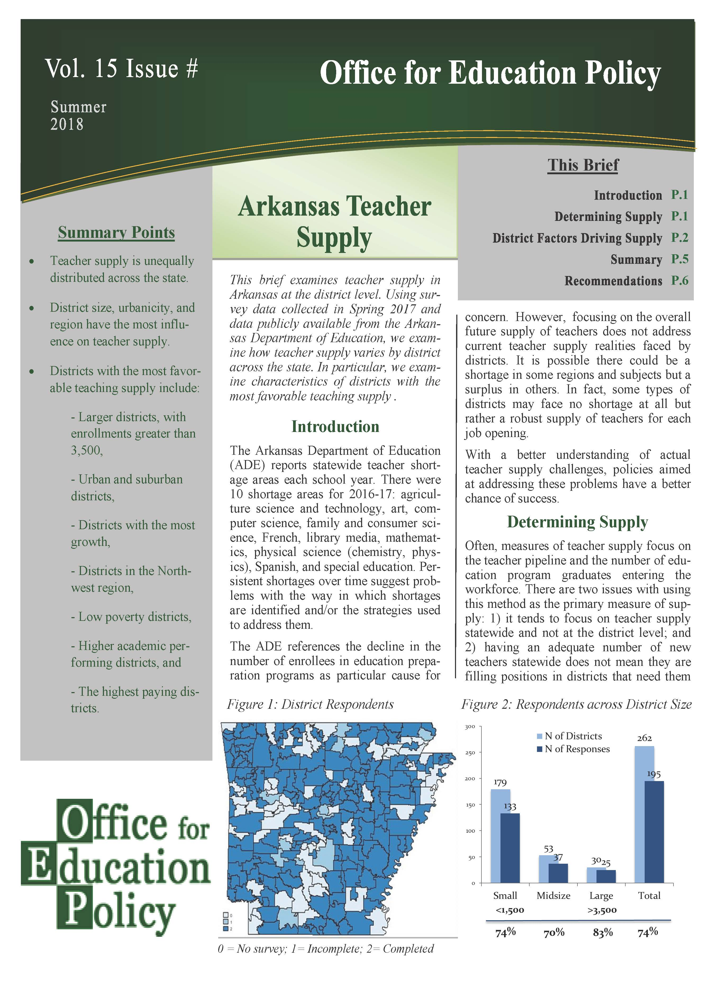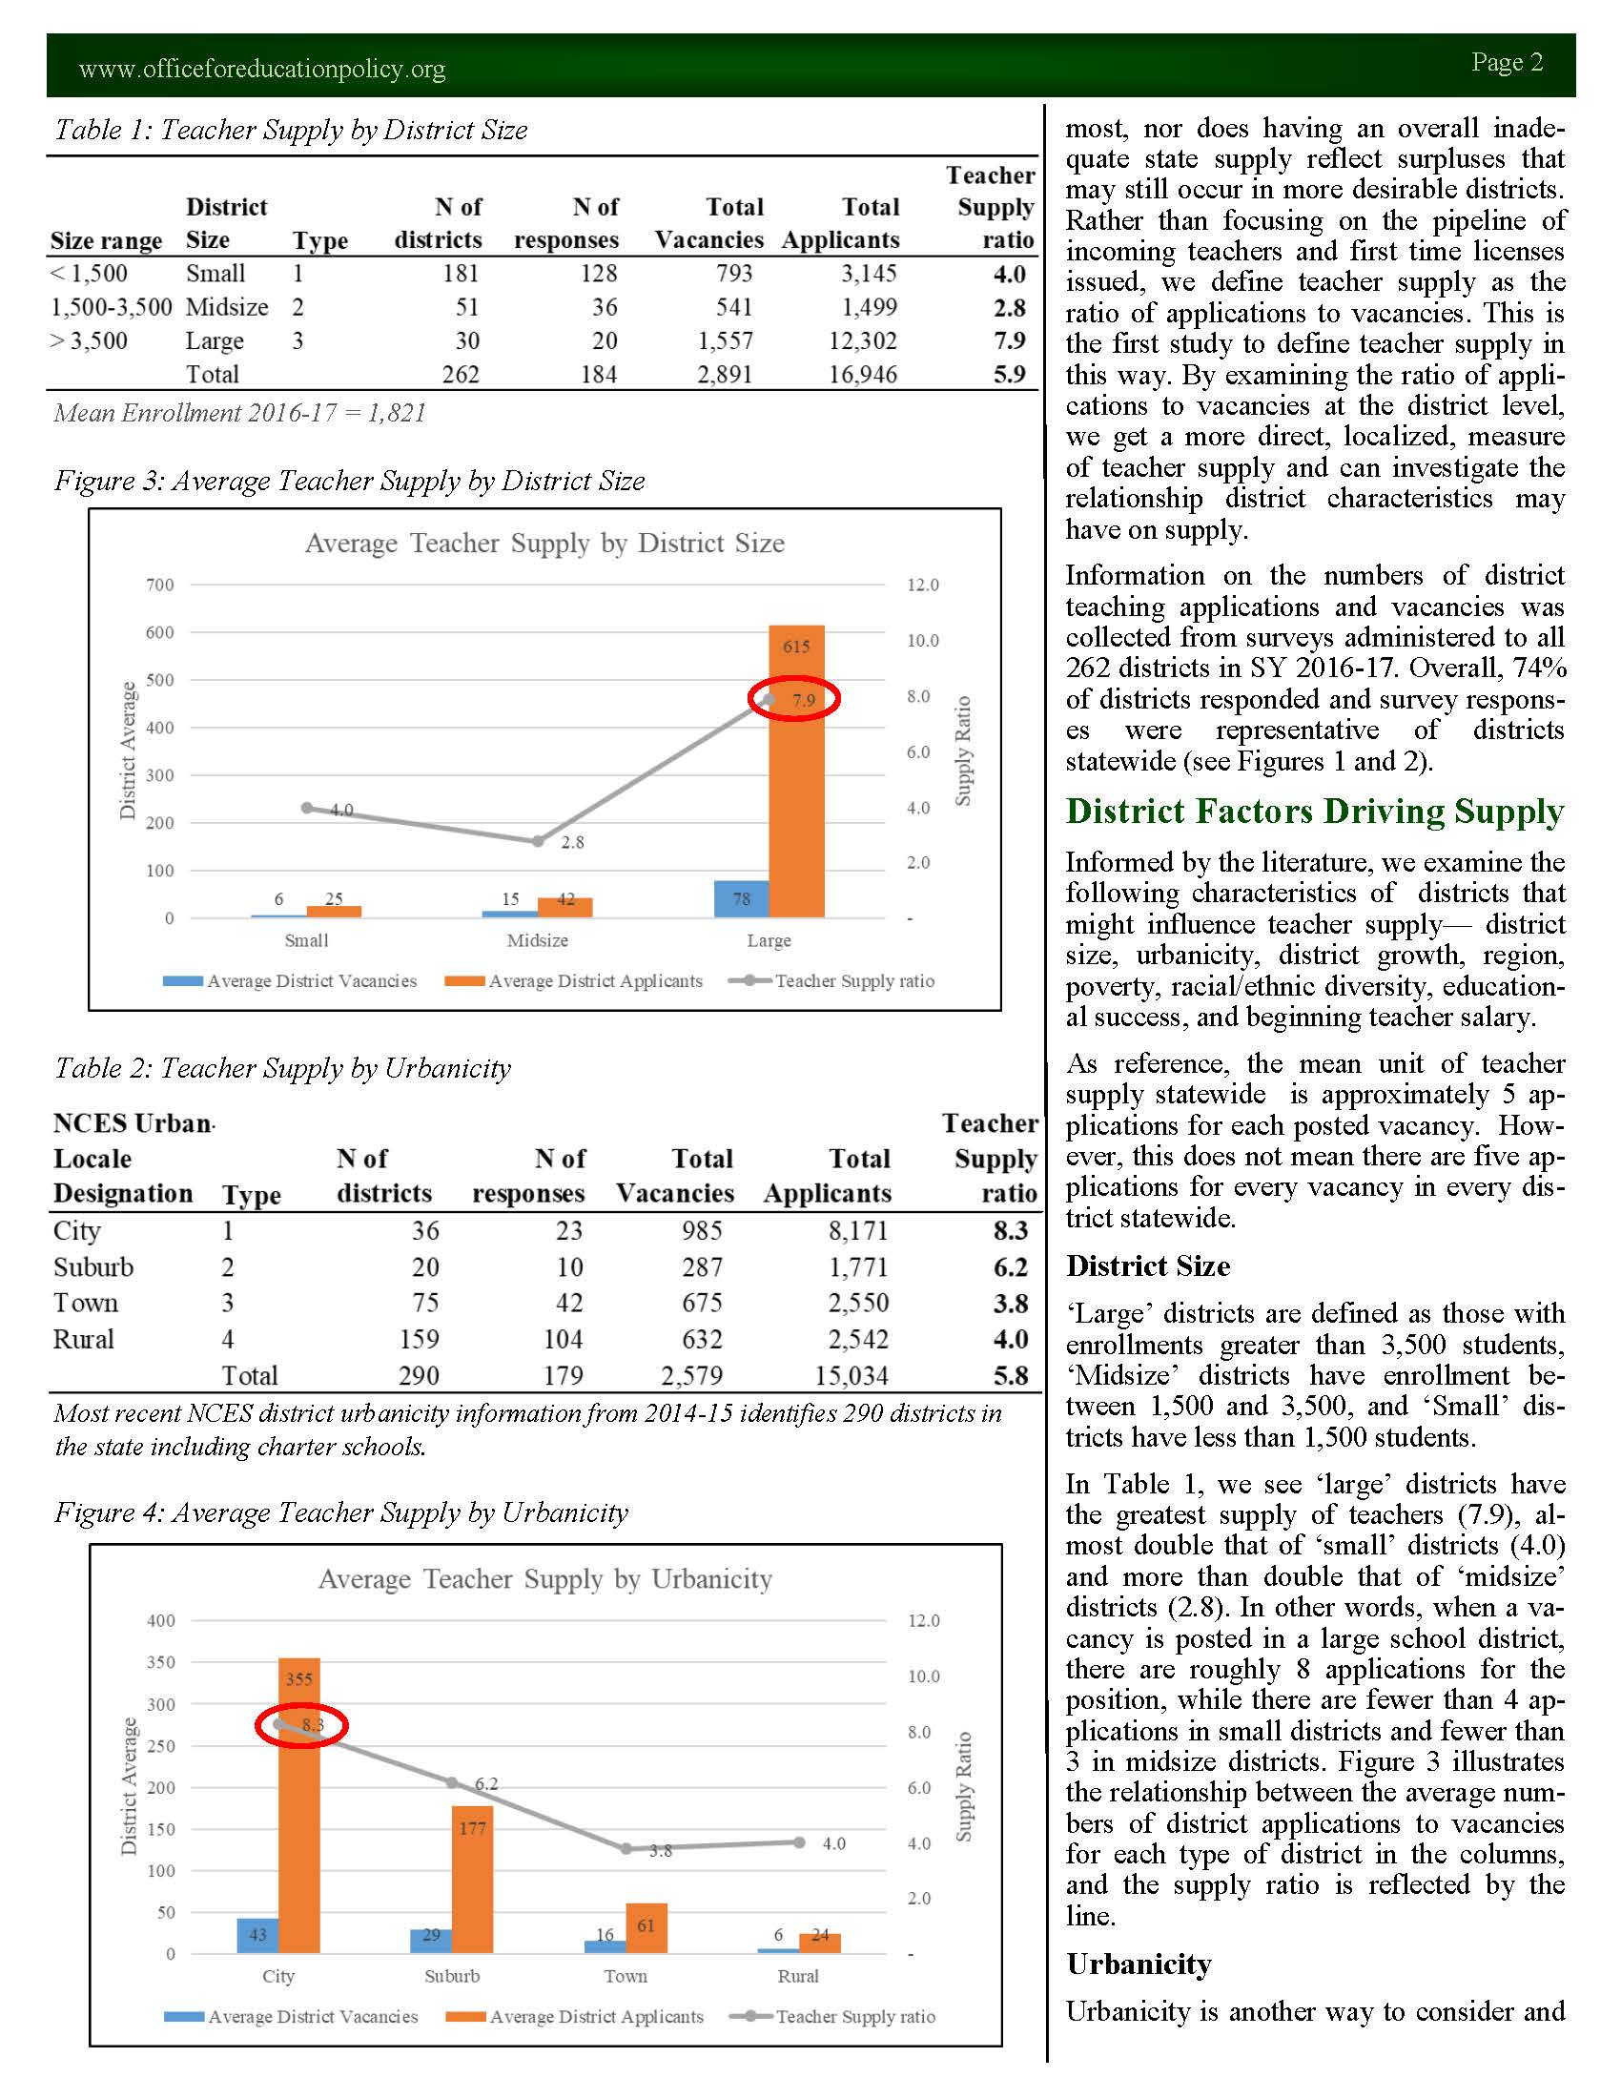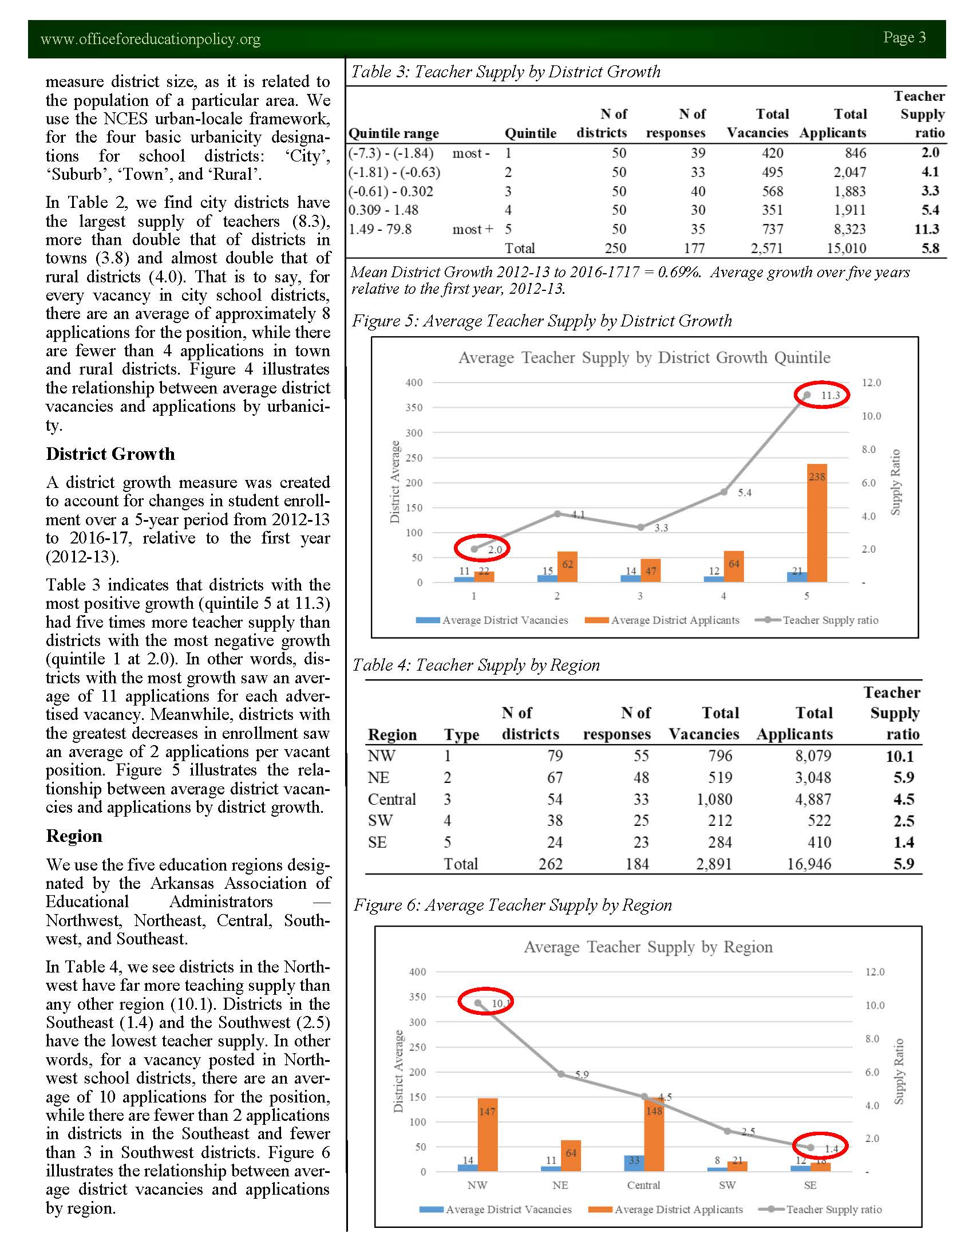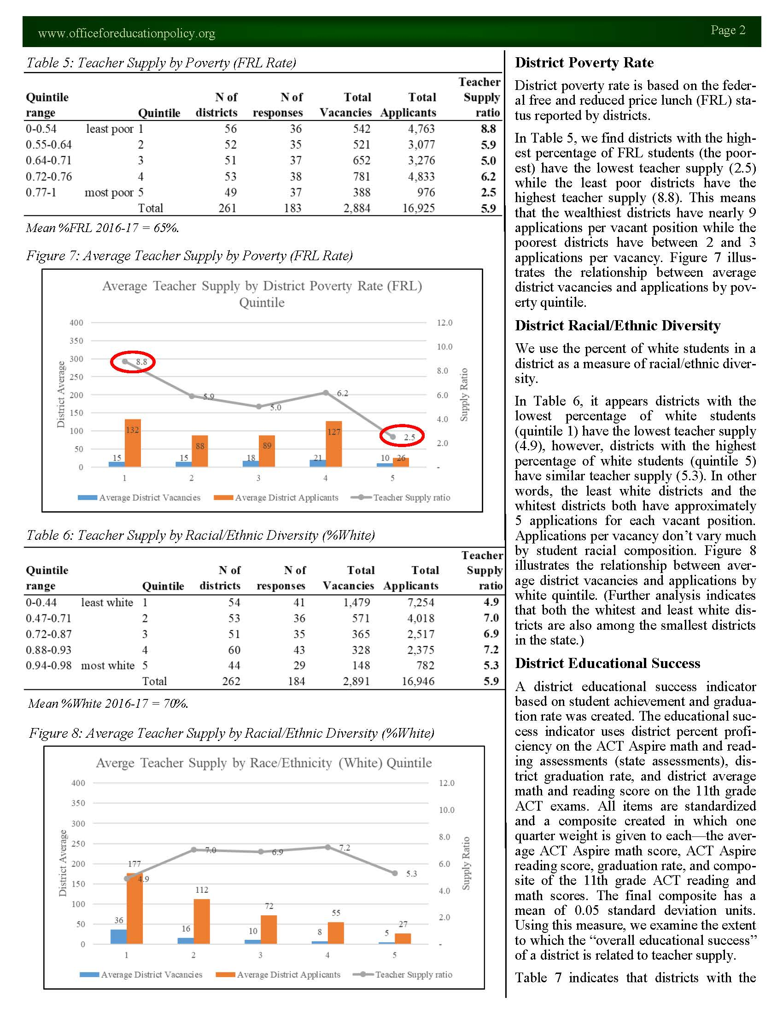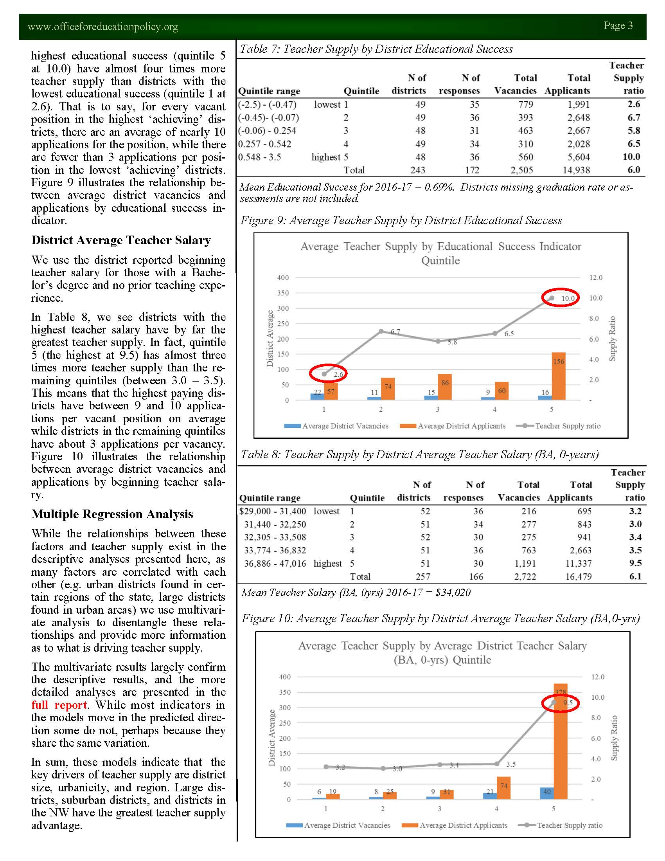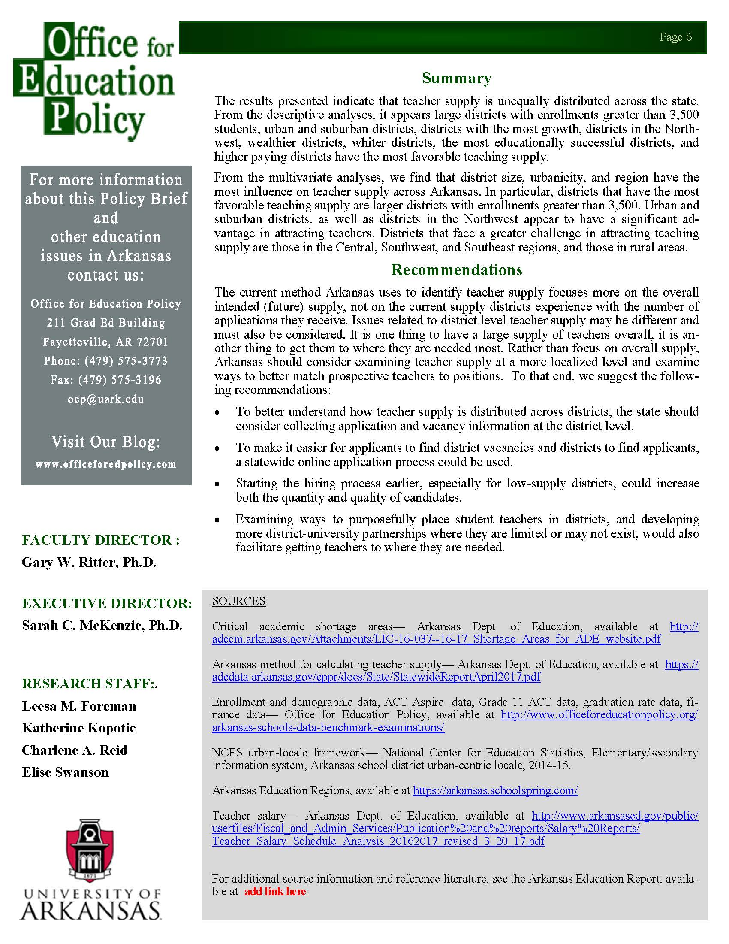Appendix D
Master of Education in Educational Equity Plan of Study
Course Name (and Number) | Type | Component | Timing | Prerequisites | Instructor of Record | Site Supervisor / Facilitator | Credit Hours
EDEQ 5003 Best Practices for Teaching in High-Needs Schools | Required | Seminar | Summer 1 | Consent of Instructor | Dr. Tom Smith | Directors of Content | 3
EDEQ 5013 Classroom Management Mechanics and Content | Required | Applied Instruction / Clinical (online) | Fall 1 | Consent of Instructor | Dr. Pamela Yancy-Taylor | Directors of Content | 3
Elective | Elective | Seminar (online) | Fall 1 | Varies | Varies | N/A | 3
EDEQ 5023 Collecting and Analyzing Student Data | Required | Applied Instruction / Clinical (online) | Spring 1 | Consent of Instructor | Dr. Pamela Yancy-Taylor | Directors of Content | 3
Elective¹ | Elective | Seminar (online) | Spring 1 | Varies | Varies | N/A | 3
EDEQ 5033 Teaching Specific Content in High-Needs Schools | Required | Practicum | Summer 2 | Consent of Instructor | Dr. Pamela Yancy-Taylor | Directors of Content | 3
Elective¹ | Elective | Seminar (online or in-person) | Summer 2 | Varies | Varies | N/A | 3
EDEQ 5043 Reflecting and Planning Content Delivery | Required | Applied Instruction / Clinical (online) | Fall 2 | Consent of Instructor | Dr. Pamela Yancy-Taylor | Directors of Content | 3
Elective¹ | Elective | Seminar (online) | Fall 2 | Varies | Varies | N/A | 3
EDEQ 5053 Understanding and Exploring Community Context | Required | Applied Instruction / Clinical (online) | Spring 2 | Consent of Instructor | Dr. Tom Smith | Directors of Content | 3
Elective¹ | Elective | Seminar (online) | Spring 2 | Varies | Varies | N/A | 3
Appendix E: Program Budget

Appendix F: Master of Education in Educational Equity Organizational Chart

15 hours of elective credit required chosen from: SPED 5173, SPED 5733, EDFD 5683, EDFD 5373 or EDLE 5033, or other advisor approved courses that support the goals and objectives of the program.

