Workforce Analysis Request Form

Directions: An institution shall use this form to request workforce data analysis of a proposed degree program. In completing the form, the institution should refer to the document AHECB Policy 5.11 Approval of New Degree Programs and Units, which prescribes specific requirements for new degree programs. Note: This form is required to be submitted by the Chief Academic Officer or individual(s) they designate. Answers need not be confined to the space allotted but may extend to several pages.
Workforce Analysis is not required for certificate of proficiency or technical certificate.

Program Information for Analysis
1. Institution:

University of Arkansas, Fayetteville
2. Program Name – Show how the program would appear on the Coordinating Board’s program inventory (e.g., Bachelor of Business Administration or Associate of Science in Accounting):

Bachelor of Arts in Italian
3. Proposed CIP Code: If the proposed program does not fit easily into one CIP Code, provide the code it most closely falls into and explain differences / nuances of your program

16.0902 Italian Language and Literature

4a. Standard Occupational Classification (SOC) from CIP-SOC Crosswalk:

Take SOC codes from NCES Crosswalk of CIP to SOC, ranked in order of relevance (i.e., the degree to which program graduates are expected to desire and/or be qualified to work in each occupation) (See Appendix A)

05.0126 Italian Studies | 25-1062 Area, Ethnic, and Cultural Studies Teachers, Postsecondary
16.0902 Italian Language and Literature | 25-1124 Foreign Language and Literature Teachers, Postsecondary
16.0902 Italian Language and Literature | 27-3091 Interpreters and Translators

In addition to these positions, our students will be prepared to work in International Business and Economics (a certificate within the program), as well as other national and international fields likes politics, law, non-profit, sustainable industries, etc.

4b. Standard Occupational Classification (SOC) from Expert/Staff Opinion (optional): If you think the standard NCES crosswalk accurately represents the list of occupations in which graduates of the proposed program will be qualified to work, leave this blank. If you think the list of target occupations is longer, shorter, or different, please provide an alternative list here, ranked in order of relevance. Feel free to add qualitative information about the variety of jobs and pay scales that may exist within target occupations, and where you expect graduates to fit in. (See Appendix A)

- Anthropology & Archeology
- Architecture: building; design; sustainability
- Art: art history; art education; communications & marketing; advertising; museum exhibition curation; arts administration; art publishing; arts non-profits; museum education; gallery and museum communications; gallery and museum development, fundraising and donor cultivation; community and public arts project coordination; community performing arts coordination; art archive and collections management; arts diversity and outreach
- Business: international business; international economics; international relations/politics
- Digital Humanities & Gaming
- Educational Opportunities: K-12; college and university; grant writing, DEI initiatives; training; non-for-profit
- Engineering
- Fashion: fashion design; fashion seller/buyer; fashion show organizer
- Film Studies: dubbing; subtitling; script writing; producing, directing; film history
- Food & Wine: agriculture; marketing; wine; distribution; sustainable industries; import/export; sommelier; wine production; wine distribution and supply; enologist; sales representative
- Library & Archival Work
- Music: music performance; music history; music education; music administration; importation of musical instruments; import/export of musical instruments
- Non-profit
- Pharmaceuticals: pharmaceuticals sales & distribution; pharmaceutical development/research
- Pre-Law, Pre-Med, Pre-Vet
- Publishing: editing; translation; layout; page design
- Tourism: management; guide; cruise line industry; agrotourism
5. Brief Program Description – Describe the proposed program, the costs and investments involved in implementing it, the students you expect to recruit into it, and its educational objectives.

Italian Major Description

The Italian Program at the University of Arkansas challenges students to think critically about the literary and cultural history which founds Italian and Italian American studies by integrating language acquisition and intercultural competence through the classroom and co-curricular activities on campus and through global experiences and high-impact practices such as study abroad (Rome Center and other programs), internships (Italy-America Chamber of Commerce of Texas, Ferrero Rocher, Italian Trade Agency – Chicago), and service learning (LiberaTerra). Beyond the more traditional outcomes of language learning and through the most up-to-date tools in foreign language pedagogy, our program encourages the importance of Italian for interdisciplinary study. Our end goal is to create global citizens who are prepared to embrace the principal aspects of Italian society and who have critically explored their native language and culture. An Italian major is a wonderful complementary course of study to numerous fields: Architecture, Art History, English, History, International Relations, International Business, Music, Philosophy, etc. A student can decide to one of two concentrations:

Transnational Studies Concentration

The Transnational Italian Studies concentration is a cross-discipline exploration of various areas relating to Italian and Italian American culture. It is aimed at students who are not necessarily dedicated to achieving advanced language proficiency but desire a comprehensive understanding of Italian literature, history, art, culture, and civilization enhancing their philosophy of global citizenry and diversity. This interdisciplinary enterprise includes a basis of Italian language courses paired with Italian-focused courses taught in English from a variety of departments and programs across campus: Architecture, Art History, Classics, English, History, Medieval and Renaissance Studies, Philosophy, and Political Science.

Literary and Cultural Studies Concentration

The Italian Literary and Cultural Studies concentration concentration is designed to be a launching pad for a more in-depth analysis of Italy’s great literary and cultural tradition. The program encourages independent and innovative thinking and research founded in the Humanities. It is aimed at students interested in achieving a high level of proficiency in reading, writing, and speaking in Italian. In addition to the studying language, coursework encompasses the literary and artistic aspects of Italian culture and their contributions to the world, milestones and major events in Italian history, modern Italian culture, current events, and politics.

Costs: The launch of the Italian Major has no additional cost to the university. We are not asking for any lines or even extra courses.

Students: Students who would be interested in the Italian Major include the following: Honors Students, Students studying in Rome, International Business, International Economics, Marketing, Economics, English, History, Translation Studies, Political Science, Classical Studies, Architecture, Anthropology, Archeology, Engineering, Music, besides students studying these fields, we will also recruit Heritage Spanish Speakers and are working to introduce Italian in some high schools in Northwest Arkansas.

Educational Objectives:

Transnational Studies
- Met ACTFL goals of intermediate-high level proficiency in speaking, reading, writing, the understanding of spoken Italian, and the ability to use these skills in a range of academic and everyday situations.
- Communication: Communicate in Italian, both orally and in writing, by engaging in interpersonal, interpretative, and presentational communication activities.
- Comparisons: Make meaningful cross-cultural comparisons between Italy and other countries
- Culture: Demonstrate knowledge and understanding of other cultures.
- Connections: Develop critical thinking by making connections and engaging creatively in problem solving activities.
- Communities: Engage in multilingual communities at home and around the world by applying classroom learning to real-world situations.
- Demonstrated capacity to read critically and closely, to interpret texts, and to evaluate arguments about cultural texts and topics.
Literary and Cultural Studies
- Met ACTFL goals of advanced-low level proficiency in speaking, reading, writing, the understanding of spoken Italian, and the ability to use these skills in a range of academic and everyday situations.
- Communication: Communicate in Italian, both orally and in writing, by engaging in interpersonal, interpretative, and presentational communication activities.
- Comparisons: Make meaningful cross-cultural comparisons between Italy and other countries
- Culture: Demonstrate knowledge and understanding of other cultures.
- Connections: Develop critical thinking by making connections and engaging creatively in problem solving activities.
- Communities: Engage in multilingual communities at home and around the world by applying classroom learning to real-world situations.
- Advanced knowledge of major periods of Italian literature and other cultural texts with understanding of historical, generic, or cultural context.
- Demonstrated capacity to read critically and closely, to interpret texts, and to evaluate arguments about literary and cultural texts and topics.
- Ability to produce an organized, well-supported argument in writing; to write clearly and persuasively; and to observe ethical and precise citation practices.
6. North American Industry Classification System (NAICS) – List some industries and/or companies which graduates would be most likely and/or qualified to work in (optional), and feel free to comment on why/in what capacity. Also, a description of the target industry in your region, its relative strength or weakness relative to other regions, and the reasons for that relative strength or weakness, is welcome. Lookup NAICS Code

N/A
7. Region of Possible Position(s) – Describe the region where you think graduates are most likely to work, e.g., in terms of a list of counties, a metropolitan statistical area, or a commuting radius:

The presence of the Walmart Corporation has generated numerous industries to maintain home offices in Northwest Arkansas. Many of these agencies are Italian or Italian American based and have positions in import/export. I will be working with these agencies to initiate internship opportunities. Additional internships/employment opportunities will stem from personal relationships I have cultivated with the Italian Trade Agency in both New York City and Toronto as well as the Italy-America Chamber of Commerce of Texas, Inc., located in Houston, TX.

- United States: Northwest Arkansas, Little Rock, Houston, Dallas, Chicago, Los Angeles, San Francisco, Miami, New York, New Jersey, Detroit, New Orleans
- Canada: Vancouver, Toronto, Montreal
- Italy
- San Marino
- Switzerland
- Vatican City
- All countries that experienced the Italian diaspora (France, Germany, Switzerland, Australia, New Zealand, Argentina, Brazil, Venezuela)

8. Existing Data – Describe any existing anecdotes or data you have that would shed light on the job prospects of graduates from the proposed academic program. This data can be helpful to ADFA in conducting labor market analysis.

Articles supporting the importance of studying world languages for the job market:
- The Economist: “The Advantages of Speaking a Second Language”
- Career Profiles: “Career Benefits of Learning a Foreign Language”
- Forbes: “How the Power of Language Can Grow Your Career and Business”
- Financial Post: “Studies Show that Speaking a Second Language Can Offer More Job Opportunities”
- Chron.: “What are the Benefits of Multilingualism in the Workplace?”
- U.S. News & World Report: “Why You Should Learn Another Language”
- Entrepreneur: “The Business Benefits of Learning a New Language”
- Language Magazine: “The Bilingual Advantage in the Global Workplace”

Importance of Italian Language in Particular:
- Alexika: “Is Italian Useful for Business? Interesting Reasons to Translate into Italian”
- British Council: “How Good is Italian for Business?”
- ClassGap: “The Importance of Learning Italian for Business”
9. Proposed Implementation Date – (MM/DD/YY):

08/15/2023
10. Contact Person – Provide contact information for the person who can answer specific questions about the program:

Name: Ryan Calabretta-Sajder

Title: Associate Professor and Section Head, Italian

E-mail: calabret@uark.edu

Phone: 847-217-1630

Email the completed form: Dr. Nicolas Aguelakakis (Nicolas.Aguelakakis@arkansas.gov).

After the labor market analysis has been completed, the institution will be invited to respond, providing further information that might shed light and help to interpret the data provided.

APPENDIX A. CIP-SOC MATCHING AND THE NCES CROSSWALK (Question 4a & 4b)
Labor market analysis for academic program requires the combination of diverse data sources. The National Center for Education Statistics (NCES) and the Bureau of Labor Statistics (BLS) developed a “CIP-SOC crosswalk” linking fields of study, classified by a well-established classification scheme called Classification of Instructional Programs (CIP), with occupations, classified by a well-established classification scheme called Standard Occupational Classifications (SOC). The CIP-SOC crosswalk is available here, and guidelines on how to use the scheme are posted online here.

In question 4a of the form, institutions are asked to copy and paste a list of occupations that match with their instructional programs, taken directly from the NCES CIP-SOC crosswalk, which can be downloaded here: https://static.ark.org/eeuploads/adhe/CIP-SOC_Crosswalk_for_Workforce_Analysis_Form.xls

To use this file to answer question 4a:
- Select Column A.
- In the Home ribbon, Editing section of the toolbar, click Find & Select to get a drop-down menu, and select the Find command. As you do this, your screen should look something like this.
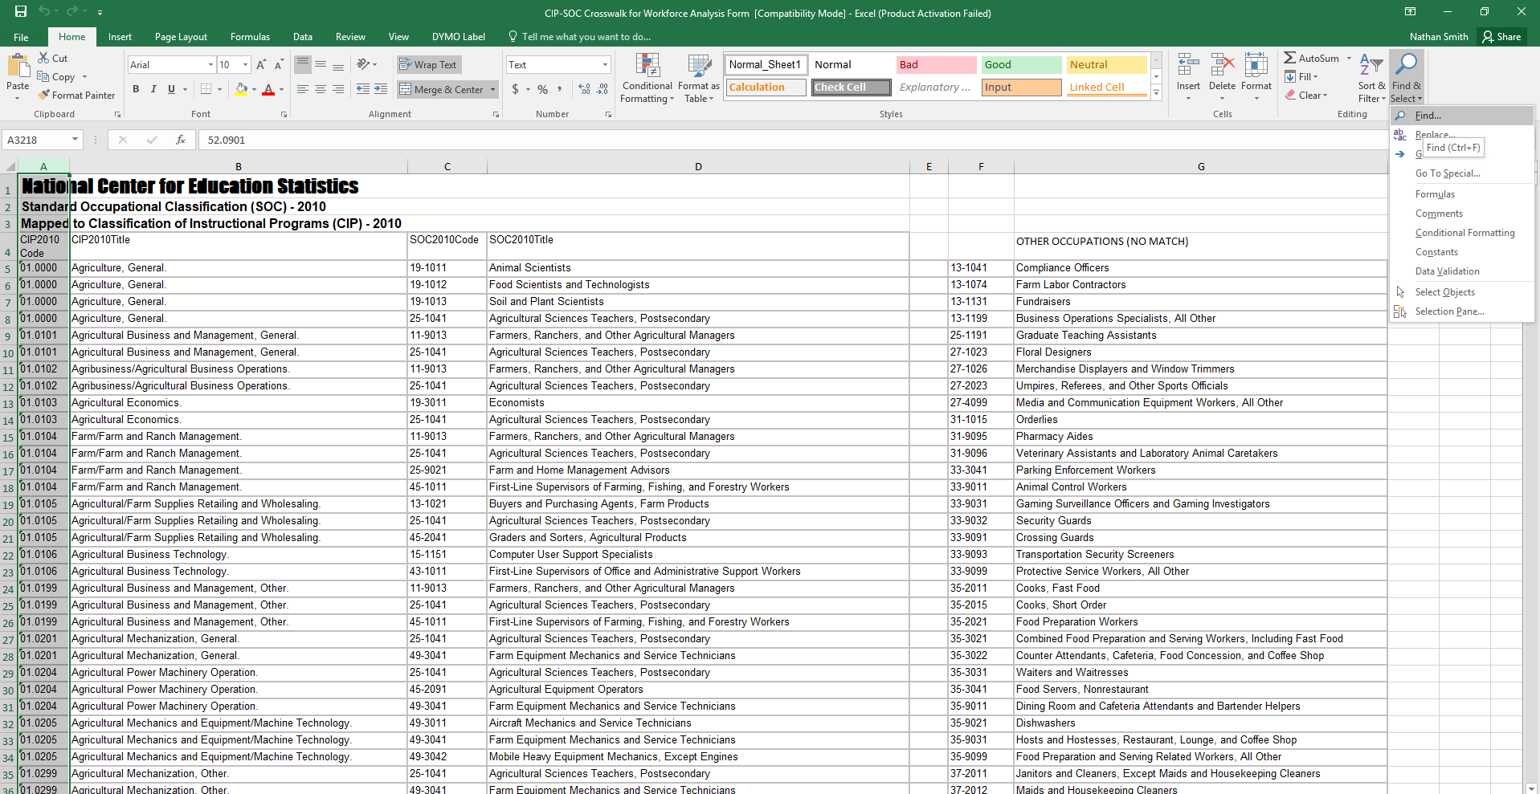

- In the Find and Replace dialog box, enter the CIP code that you’re interested in, and click “Find Next.” Your screen should then look like this:

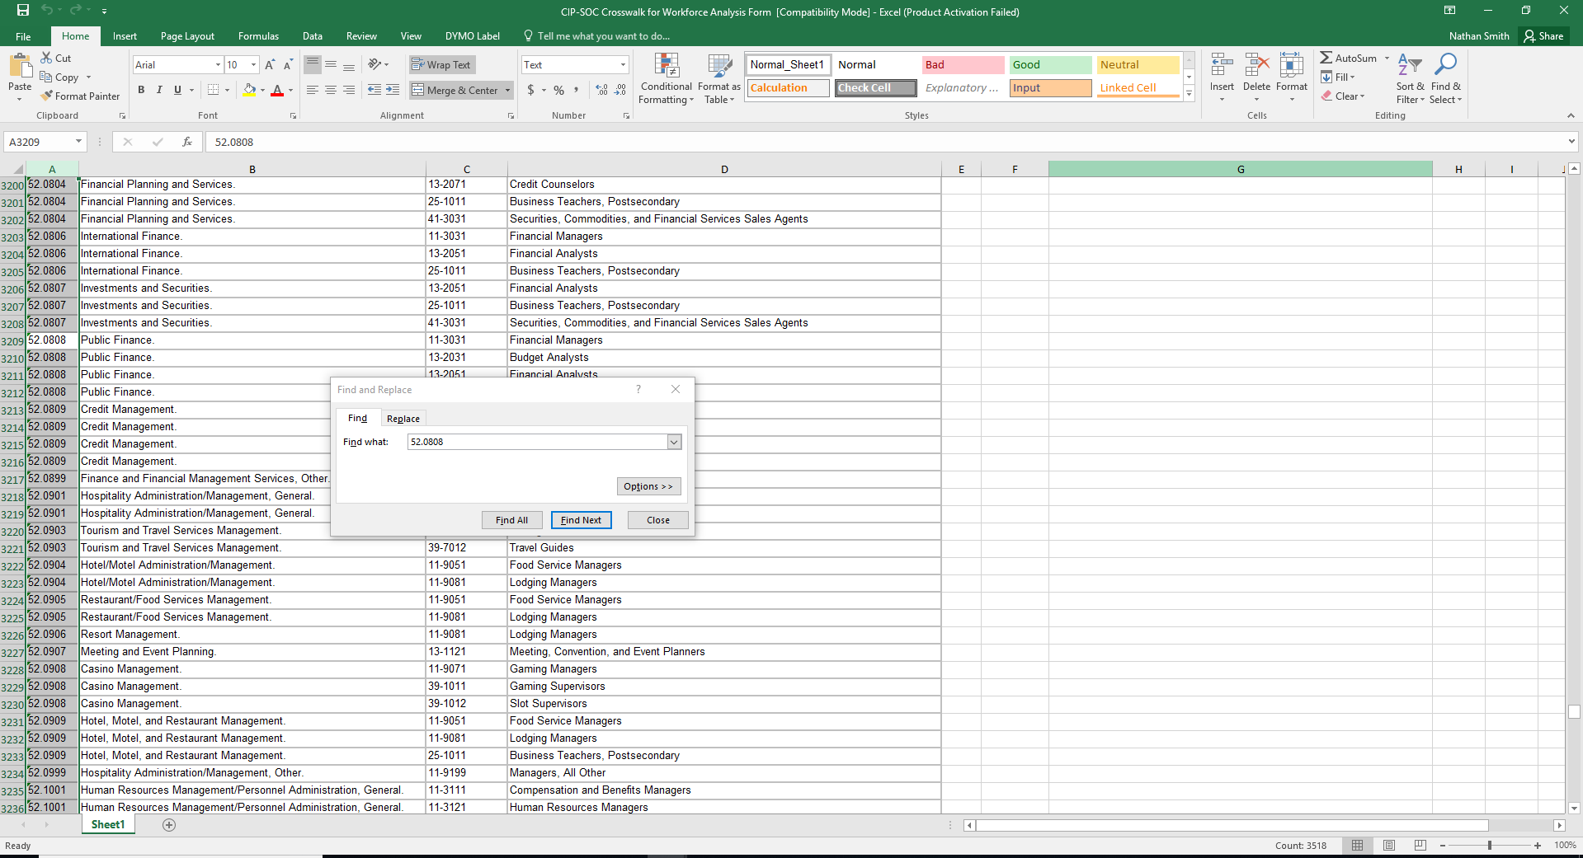

- Since the CIP-SOC crosswalk file is already sorted by row, you can find all the rows corresponding to your CIP simply by starting from the first cell selected and then reading down in column A until you encounter a different CIP code.
- Select all of these rows, columns A through D, this will form a table that can be pasted directly into the response field for question 4a.

52.0808 | Public Finance. | 11-3031 | Financial Managers
52.0808 | Public Finance. | 13-2031 | Budget Analysts
52.0808 | Public Finance. | 13-2051 | Financial Analysts
52.0808 | Public Finance. | 25-1011 | Business Teachers, Postsecondary

- If desired, ask a faculty or staff member to sort the matched occupations from the CIP-SOC crosswalk by relevancy/importance, with the occupations that seem most likely to employ your graduates ranked first.
- Missing occupations from the list should be addressed in question 4b.

Question 4b, is requesting information from your local staff/workforce experts at your institution on the applicability of the NCES list. We are aware that the NCES might be “globally” wrong—the CIP/SOC match may never have been very accurate, or may become obsolete as fields and occupations evolve—or “locally” wrong—the CIP/SOC match may be reasonably robust in general, but fail to capture the role your particular program plays in students’ career paths. Graduates of a particular program may be over or underqualified for some of the matched occupations. Also, there may be SOCs not matched to your CIP by NCES for which, however, your program does help to prepare students, and which are likely to provide gainful employment for your graduates. Question 4b is the place to tell us about those as well.

The UofA Rome Center is another avenue for the Italian Program to send students wanting an internship or researchship opportunities.

