Human Development & Family Studies Online Bachelor’s Degree
Academic Benchmarking & Labor Market Report

Contents
Modality Overview 3
Arkansas Public Institutions: 4
SEC Cohort Institutions: 4
Top 10 Enrolling Online Programs: 5
Occupation: Social & Community Service Managers 6
Arkansas Summary: 6
Northwest Arkansas Summary: 6
Occupation: Social & Human Service Assistants 7
Arkansas Summary: 7
Northwest Arkansas Summary: 7

Modality Overview
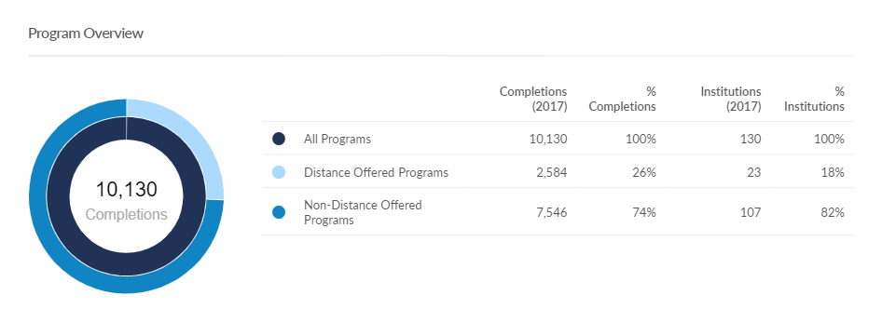

Arkansas Public Institutions:
Institution | Program & Concentrations | Bachelor’s Degree  Completions & Growth (2017) | Undergrad Tuition Per Credit Hour  (In State)
None

SEC Cohort Institutions:
Institution | Program & Concentrations | Bachelor’s Degree  Completions & Growth (2017) | Undergrad Tuition Per Credit Hour  (In State)
Kansas State University | B.S. – Human Development & Family Science | 190 completions  Insf. Data on growth | $436/credit
University of Alabama | B.S. – Human Environmental Science  Concentrations:  Consumer Sciences – Consumer Affairs  Family Financial Planning  Human Development & Family Studies: Child Life  Human Development Family Studies: Child Development Practitioners | 77 completions  -20% decline YOY | $375/credit

Top 10 Enrolling Online Programs:
Institution | Program & Concentrations | Bachelor’s Degree  Completions & Growth (2017) | Undergrad Tuition Per Credit Hour  (In State)
Oregon State University | B.S. – Human Development & Family Sciences | 352 completions  -2% decline YOY | $309/credit
Brigham Young University - Idaho | B.S. – Marriage & Family Studies | 264 completions  39% growth YOY | $125/credit  (Part of “pathway” program with specific tuition)
Colorado State University -Fort Collins | B.S. – Human Development & Family Studies | 257 completions  -15% decline YOY | $476/credit
Kansas State University | B.S. – Human Development & Family Science | 190 completions  Insf. Data on growth | $436/credit
Pacific Oaks College | B.A. – Human Development  Concentrations  Early Childhood Education & Development  Active Learning Across Lifespans  Elementary Education  Social Change  Working with Adults | 188 completions  -2% decline YOY | $350/credit – lower  $676/credit - upper
Utah State University | B.S. – Family Life Studies | 179 completions  13% growth YOY | $301/credit
Washington State University | B.A. – Human Development | 173 completions  12% growth YOY | $518/credit
California State University – East Bay | B.A. – Human Development  Concentrations:  Adult Development & Gerontology  Women’s Development  Early Childhood Development | 164 completions  1.9% growth YOY | $396/credit
University of Wisconsin | B.S. – Family & Consumer Sciences Education | 97 completions  -8% decline YOY | $334/credit
University of Alabama | B.S. – Human Environmental Science  Concentrations:  Consumer Sciences – Consumer Affairs  Family Financial Planning  Human Development & Family Studies: Child Life  Human Development Family Studies: Child Development Practitioner | 77 completions  -20% decline YOY | $375/credit

Occupation: Social & Community Service Managers

Arkansas Summary:
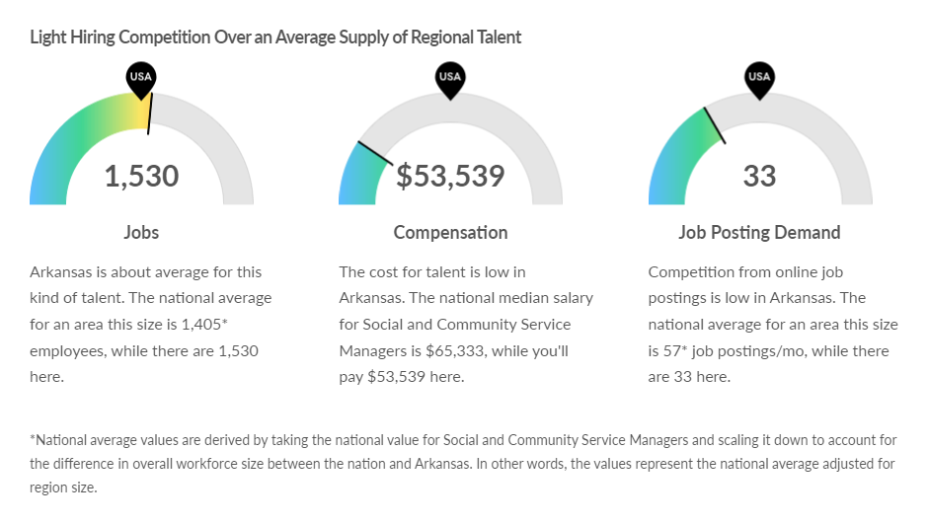

Northwest Arkansas Summary:
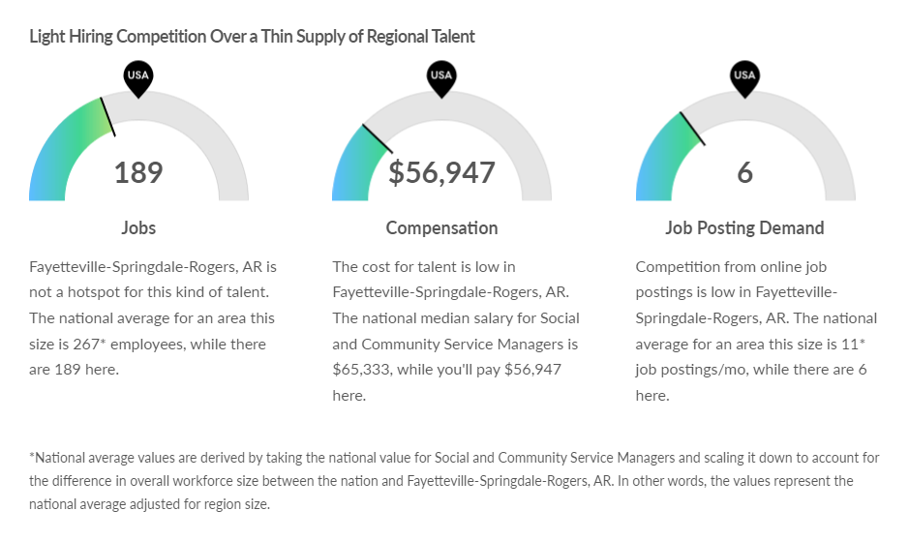

Occupation: Social & Human Service Assistants

Arkansas Summary:
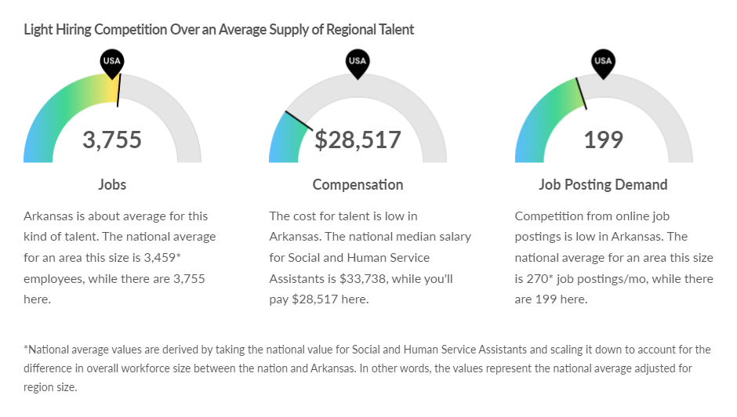

Northwest Arkansas Summary:
